Best Regards and Please Follow Us!
Website | Facebook | LinkedIn
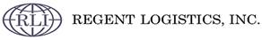
Kenneth Velardi Import/Export Operations
870 E Higgins Road Schaumburg IL, 60173
P-(847) 969-9116
F-(847) 969-9117

