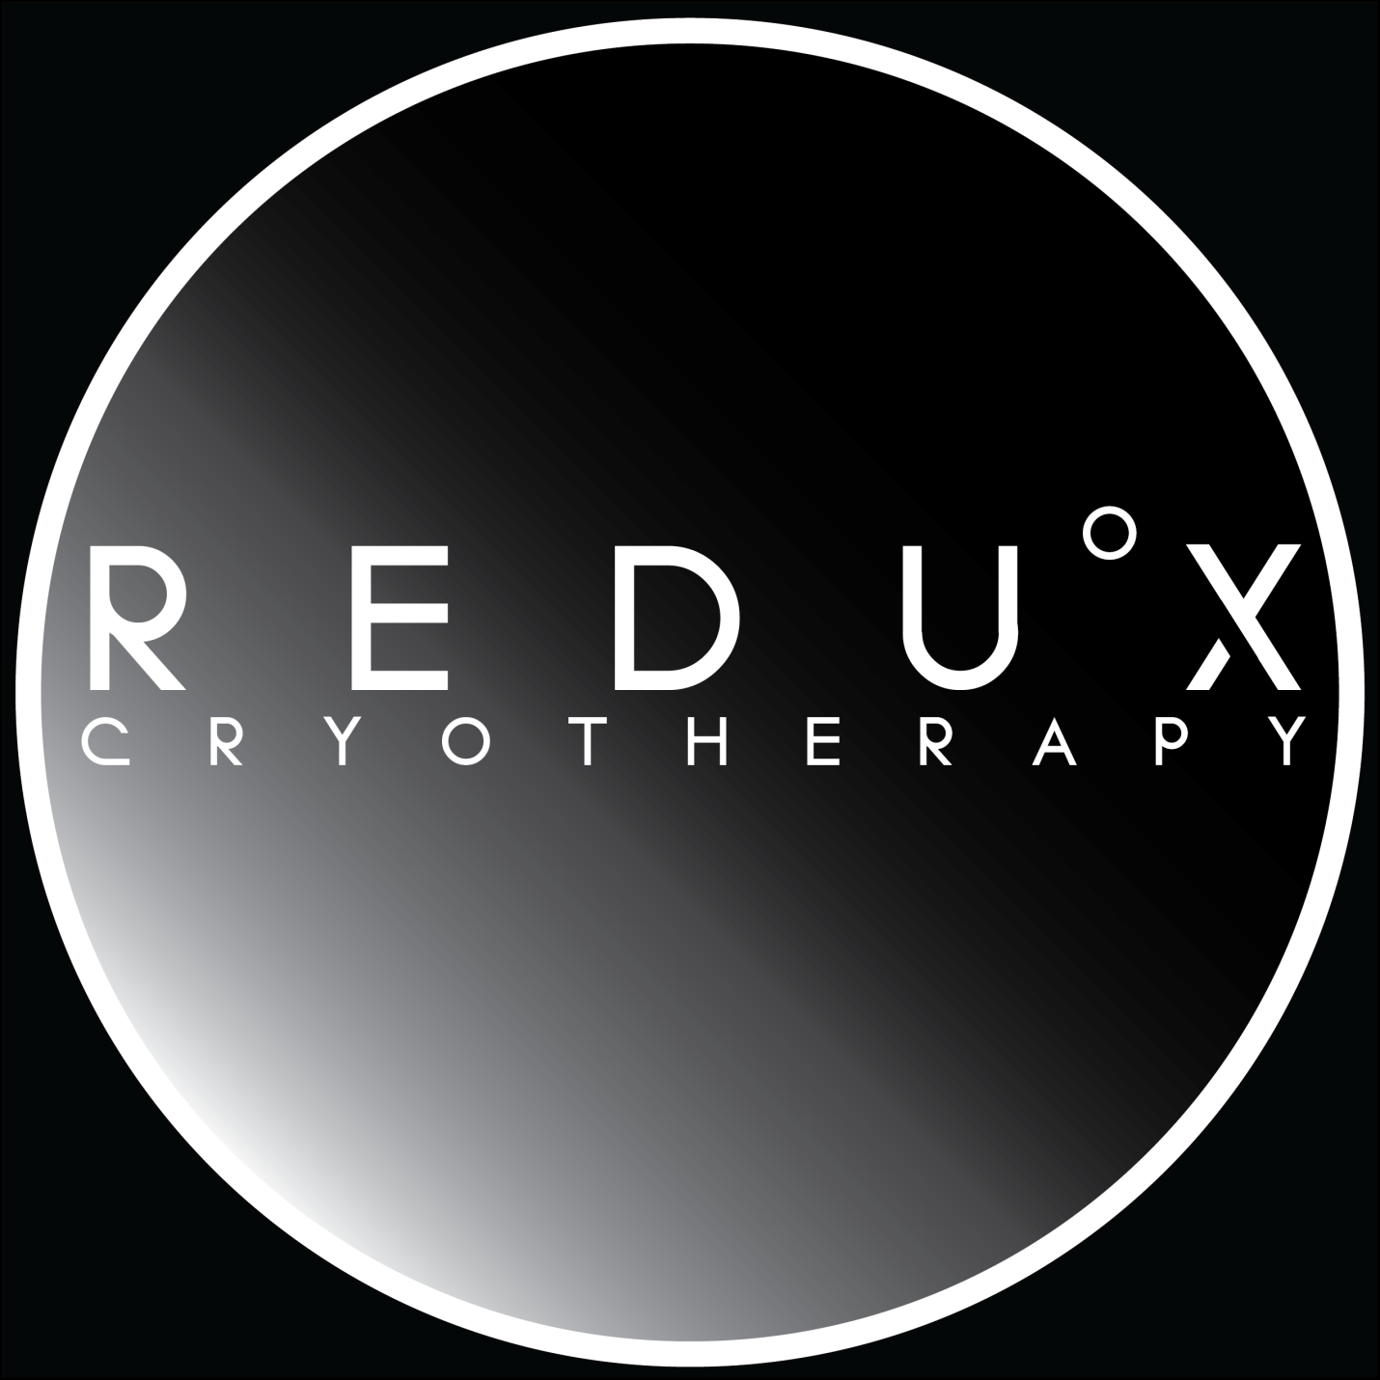
Another concept we like doing something like this with the “gradient” look. But using a brilliant “Blue” color. We would like to see “Celsius” about one third the size (with the degree image, above the “S” in Celsius” And Cryotherapy below. Try different fonts. Also Try doing a version of the above with” Celsius “ lettering spaced like above.

