LOGO DESIGN BRIEF

The Job | Design logo for ecommerce business
About Us  (max 2-3 lines) | Bear & Kub will be suppling quality baby / kids products
Geographical audience | Global
Target audience | Female / Working Mums / New Mums
THE SPECIFICATIONS
Logo use  Where will this logo be shown? | ONLINE – website, social media channels, online marketing  PRINT - business card / flyer insert
Logo formats required | Include as shown below:  BOTH print ready and web files are required. High res JPEG, Vector File and Source file to be supplied upon completion.
Business name | Bear & Kub
Graphic device  (example below)  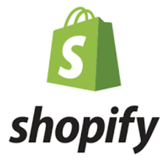 | I would like to incorporate an image of a mother and baby or a play on words.
Preferred colours  (if any) | COLOUR COMBINATIONS  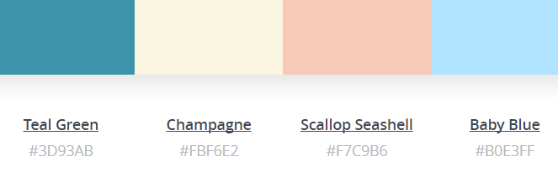  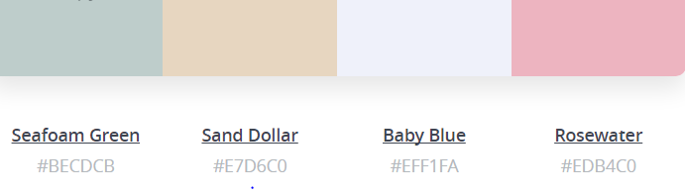  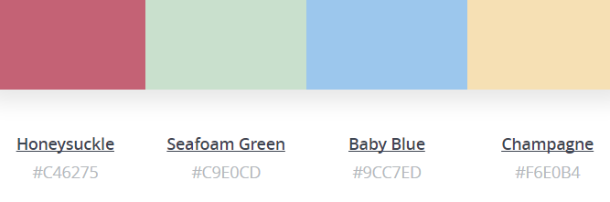
Examples of logos we like.. | 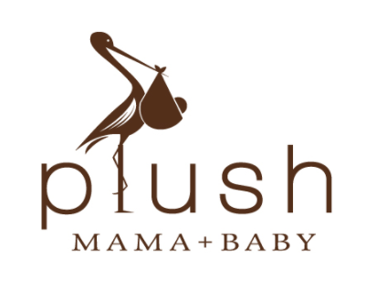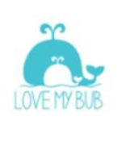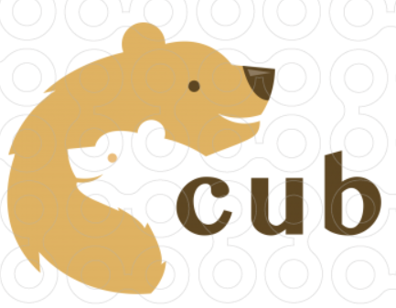  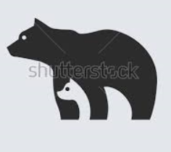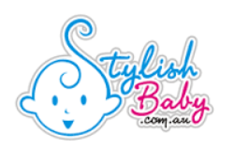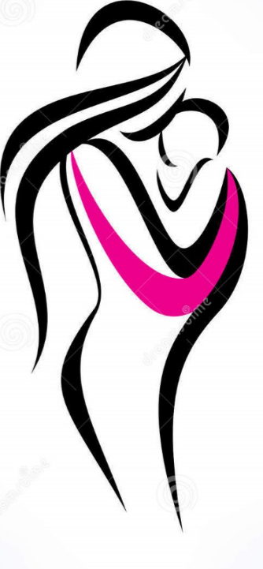
What we don’t like.. | Too many colours and too much detail
Design requirements | The design must:  - appeal to both boys and girls, but a design that mum likes also (as she does the purchasing). Not too cutesy.  - it must also come across as modern and progressive.
Artwork deadline  (if applicable) | ASAP

