Thanks for taking on this project.
I need a logo designed for an autonomous, tractor start-up. I would like the design to be modern, but not too flashy because farmers are a conservative group of people. My general thought is some combination of a Rabbit silhouette and text. Below is a rough example. I need: a leterhead logo, a basic no-text logo, and a full logo. If there are more variations you think I would like then please mention them to me.
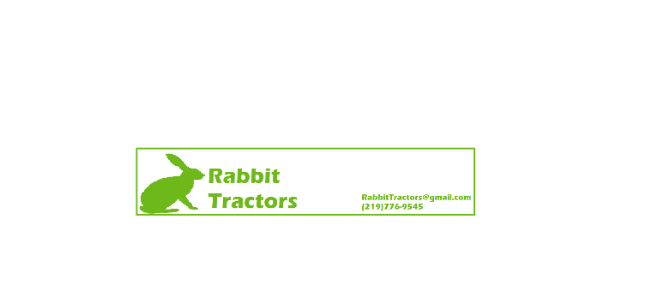

I want to use these colors. White being the main color, then next green and only a slight bit of gold/gray (if any at all).


I do not want my logo to look too similar to the John Deere logo.
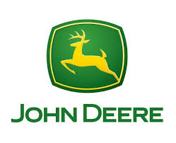

Here are some examples of logos I like. Note that some of these are my competitors so nothing too similar.


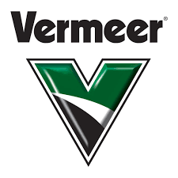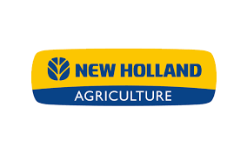
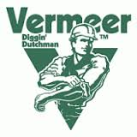

This first rabbit logo is a little more modern than what I am going for; the other two are slight not “aggressive” enough
