Front page (Clean, comfortable, high end design)

Logo

Philosophy
Our body is composed of 60-75% of water; our blood is composed of 92% of water. Water is in fact an extremely crucial factor to maintain body’s health. We believe that the most effective and direct way to retain and improve one’s health condition is by changing the water one drink every day. Good quality water possesses the qualities as those found in natural springs in environment-preserved areas: clean as in without impurities, high alkaline level, hydrogen rich, high level of negative ions, and small molecular clustered. Knaussvo urge to raise more awareness on the quality of daily drinking water and their effect on our overall and cellular health. We advocate the most natural way to maintain and regain body’s health.

Mission
  - To bring health, beauty, and happiness
  - To diminish world's chronic diseases
  - To create value and make a difference
We consider our mission statement a commitment to our customers. We deliver on that commitment by striving to create and provide the best drinking water that most benefit human body

Vision

Have Knaussvo Water Purification System in every kitchen, ending the fear and suffer of major chronic diseases and becoming the quality leader in water purification industry.

Core values

Our Faith

Knaussvo is confident in solving many of your health concerns. With a three-month risk-free improvement guarantee, customers with diabetes type II, high blood pressure, high cholesterol, and high triglyceride are assured to get the results they are looking for and to be completely satisfy with the experience. Our customers value highly in their health, and we care deeply for our customers.

Our Responsibility

Knaussvo cares deeply for our customer as well as our environment. Knaussvo insist on saving energy resources while protecting the environment. The whole system is smart designed but unpowered, does not discharge waste water, and protects you from radiation or EMF emissions.

“Water and Sanitation is one of the primary drivers of public health. I often refer to it as “Health 101”...”
– World Health Organization

“Water-Related Diseases are responsible for 80 percent of all illnesses, deaths...”

Water- Related Disease
Caused by drinking untreated water, tap water, distilled water, bottled water and water with impurities including toxic chemicals, heavy metals, fluoride, lead, chlorine, radiological hazards, infectious agents

- Cardiovascular Disease
  - Diabetes Type II
  - High Blood Pressure
  - High Cholesterol
  - High Triglyceride
  - High Uric Acid
- Chronic Kidney Disease
- Chronic Liver Disease
- Cancer
- Brain Damage
- Autonomous Nervous System Disorder
- Immune System Disorder
- Infectious Diseases

29 % of population have high blood pressure, greatly increases the risk for heart disease and stroke, the first and third leading causes of death in the United States as in 2016

15 % of population have chronic kidney disease, which leads to hemodialysis

9.3 % of population have Diabetes, and 1/3 of the population has been diagnosed as pre-diabetes

DRINKING WATER WITH IMPURITIES WILL SLOWLY CAUSE SEVERE DAMAGE TO HUMAN BRAIN AND BODY

WHY KNAUSSVO WATER CAN FULLY IMPROVE AND PREVENT CHRONIC CARDIOVASCULAR DISEASE
The small molecular cluster we create is composed by only 4-6 water molecules, while other water contains 20+ water molecules. Knaussvo water attain a frequency like that of human body; it does best in absorb and thus, detoxify. It keeps your sugar level/ /blood pressure/nitric acid/cholesterol/triglyceride normal by washing away excessive component in the blood and by regulating your hormones thus strengthening your pancreas.

THE IMPORTANCE OF DRINKING WATER

DISTILLED/BOTTLED/PURIFIED WATER ARE NOT ENOUGH FOR YOUR BODY.

WATER IS FOR DITOXIFICATIOIN AND BALANCING.

Why you need to drink Knaussvo.

DETOXIFY
Our body metabolize and discharge wastes through urination, defecation, and perspiration. The main task of water is to help you detoxify: discharge toxic or unhealthy substances from body.

MAINTAIN WATER BALANCE

The body of an adult human being contain 60% - 72% water. Blood contain 92% water. Every cell, tissue, and organ needs water to maintain its balance for the body to work properly. The water one drink needs to be easily-absorbed to stay hydrated.

QUALITY DRINKING WATER CONDITIONS THAT SATSIFY OUR BODY’S NEEDS:
ALKALINE
NEGATIVE IONS
HYDROGEN RICH
NATURAL MINERALS
SMALL MOLECULAR CLUSTERED

The Ultimate Revolutionary System

Filtration
Stage 1 5 Micron Sediment Filter
- Removes all particles of sediment, dirt, and silt
Stage 2 & 3 Ion Exchange Resin Filter
- Removes fluoride and calcium carbonate
- Softens water
Stage 4 1 Micron Sediment Filter
- Removes bacteria, sediment, cysts, environmental hormones
Stage 5 High Density Activated Carbon Filter
- Removes chlorine, benzene, fluoride, radon, volatile organic chemicals such as pesticides and herbicides
- Removes heavy metals
Stage 6 Nano Silver/Copper Titanium Alloy Filter
- Removes heavy metals and fine sediment particles down to 0.5 microns
Stage 7 Nano Ag-based Lead 0.02 Micron Ultrafiltration Filter
- Removes all bacteria, microbes, chemicals, and heavy metals

Generator
Stage 1 Pi and Magnetic Resonator
- Creates small water molecule clusters
Stage 2 Nano Microcrystalline Ion Filter
- Generates and stabilized natural minerals
Stage 3 Activated Hydrogen Generator
- Generates hydrogen ions
Stage 4 Negative Ion Generator
- Generates negative ions and stabilizes hydrogen
Stage 5 Oxygen Uptake Enhancer
- Stabilizes water molecular clusters and increases oxygen uptake

(Size Picture)

Under-counter to save space

Smart Design: 500 to 1500-gallon water meter that cuts off water when it’s time to change filters

Stainless Steel Long-lasting Generator

Easy Installation: Quick connections 3/8” inlet 1/4” outlet

Unpowered
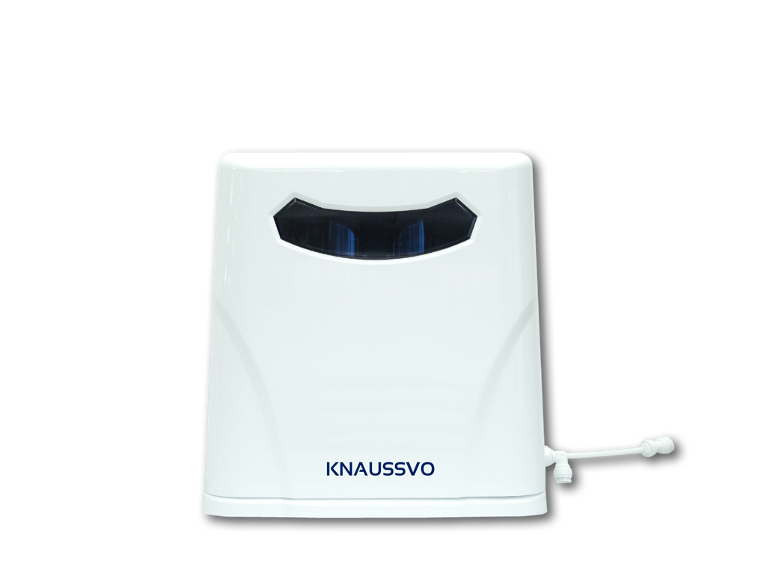
No waste water

No pressure problem

5-year limited warranty

NSF certified 51 &61 Fittings and Water Lines

NSF certified 40 &41 Water filters

FDA approved material

The Science

In recent years, clinical trials on chronic illnesses and health research on hydrogen has shown the most successful and promising results.

FACT
Hydrogen water is naturally alkaline water; however, alkaline water is not necessarily hydrogen water. There are many kinds of alkaline water, including electrolyzed/ionized water, water containing chemical additives, spring water with large mineral particles, or naturally generated hydrogen water. Yet only clean hydrogen-rich water serves as the alkaline water that most benefit human brain and body.

5 Main Features of Knaussvo Hydrogen Water

Hydrogen: Smallest and Strongest Anti-Oxidant/Anti-aging Element
- Targets and Neutralizes Free Radicals
- Repairs damaged cell
- Removes Cellular Waste

Negative Ion: Oxygen atoms charged with an extra electron
- Coordinates autonomy nervous system
- Neutralizes positive ions and EMF emissions
- Builds stronger immune system
- Purifies blood

Stable Alkaline pH 8.5: Best pH for drinking water
- Neutralizes acids in the body
- Prevents cell mutation

Small molecular clustered: 4-6 water molecules cluster
- Reaches a frequency compatible with that of body and blood
- Allows easier absorption
- Strengthens digestive system

Natural Minerals: Low amount and small molecules of Zinc, Magnesium, and Calcium that body can absorb
- Zinc and Calcium are essential for body’s growth and development
- Magnesium prevents cardiovascular diseases and other health problems
- Prevents mineral loss from the body

Our Technology

Knaussvo has successfully applied nanotechnology in making hydrogen water.

Generally, nanotechnology application mix hydrogen and water with high pressure and with the characteristics of bubble to improve the efficiency of hydrogen, thus obtain ultra-high hydrogen saturated solution. Also, known as the micro-nano-bubble technology.

The outstanding advantage of this technology is to obtain high concentrations of hydrogen water up to 1.6 ppm saturated hydrogen concentration in water. It does not affect the nature of water, does not produce any harmful chemical by-products, and is the safest hydrogen production technology. Moreover, it allows the system to run without electricity.

Electrolysis water technology has been around in Japan and other countries for decades. While hydrogen concentration ranges from 0.05- 2.5ppm, electrolyzed water can only reach 0.1-0.7ppm. Because people do not understand the basic effect of alkaline electrolysis of water is hydrogen, in the past, technical improvement of electrolyzed water was mainly about how to achieve the desired pH, rather than how to increase the concentration of hydrogen. Many complications on safety and limitations had inhibit us to adopt the electrolyzed water technology.

Back Cover

Join the Water Revolution
Drink Knaussvo

