Examples I like
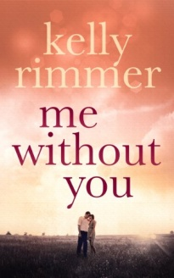
https://www.amazon.com/Me-Without-You-Kelly-Rimmer-ebook/dp/B00KRQCDV6/ref=asap_bc?ie=UTF8
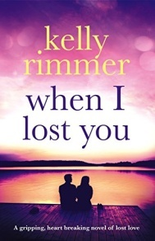
https://www.amazon.com/When-Lost-You-gripping-breaking-ebook/dp/B01BLSZ2KW/ref=asap_bc?ie=UTF8

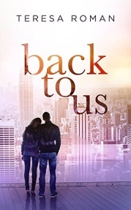
https://www.amazon.com/Back-Us-Teresa-Roman-ebook/dp/B0106AIQFY/ref=pd_rhf_se_p_img_4?_encoding=UTF8&psc=1&refRID=4F9R2VBJ6288RKXRS86F
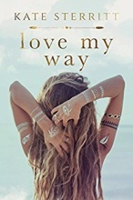
https://www.amazon.com/Love-My-Way-Kate-Sterritt-ebook/dp/B071PDFJK3
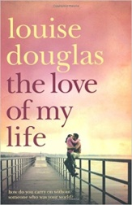
https://www.amazon.com/Love-My-Life-Louise-Douglas/dp/0330453580
