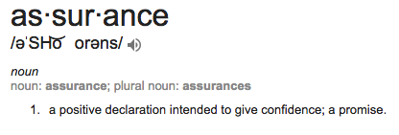

- We want to really play off the word Assurance: that people can be assured that we will do exactly what we say we do.
- We have the resources of a big company with the personal touch of a small company.

