Visual identification of AWSM KIDS

Description of the collection
The design of caps, beanies and trackies suit will be inspired by the world of skateboarding and surfing, which evokes the active life of children. These apparels will be simple, stylish, sometimes amusing, but above all unique and creative.

Like its collection, the logo must be simple, stylish, creative, amusing, minimalist, but most representing the active life of every kid. It must be unique, and will be an integral part of the designs of the caps and apparel.

The word kids is optional in the logo.

Logos I like
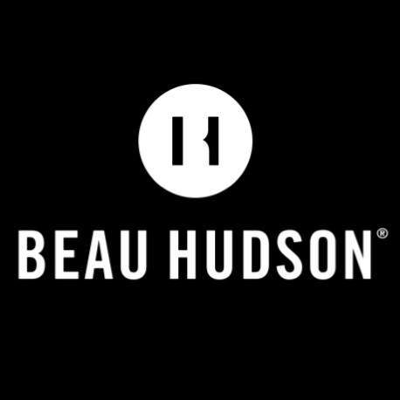


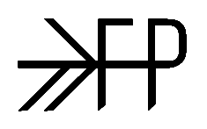
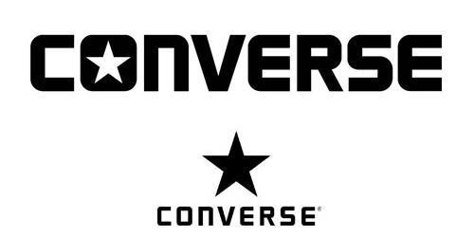

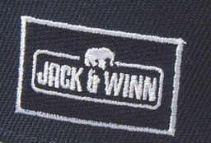

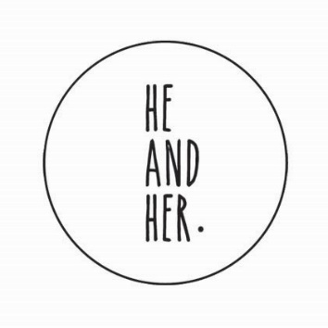

Competitors Logos
