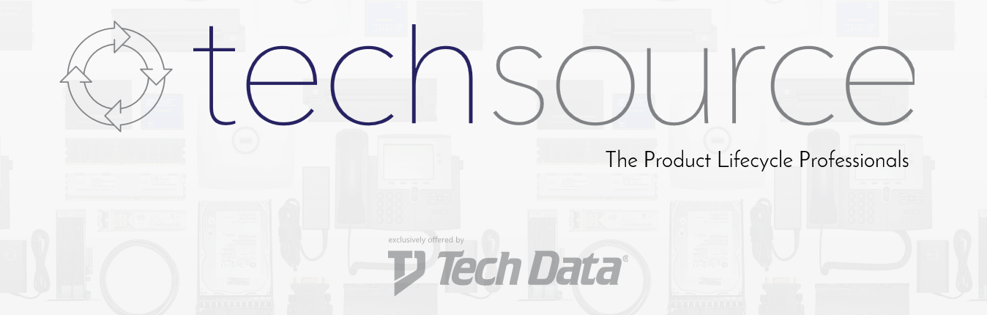
TechSource is an End-of-Life IT hardware and service provider for all Tier 1 manufacturers which allows customers to extend the life of their current infrastructure and lower overall ownerships costs. With an exclusive relationship with Tech Data, TechSource is able to provide your customers with a one-stop shop for all of their IT needs which will lead to increased customer service and repeat business. All of our products carry advanced warranties supported by our US sales and support team.
