Product Descriptions
AN0026 Ankle Guard
This ankle guard offers firm support to provide pain relief due to ankle sprains, chronic ankle instability or overuse. It also helps to provide further protection from injury. Breathable material for all day comfort.
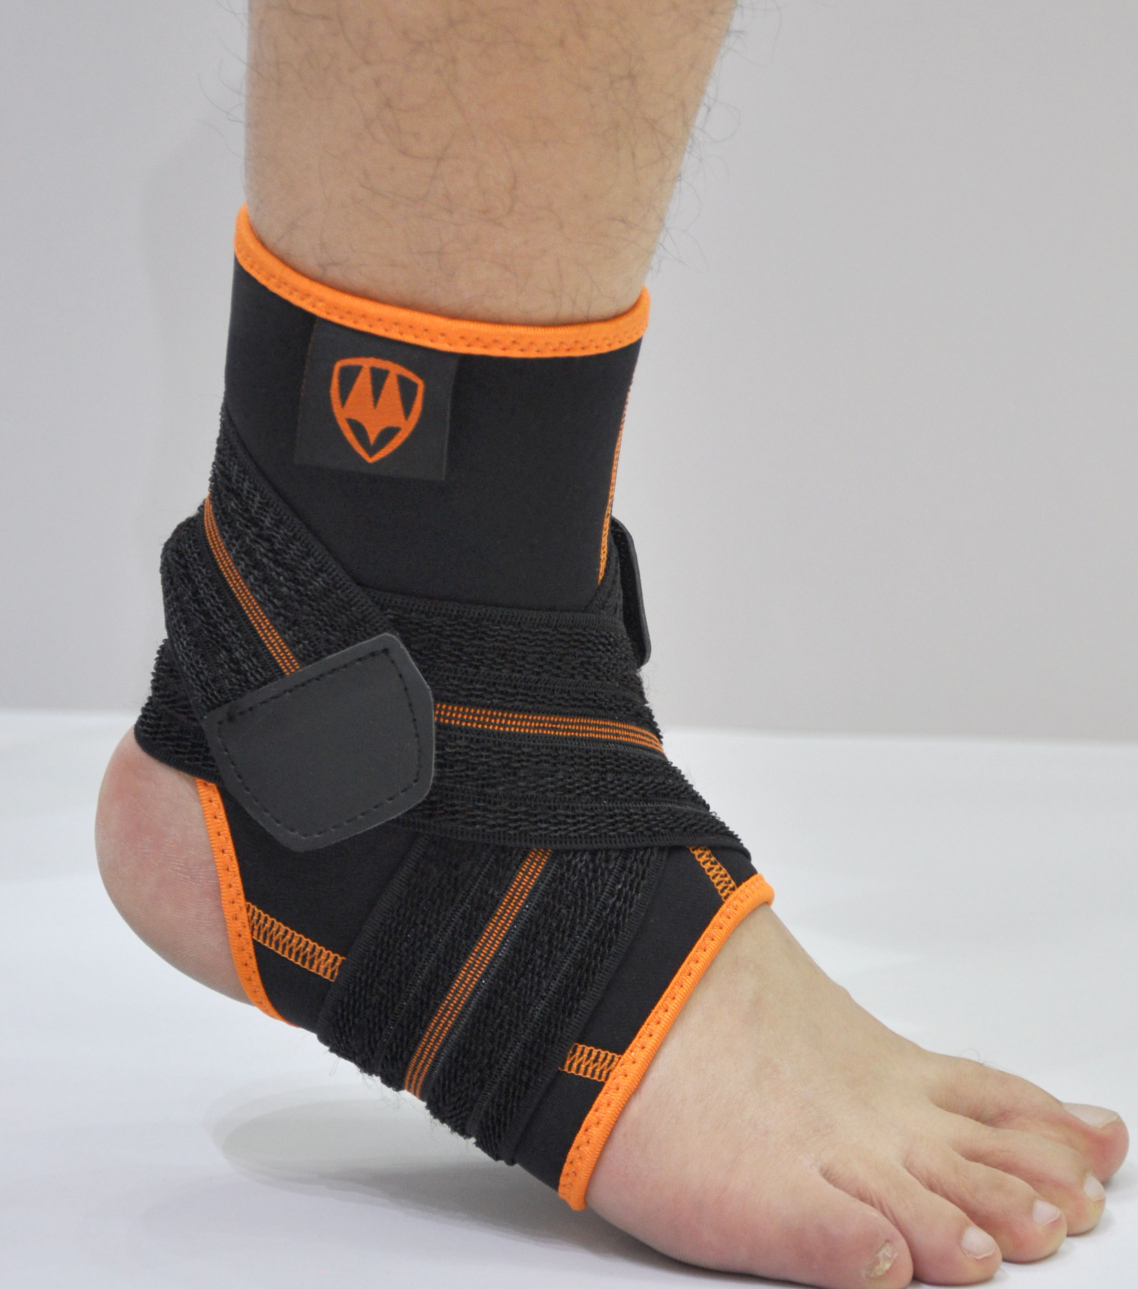

AN3002 Ankle Guard
This lace up ankle support is the best of it's class and is designed to provide stability and take pressure off of the injured foot to speed up recovery and prevent future injury. It helps overcome ankle injuries, instabilities and chronic pain.
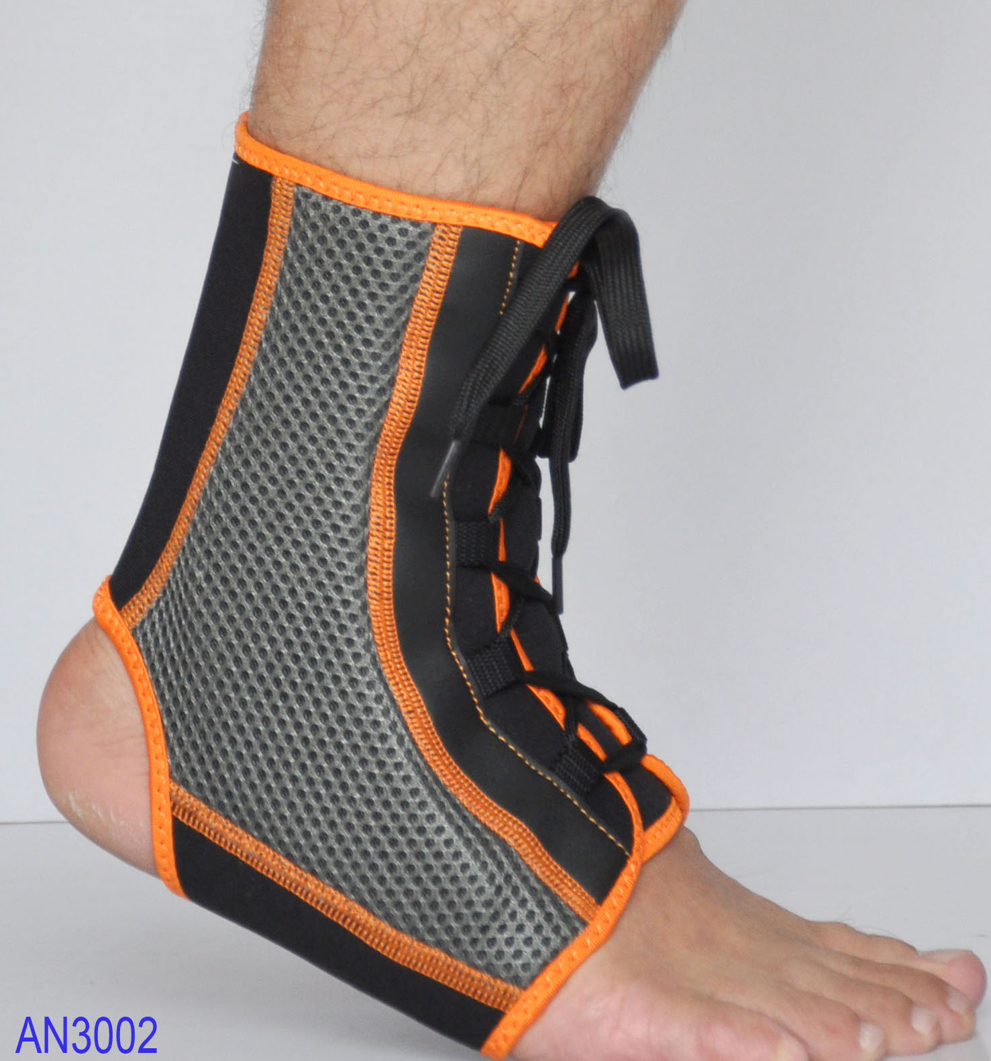

AR3001 Shoulder Support
This shoulder immobiliser ensures that the shoulder remains stable, and will prevent the arms moving away from the body. This is suitable for sprains, strains, arm fractures, and any injuries requiring immobilisation.

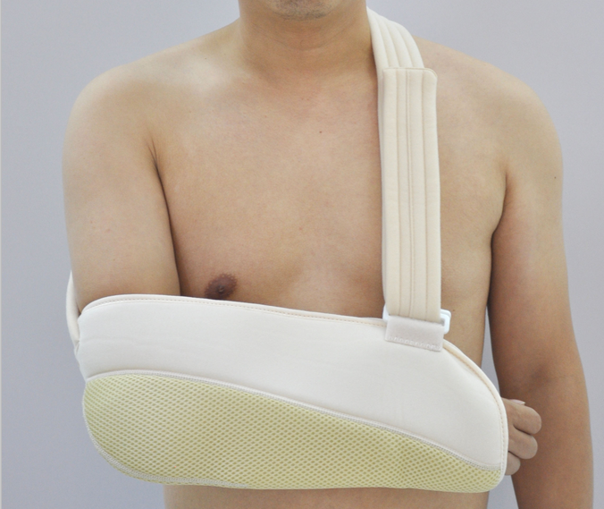

KN0006 Knee Support
This knee brace offers excellent support to the knee without compromising comfort. It keeps you moving with compression, strength and support where you need it. Helps provide protection on the track, court or green. Ideal for sprains, strains, stiff, weak or injured knees.
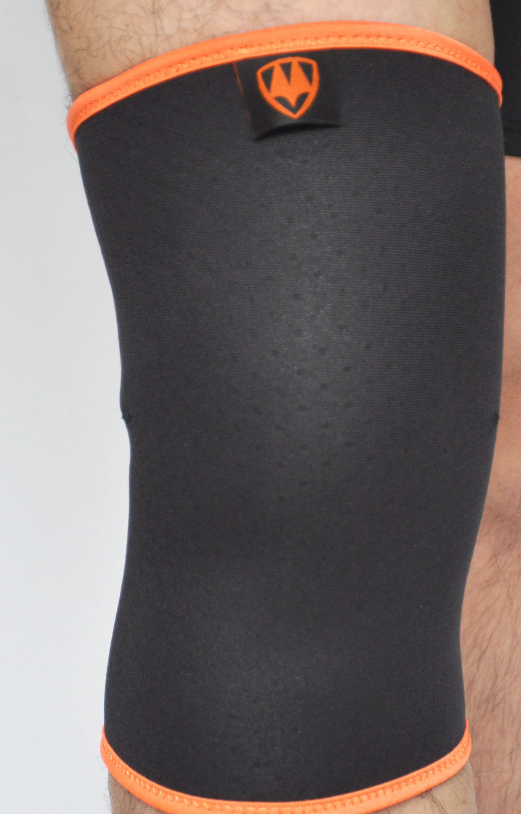

WA0009 Waist Support
This waist and back support is velcro adjustable for custom fit and level of support. Helps to prevent re-injury, and provides firm support and protection to the lower back region. Breathable and comfortable.
