FY904BXP Wheelchair

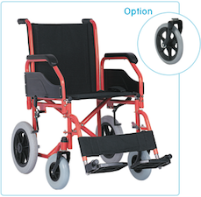

Powder Coated Steel Frame
Detachable and Inclined Armrest
Detachable Footrest
200mm by 50mm Solid Castor Wheels
Rear MAG wheels with PU tires
Plastic Sideboards
Footplate
Foldable

Hire: $20/week
$220

