FY976LABP Wheelchair

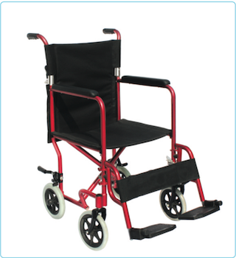

Aluminum Frame with drop back handle
Fixed Armrest
Detachable Footrest
Solid Castor Rear MAG wheels with PU tires
Plastic Footplate
Lightweight
Foldable

Hire: $20/week
$230

