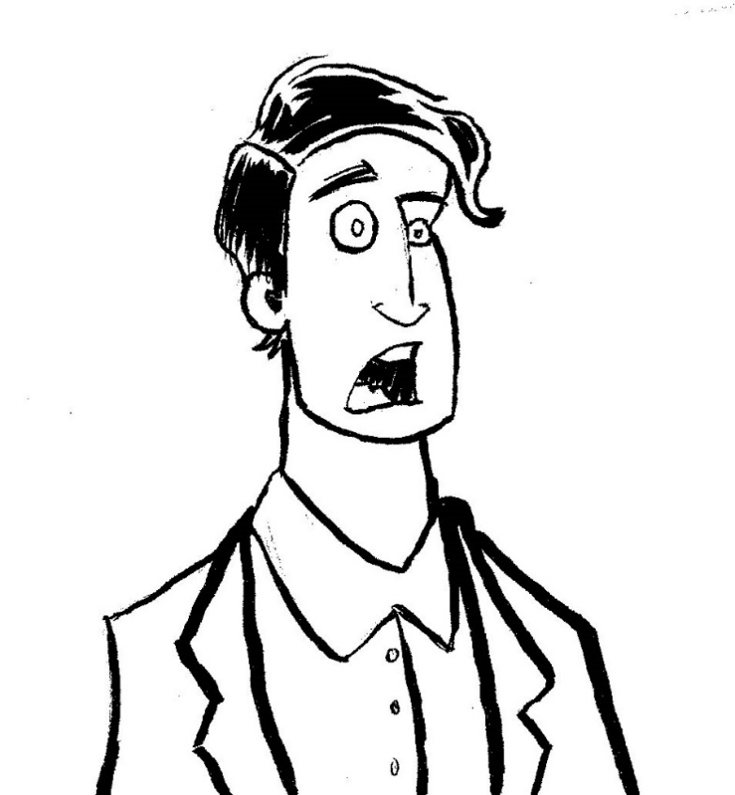

8 Ways
You Can Be Charged With Child Neglect

- Leaving your child to play outside by themselves, whether they are on your property or not.

- Leaving your child in the car unsupervised, despite the length of time they are left alone.

- Leaving your child home alone without arranging for reasonable care or supervision.

- Becoming emotionally or physically combative with the other parent while your child is present.

- Failing to provide your child with regular medical attention, despite your income.

- Failing to give your child adequate attention, regardless of your time constraints, and refusing help from others.

- Allowing your child to wear clothes that are deemed inappropriate for the weather, their age, etc.

- Not being present if/when your child throws a party in your home.

- Jail time

- The loss of custody or parental rights

- Fines

- An Injunction

- Registration as a sex offender

- Restrictions on probation and parole

- Involuntary commitment to a mental institution

7 Consequences of A
Child Neglect Charge

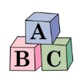
National Committee to Prevent Child Abuse (NCPCA), defines neglect as failing to meet a child’s physical, emotional, and educational needs, as well as failure to provide a child with proper supervision.

- Make sure that your child is well supervised by a trusted adult if you will not be home.

- Ensure that your child has adequate health/hygiene products.

- Ensure that your child is receiving regular quality medical care.

- Avoid getting into altercations with your child’s other parent if/when your child is around.

- Keep an eye on your child if/when they are playing outside, whether they are on your property, or you’re away from the home at a playground, friend’s house, etc.

- Avoid handling chores that require your full attention when on-the-go with your child(ren).

6 Ways to Avoid Child Neglect Charges

Sources:
- https://www.psychologytoday.com/conditions/child-neglect

- http://www.umm.edu/health/medical/ency/articles/child-neglect-and-psychological-abuse

- https://www.hg.org/article.asp?id=31009

