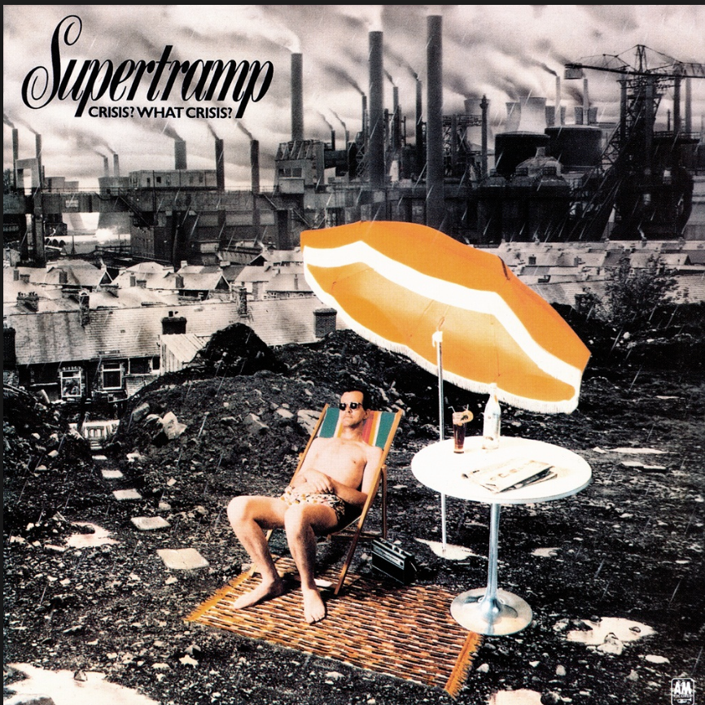
Seeder Album Cover Brief Feb 7 2017.

Taking Supertramp’s Crisis What Crisis album cover for inspiration.
Using a series of composite shots as a background, and a photograph of the 3 boys from Seeder will pull a plough (hire) attached to them with Guitar straps that will be dropped in to the elements to create an image with the ploughing creating vinyl record tracks that become the ploughed field, from which the Seeder logo springs up.
Background also houses an urban skyline (not as dark as the Supertramp cover). Tones graded from B&W toreds and greens slightly saturated.

Reference Images below. Stock shots as per Adobe and Getty Images




