Introducing FloatoRack® for Floating Solar

The world’s only floating solar product with a 50-year expected life, extreme wind tolerance, and flexible tilt & row spacing. FloatoRack® offers 8%+ increased kWh output & lower installation cost than all-plastic products.

- Developed, designed & manufactured by FloatoRack Corporation, Berkeley CA (a Green Reach company).
- Offered & Financed by Pristine Sun Corp, San Francisco CA, a leading California solar developer (top 3 in wholesale distributed generation; formed 2009 & achieved >$80 Million of assets on balance sheet by 2015).

History:
In 2014, Pristine Sun was awarded 25-year contracts for 20 MW of floating solar in Sonoma County CA, the largest floating solar project in North America. We were concerned about the lifespan of existing floating solar products. So, we designed a new product. In 2016, a $900,000 government grant was awarded by the U.S. Department of Energy & the Israel Department of Water & Power to commercialize our product. Led and funded by Kenny Forrest (lead engineer) & Troy Helming, a successful solar & wind energy CEO & author of The Clean Power Revolution, the design was refined & a series of (4) prototypes were built & tested on water. In late 2016, our final prototype was wind tunnel tested & then approved for a 6-month trial by the CA Department of Safety of Dams & the Sonoma County Water Agency on the Oceanview Reservoir. It passed all tests, even during several intense high wind rainstorms over the winter of 2016-17: the commercial version 1.0 (pictured below) did not break, buckle, sink, capsize or taco despite the high winds and near maximum change in water level at that pond (from nearly empty to completely full). After 3 years of development, in 2017 the FloatoRack achieved a 100% final design status and construction of a 1.3 MW (7 acre) system is to commence summer 2017.

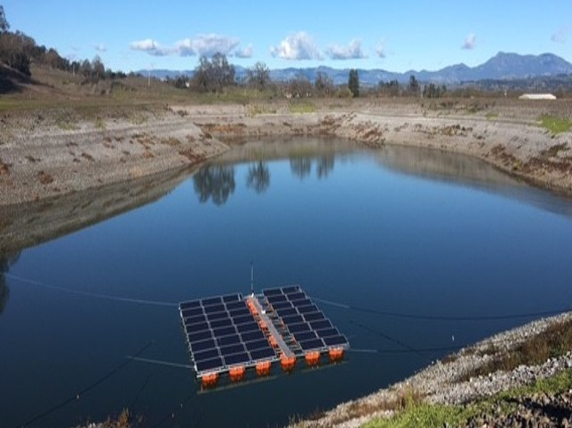
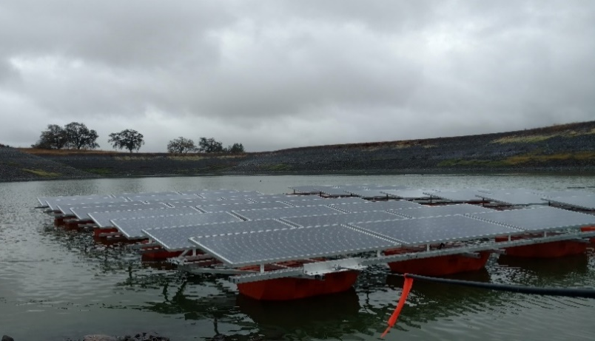
Oceanview Wastewater Reservoir, Sonoma County CA
6-month test successfully completed during 2016-17 winter storms

WHY Floating Solar?

- Reduces Evaporation
- Reduces Algae growth & reduces CO₂
- Convert reservoirs to dual-use water resource
- Located closer to where the power is needed
- Preserve land for Open Space or agricultural use
- Cooling effect of the water = 5-10% ↑ kWh
- Cleaner panels (water rinse) = 3-20% ↑ kWh
- Utilize existing utility electrical grid connections
- Lower costs for water agencies
- Easier permitting (in some cases)

Who pays for it?

Pristine Sun has $75 Million financing available from our capital partners. Help us spend it! Options:
- Most popular: sign a 25 to 40-year Power Purchase Agreement (PPA) with us. We’ll take care of everything: engineering, permitting, construction, operation & maintenance. 100% of all costs covered by Pristine Sun. You get solar electricity at a discount below what you’re paying today. In many states, we can offset 100% of your electric meters across your entire system (virtual net metering) with just one floating solar system. Typical PPA prices:
  - 4-7 ȼ per kWh in areas with ≥ 5.5 kWh / m² / day; 5-9 ȼ per kWh in areas with 4.0 to 5.0 kWh / m² / day.
- Lease us your water & we sell the electricity to a 3rd party (an electric utility). You earn $ from lease payments.
- Hire us for a design / build of a floating solar system that you pay for and own. We can maintain it, or you can.
- Purchase FloatoRack® materials from us, complete your own design and take care of your own installation.
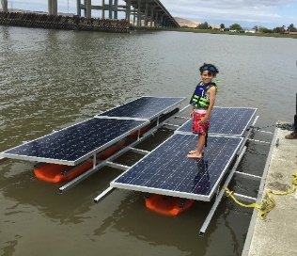
Budgetary Price Estimates:
Child standing on Gamma Г (3rd) Prototype

- 20-25 ȼ per watt DC for FloatoRack®
- 30 ȼ per watt DC for FloatoTracker®
- 5 ȼ per watt DC for installation of either FloatoRack® or FloatoTracker® incl. anchors.
- 5 ȼ per watt DC for installation of solar panels, inverters, transformer(s) and switchgear.
- $1.00 per watt DC or less for most turnkey systems.

Options available: auto-wash panel rinsing system, extra walkways, electric cart(s) & stoppers for the metal rails, security lighting, security HD video cameras, turnkey project development services (engineering, permitting, utility interconnection process management, etc.), and turnkey installation.

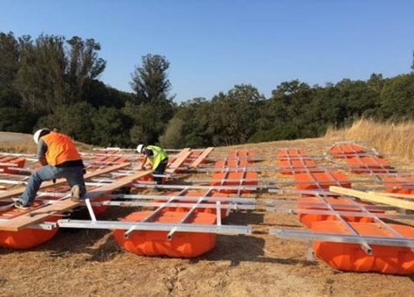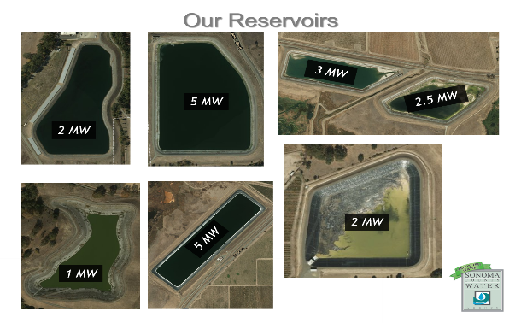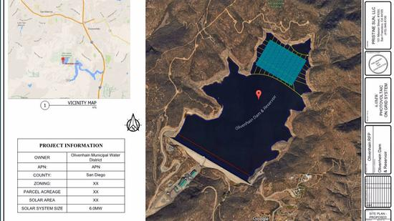
Sonoma County wastewater ponds going solar
9 MW: Olivenhain Reservoir, San Diego County Water Authority
Easy to Assemble

FloatoRack Advantages vs. Competitors:

- Cost-competitive with highest project IRR available
- Up to 10% more kWh than plastic floating solar
- Made in USA (manufactured in California)
- 75-year design life, 50-year+ expected life
- Armature is aluminum, not plastic = structural strength
- Floats are shaded by their solar panels: less sun damage over time; no “leakage” of plastic particles into water
- Can accommodate any solar panel size. Want to upgrade your panels someday? No problem.
- Flexible row density (GCR) = ↓ inter-row shading
- Flexible panel tilt (5°-22°); 22° = 8% ↑ kWh than 5°
- 30-75% fewer anchors (subject to size & Geotech)
- Plastic is HDPE (High Density Poly-Ethylene)
- Our floats are Roto-Molded for uniform wall thickness, whereas Blow-Molding creates thin spots in wall thickness.
- Wind tunnel tested
- No floor anchors needed (lined or unlined ponds)
- 100% recyclable (aluminum has high recycle value)
- Metal rails allow for an optional electric cart to quickly zip workers & materials from one end to the other.
- Can upgrade to FloatoTracker for ↑ kWh
- Easy maintainability
- High durability in extreme conditions
- Floats with internal holes for rail bolts; much stronger than protruding / overhanging ear attachment points.
- Bankable with institutional lenders (3rd party IE)
- Non-toxic & environmentally friendly for full life
- Rounded underside: won’t beach (get stuck) in mud or silt
- Custom FloatoRack® molded floats based on industry gold-standard, time tested Dredging Floats.
- Dredging Float’s cylindrical geometry has a proven track record of plastic cost efficiencies and mechanical strength.
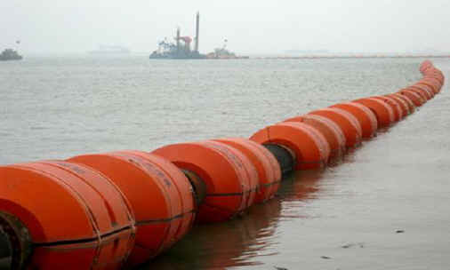
- Float top sheds water. No pooling water = no mosquito habitat.
- 25-year warranty.

Other Applications:
- Mollusk / bivalve habitat – we’re developing a sub-surface system hanging underneath the FloatoRack to support bivalve colonies such as clams, oysters, mussels and scallops. For bodies of water that could use filtration and/or cleaning, bivalves are a terrific natural remediation solution. Available in both freshwater and saltwater.
- Tracking – we’re developing the FloatoTracker, to track the sun (rather than remain in a fixed position) to increase kWh produced annually by up to 35%. This upgrade to FloatoRack is possible due to our aluminum frame.
Traction:
- August 2016: after 3 working prototypes were built & tested, commercial v1.0 was wind tunnel tested.
- March 2017: completed 6-month test of a small FloatoRack system on the Oceanview Reservoir in Windsor, CA.
- April 2017: presented at energy committee of AWWA CA-NV conference. 115 water agencies want proposals.
- May 2017: submitted 99.9% permit design blueprints for 1.3 MW FloatoRack system in Sonoma County CA.

Intellectual Property: multiple provisional patent apps filed Nov. 2016 with U.S. Patent & Trademark Office; more pending.

Total Addressable Market: through 2025, the global solar industry is expected to add ~500 GW of new solar. Floating solar expected to grow at 45%-65% CAGR. EPA’s Clean Power Plan requires 283 GW of renewables. To power 25% of the USA, ~1,000 GW of solar is needed. 42 GW installed in the US, 271 GW worldwide. Expected growth curve is enormous.

Media Coverage:          NEN

Green Reach Inc., C corp. formed 1998 in Delaware, owned by two high net worth families.
Most bodies of water have pumping stations; some have hydroelectric facilities. We can “piggy-back” on this existing electrical equipment to save costs.
Assumes minimum size of 2 MW ac & 25-yr PPA term. Costs drop with larger size, longer PPA term, solar insolation above 6 kWh/ m² /day. RFP may not be required.
Excludes taxes, freight, permitting costs. Assumes 2 MW ac size, non-union labor. Volume discounts are available for larger projects and/or multiple sites.
Due to increased panel tilt, increased row spacing, cleaner panels, bifacial panels (for albedo reflection) and accommodation of larger more efficient panels.

