FOXES
These are copied from an Internet search—some are currently in use, others are mock ups of possible logos

Presented to illustrate components I like or dislike

This is a video game company.
LIKE: simple clean lines
Identifiable as a fox
Ear extends beyond circle

DISLIKE: one pointy and one round ear (this probably has
meaning to the company using this logo)

LIKE: moon, field, fox

DISLIKE: tail out of proportion
Legs are unnatural (too stylized)

LIKE: Clearly identifiable as a fox
The way the brush of the tail is shown

DISLIKE: would like ear better delineated somehow, like brush
of tail & chest fur
angry/evil looking eye—Want a kinder eye

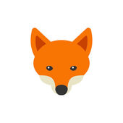

LIKE: nice, friendly, clearly a fox
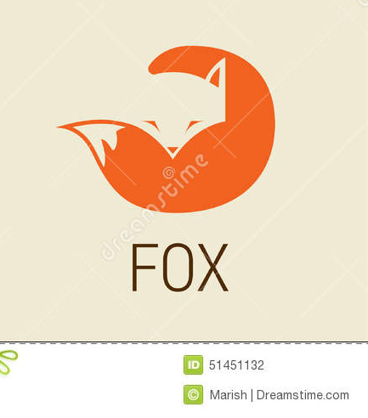
Stops just short of being too cartoonish

LIKE: identifiable

DISLIKE: would like to see a little bit of left ear
Would want kinder, less angular eyes

DISLIKE: Too stylized

DISLIKE: Looks more like a coyote…we have those too, but I’m not naming the farm after them

