REQUIREMENT SHEET

- What is the complete name of your company? (As you want to appear on the logo.)

Pipeline Design & Engineering, LLC (not sure if I want/need the “LLC” part in the logo)

- What is the core focus area of your business?

We design & engineer hard good products (medical devices, phone cases, machines & tools, etc)

- Who are your main competitors? (If any) Please provide links to their website if possible.

http://www.spannerpd.com/
http://juggernautdesign.com/wp/portfolio/
http://www.arizona-ideaworks.com/
http://pensardevelopment.com/
http://www.padtinc.com/index.html
http://www.atomdesign.com/

- What is the age range of your target customer base?

20-60 years old (our customers are inventors or product companies looking for an engineering or design service provider)

- Which type of logo are you looking for? (Select from the below given options)
- Logo only
- Logo + Text
- Text only (Text will be customized)

- Do you have any specific image or concept in mind for your logo?
No, not specifically.

- Do you have any color preferences or existing brand colors?

I like white space with grays tones mixed with other colors. Red, gray, white and black are currently used on our website (http://designtheproduct.com/), but don’t feel like you have to use the same colors currently on the website. I am definitely open to other colors. Personally, I like blues and greens.

- Do you have any colors that you do not wish to use?

Purple, gold, pink, brown

- What feeling or message do you want your logo to convey to those who view it?

Precision, mechanical, creation/creativity, intelligence

Please read our mission statement (copied below) to gain a sense of our company’s purpose.

Creation is in our DNA. It has taken the world from the abacus to supercomputers. At Pipeline, the drive to create—to reach into the void and transform a shapeless concept into a physical reality—is the most thrilling thing we do.

Using powerful design tools, we first develop ideas within a digital 3D space then advance those models into real-world parts. Putting all the pieces together to form a functional product you can hold in your hand is our true passion.

We are professional creators looking to find (and be found by) other creators. From the raw elements of mind and material, Pipeline creates.

So join us. As customers, employees, fellow innovators, join us in bringing products to life.

- How would you like the typography to appear? (Example : script, bold, light, hand drawn, custom lettering)

I like Apple’s text (see screenshot below). Prefer something light but easy to read. Probably a sans serif (although I don’t dislike this Garamond font you’re using).
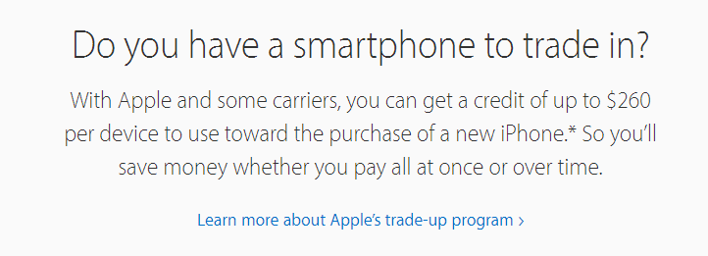

- Your favorite logos

I just looked though google images and these are a few I liked:
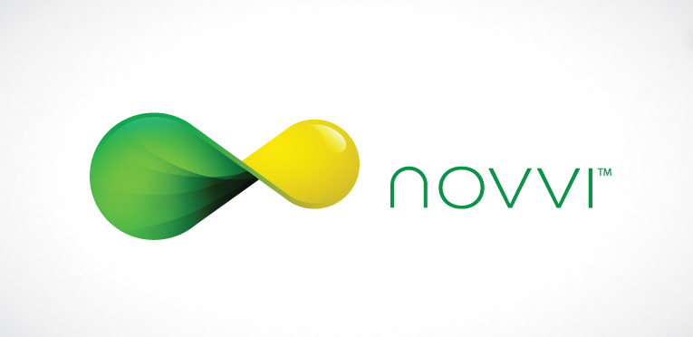
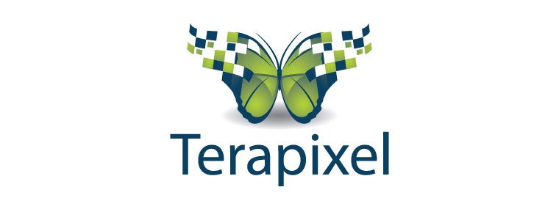
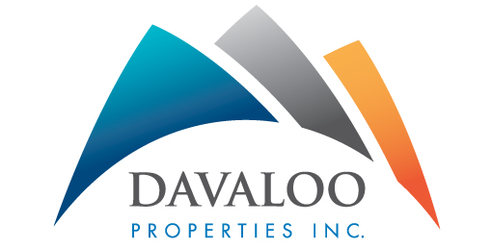
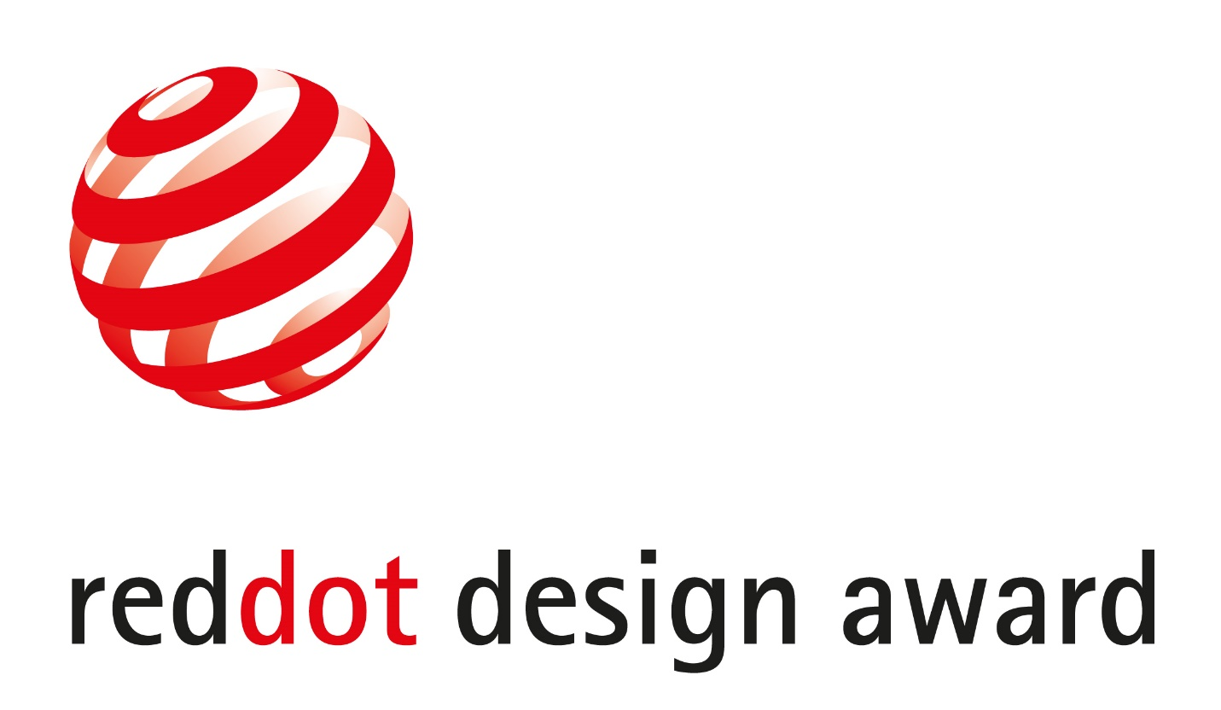
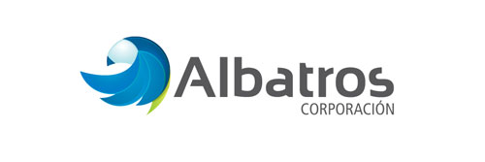
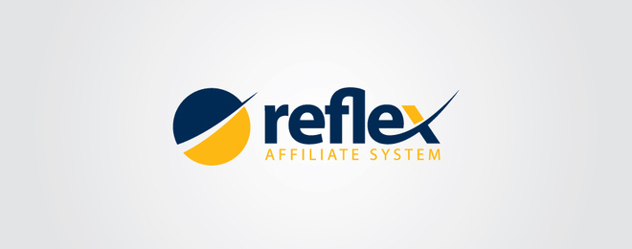

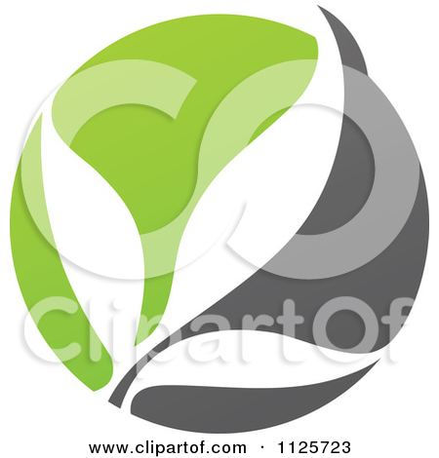

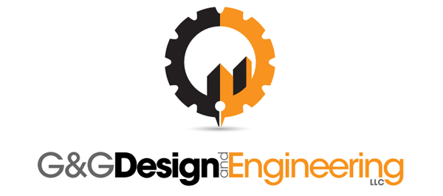

- Any other requirement you want to share with us.

Not a requirement, but the name Pipeline is taken from a beach in Hawaii where I grew up, more specifically a surfing wave (Banzai Pipeline…see image below). It has nothing to do with the services the company provides, but it is a part of me (I grew up surfing in Hawaii). Would be cool if you could incorporate some element of that. Again, by no means a requirement, though.
