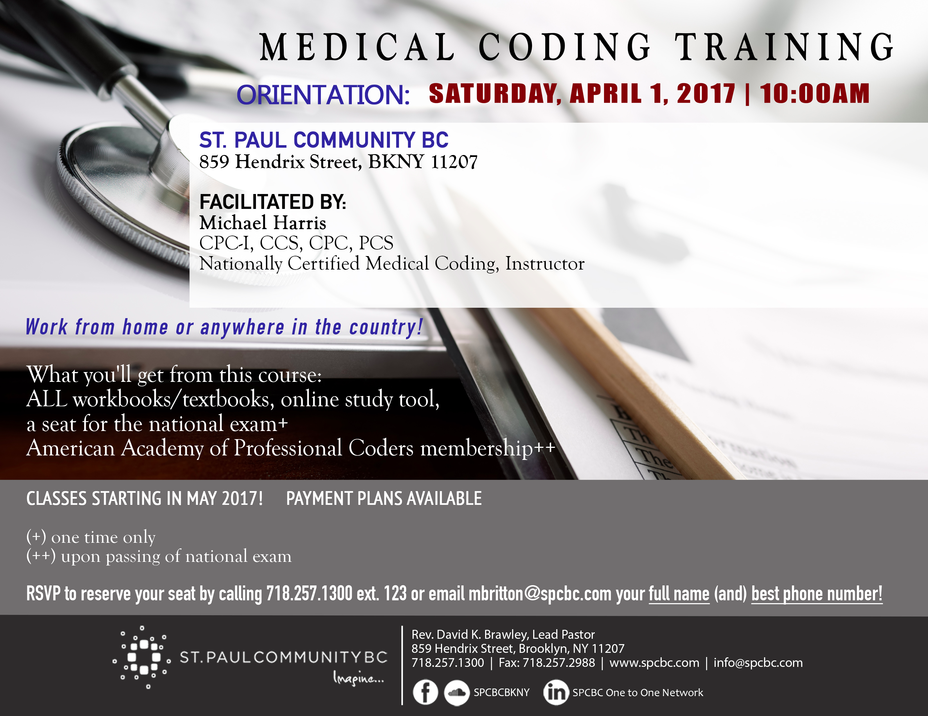





Five Reasons to Enroll:
- 1Success in Passing: Students who complete this course are twice as likely to pass the CPC exam!
- 2Convenient local class schedule.
- 3Expert, Nationally Certified Instructor, Michael Harris.
- 4Low cost compared to other training programs. Flexible Payments.
- 5Hands on practice coding real world, redacted medical records using CPT®, ICD-10-CM and HCPCS Level II code sets.

Information Sessions: May 16, May 23, May 30 at 5:30pm
at New View Test Centers 3250 Westchester Avenue Suite 126
Bronx, NY 10461 (347) 281-8950
www.newviewtestcenters.com

