Design instructions for Designcrowd
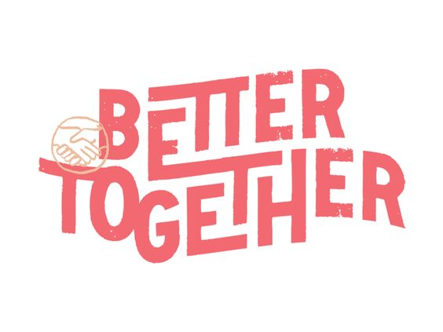

Write Mowgli Market in a similar way like this “Better Together” logo (in rusty yellow colour with a vintage look)

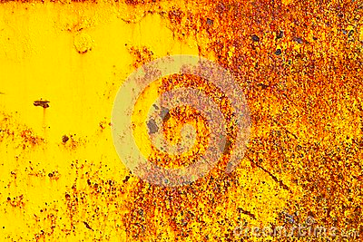

and create a stamp similar like the hands in this “Better Together” logo - one we could also use as a seperate icon. Something like this for example:

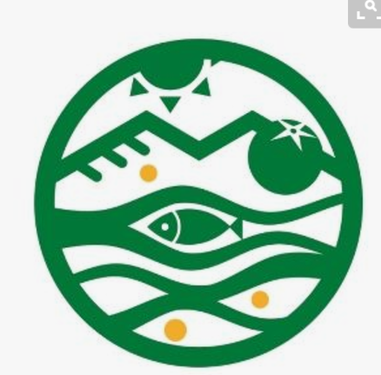

With a sun, a leaf (or something other natural like een lemon/orange slice (which could also be a sun at the same time) , some lines representing waves and some lines representing field and perhaps a wheat element.

Maybe you can add somewhere the text: Plant-based café & grocery. Like in this logo we like very much:

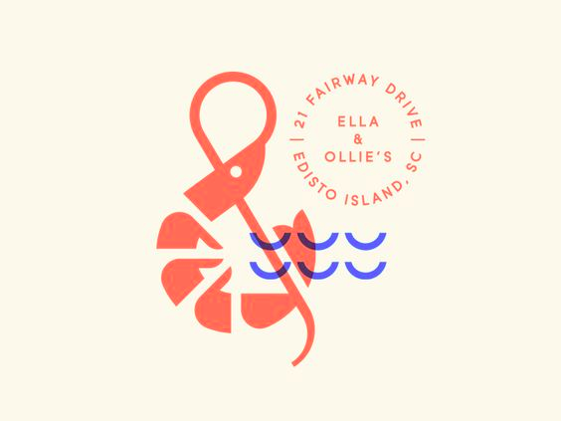

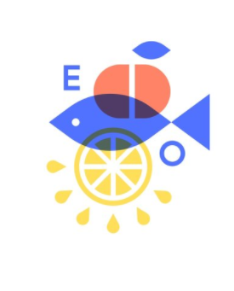
Or you could try to recreate something like this. But instead of the E and the O, two times the M. This(or part of this) could also be the stamp in the first logo option we described. Perhaps put it inside a circle. And instead of a fish, you could use an image of a leaf, like this one we like very much:

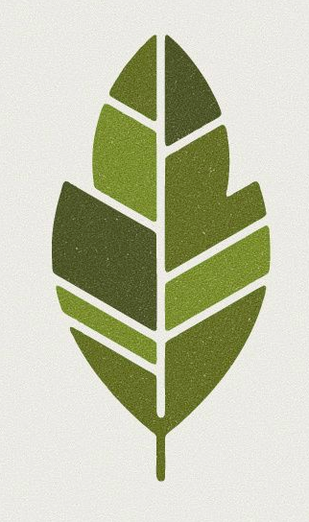

And a wheat like this:
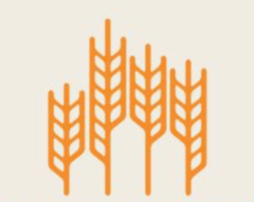 Or this:

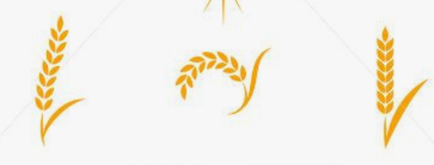

En in stead of the apple maybe an onion or garlic like this:

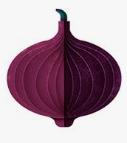

Or a lemon slice like in the example, or a tomato like this or whatever… some cool vegetable that will like nice in a minimalistic graphic ;)

Tomato?
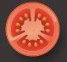

We want the logo the be classy, but playful, and not too cartoony.

Thank you all.

