1. Made of eco-friendly solid beech wood
- All natural with no formaldehyde releasing glues or VOC-releasing finishes often used to fuse bamboo shoots.
- Safe to clean and will not crack after washing.

2. Barcode should be taken as is with the title (wooded baby…. New)
as in the barcode file also the exact size. (I didn't pay attention before)

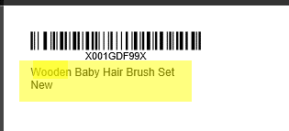

2. front:
Soft Hair brush….
massage hairbrush….
premium wooden comb….
I think we need here some kind of separation between the lines to show there are 3 different products – it will be in a photo on Amazon so people should see what it contains – yet not something that will dramatically change the design.
Maybe a little bigger with space? or other idea you have?

3. The site and mail – need to be seen better – maybe Bold



