BOX DESIGN 2
1. Barcode (attached separately)
2. Made in china – No flag
3. www.haandda.com
4. Contact us: info@haandda.com

The LID:

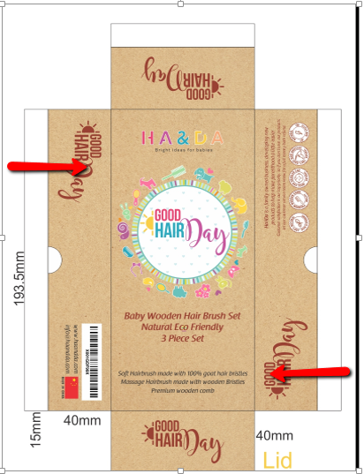

- Take off the "good hair day from sides where the arrows are

- )Take off the china flag

- On the side of the barcode add the text: :
Ha&Da is a family owned business, developing new products to help make parenthood a little easier (take off the other text that was before)
With e-mail and web site

On the other side:
- . Neutrality symbols: let's use only 3 Can you use this 3 ? In white?

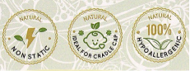

- And add the text: (on the other side of this side)
Made of eco-friendly sold beech wood
- All natural with no formaldehyde releasing glues or VOC-releasing finishes often use to fuse bamboo
- Safe to clean and will not crack after washing

Bottom

1.Title:
Baby Wooden Hair Brush Set
Natural Eco Friendly
3 Piece Set

I have changed the text a little so it won't be too crowded so please use this one:

Text:

The silky soft hair bristles are gentle for the sensitive scalps of newborn and toddlers.

All natural beech wood bristles stimulate the scalp and increase circulation while relaxing your baby.

100% goat hair and wooden bristles condition baby's hair and evenly distributes natural oils down the shaft.

Premium wooden comb perfect for sectioning hair and great for cradle cap.

Bonus inside

Baby Nail File. Made from tempered Czech glass of the finest quality with smooth rounded ends, especially suitable for your baby (not block letters)

2. Add The "good hair day" logo where the arrows are.

