- Is there something else to do with the line in : Bonus inside? (marked in yellow)
2. especially suitable for your baby. – needs a dot at the end, (my mistae) and let's try it in bold please -

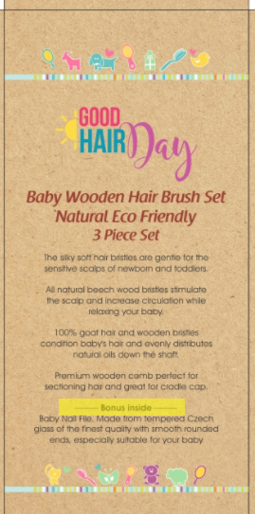

.
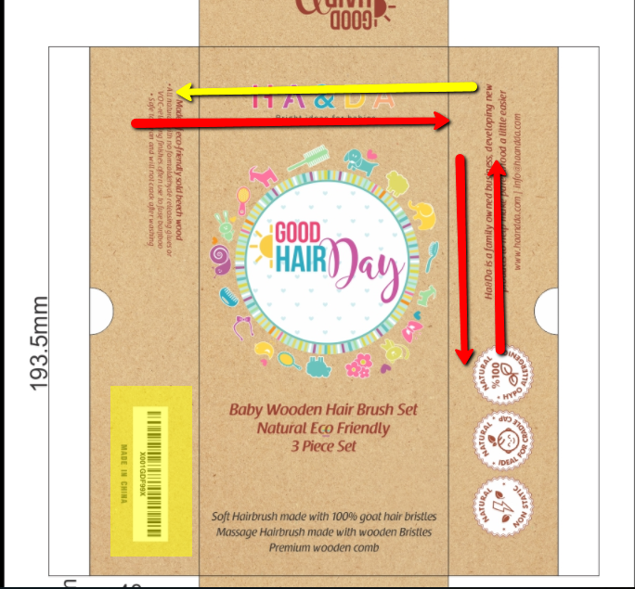

3. Can the barcode be without the white background (will it work?)
4. I prefer those symbols
5. Replace sides between the symbols and the text
6. Replace the sides of text – where the barcode is we put the text: Ha&Da is a family owned business, developing new products to help make parenthood a little easier with site and e-mail
And on the side of the symbols put the the text:
Made of eco-friendly sold beech wood
- All natural with no formaldehyde releasing glues or VOC-releasing finishes often use to fuse bamboo.
- Safe to clean and will not crack after washing.
6A . There should be with more space between the points and maybe a symbol in the beginning of each point.

7. Is the small text in the same font?
8. Can you show it to me in 3 D? So I'll understand which side is which. will give me a better point of view

