Project Name | Self Academy Logo Design ‘ Letterhead and Bussines Card Design

Executive Summary
Insight :

There are many leadership and education organisations in Turkish Market however not any related to Jung Principles. ‘Self Akademi’ is built on Carl Jung principles and was established by most experienced leader and educators in the are in Turkey.

Brand Commitment: “Self Akademi ‘ will be the most strongest local leadership training academy and will focus on business leadership together with person internal balance in order to advance the society,
Main Message: “Who looks outside dreams’ who looks inside awakens” Carl Jung

Objective
Objective of the Project: To find out the best reprasentative archetypal logo design for ‘Self Akademy’. The designer need to understand the psychologist Carl Gustav Jung, used the concept of archetype in his theory of the human psyche. He believed that universal, mythic characters—archetypes—reside within the collective unconscious of people the world over.
The Self in Jungian psychology is one of the Jungian archetypes, signifying the unification of consciousness and unconsciousness in a person, and representing the psyche as a whole.
For Jung, the self is not just 'me' but God. It is the spirit that connects and is part of the universe. It is the coherent whole that unifies both consciousness and unconsciousness. It may be found elsewhere in such principles as nirvana and ecstatic harmony.
Jung described creation of the self as a process of individuation, where all aspects are brought together as one. Thus 're-birth' is returning to the wholeness of birth, before we start to split our selves into many parts.
There for the image in the logo should represent the self achetype. When imaging self archetype it is a cylinder , a mandaka or a square. Some of the archetypel images are as follow to be inspired:
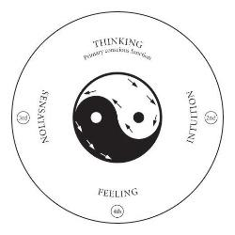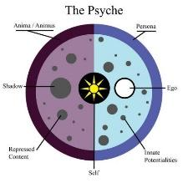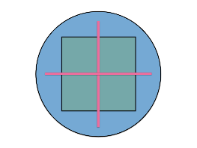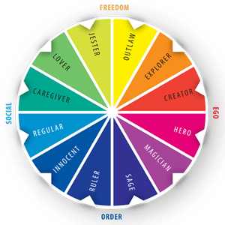

The designer needs to create the logo to be sizeable both may be used in mobile apps or in letterheads and businesscard therefore it should be versatile and clear image. Logo should give an unconsious mesaage of enlightment, and it should be simple trustuble and need to have modern look.

Target Market
Target Market will be both prosumers and large corporates . Therfore the design need to have an attraction to those people who are over 30 years old have higher education , open for self improvment and would have a corporate trsut look and feel.

