Creative Brief
Your business
Business Name: Out & About
Tag-line or slogans? Bus Charter
What does your business do?
Put simply, the business name is Out & About and we do Bus Charter.
To describe the business I have written it in a frequently asked questions style:
-What area do the bus charters and transfers service? Melbourne, Sydney, Brisbane and Gold Coast and Adelaide.
-Do you offer interstate bus coach charter? Yes we offer interstate trips between Melbourne and Sydney, Sydney and Melbourne, Melbourne and Adelaide and Adelaide and Melbourne.
-Are drivers provided with the bus and coaches we hire? Yes.
-What size buses do you provide? Mini buses, mini coaches and full size coaches.
-Do the buses have comfortable seats and air-conditioning? Yes.
-What group sizes can you cater for? Any size group, with the maximum in one bus being 53 people.
What kind of bus charter do you offer?
*day trip, school bus services, camp bus charter, wedding bus hire, charter bus for church trip, general travel needs, corporate bus charter, teams sports days bus charter, airport transfers, shuttle bus hire.
Your logo design
-You have any logo ideas?
No / Yes-
-A road could form part of the logo.
-If the designer thinks this might work, another option, is the “&” sign in the business name, Out & About, could be made into a winding road.
-You have any specific colours?
No / Yes
-Black
-Blue (blue in “google” and/or the blue used on the acquante logo in this page: https://crazydomains.designcrowd.com.au/)
-Green (green in “google” and/or the green in this print icon, 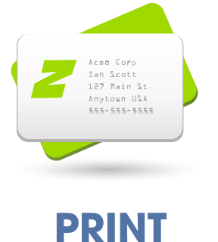, from this page: https://crazydomains.designcrowd.com.au/
-Red (red in “google” and/or the red used in the wording of the bug house logo in this page: https://crazydomains.designcrowd.com.au/)
Black where you think appropriate, or needed, in business name, tag line and logo. Want Blue used as it is the colour used to gain a client’s trust. Green and Red also evoke certain feelings and I’d like these colours used also. Blue is important as gaining the clients trust is important to this business and hopefully Green and Red can also be used, in a way that looks good/suits the design and doesn’t make the logo to busy, with to many colours and to much going on.
Any additional comments:
-NO EMBLEM STYLE, NO CHARACTER STYLE.
-DON’T TAKE INTO ACCOUNT THE COLOURS USED IN THE WEBSITE AT THE MOMENT, THEY WIILL BE CHANGED TO MATCH/COMPLIMENT THE NEW LOGO.

