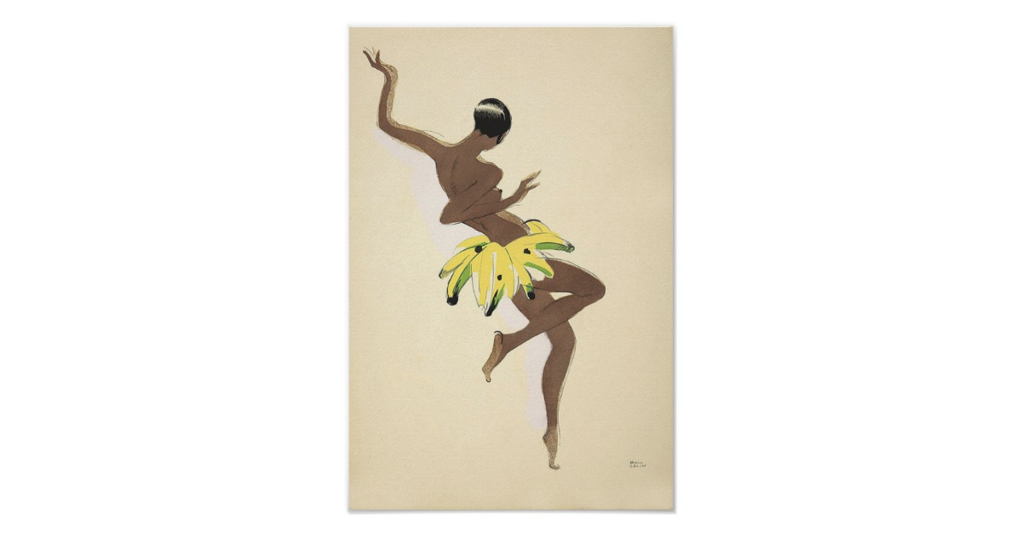
BANANA GIRL
BANANA GIRL

