Gender Neutral Sign & Gender Neutral Ambulant Sign

We need two separate logos for toilets.
The first is a Gender Neutral Toilet
The second is a Gender Neutral Ambulant Toilet.

A Gender Neutral Toilet is a standard toilet with a hand wash basin that can be used by anyone.
A Gender Neutral Ambulant Toilet is the same as the Gender Neutral Toilet except it has additional design features for people with an ambulant disability.
An ambulant person with a disability is someone that uses crutches, walking frames, or has a condition affecting their gait. They are NOT people who use wheelchairs.
More information here
https://www.disabilityaccessconsultants.com.au/cant-unisex-ambulant-toilet/
https://sourceable.net/why-gender-neutral-toilets-are-here-to-stay/
In Australia the standard ambulant toilet signs are as follows:
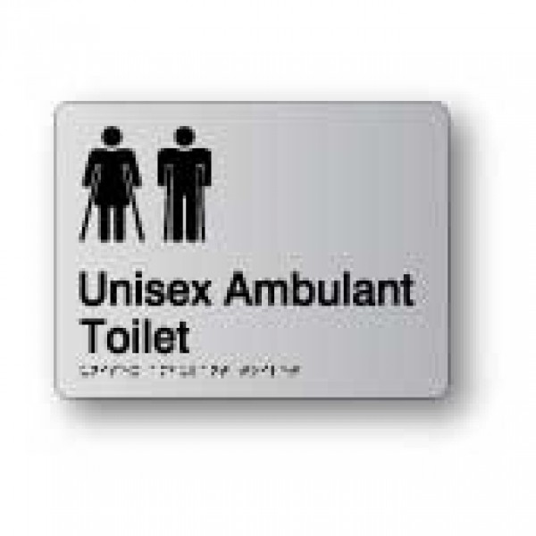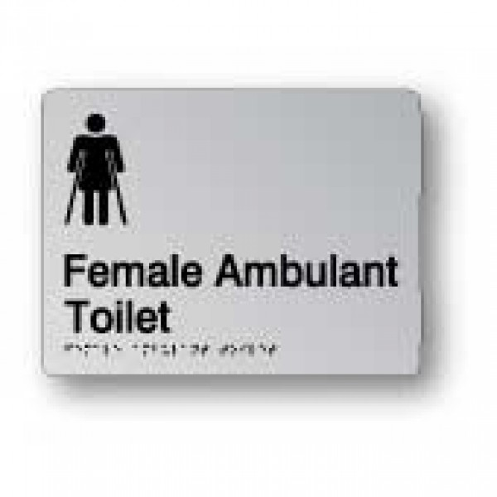

Why not use Unisex?
“Unisex” should not be used as it implies a toilet that can only be used by Males or Females.
Gender classification becomes a problem when an individual does not identify themselves to belong to either gender, or does not view themselves as either or both genders.

Current Available Signage
The following signage is currently being used, however they are not satisfactory.
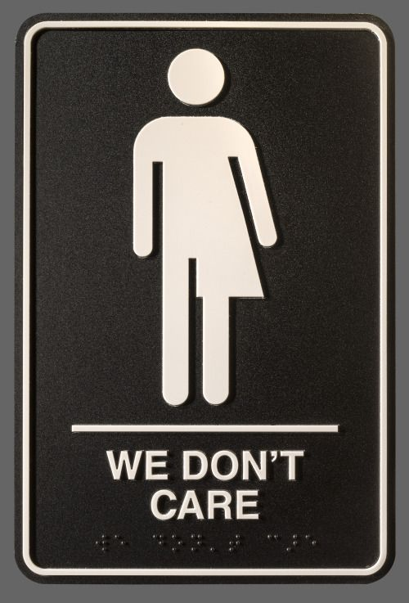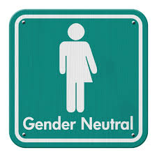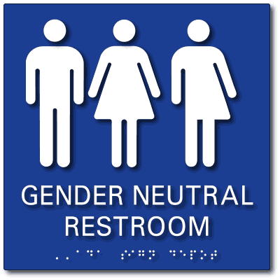

These are not satisfactory as they reference either Male or Female.

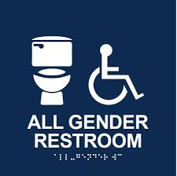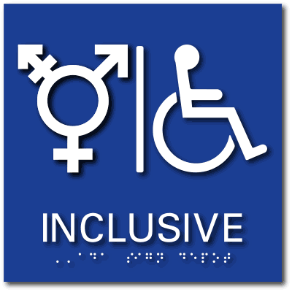
Do not use the wheelchair symbol as these are not wheelchair accessible facilities.

