

ATTENTION MULTIFAMILY AND RETAIL PROPERTY OWNERS
UGLY DUMPSTER?
EXPENSIVE CORRAL?
BROKEN GATES?

AS FEATURED AT THE WASTE EXPO IN LAS VEGAS, NV
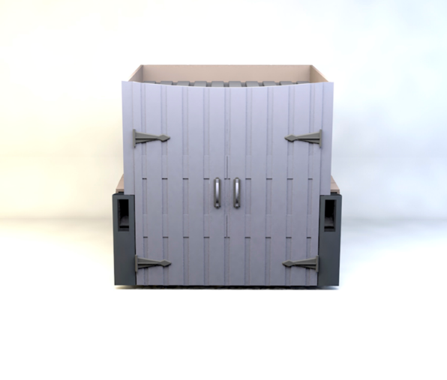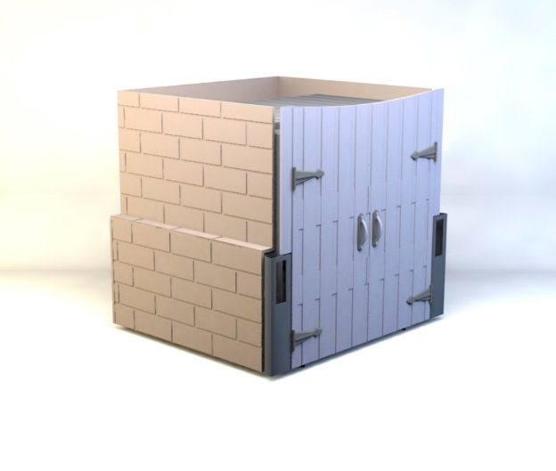
APPROVED VENDORS
- County Waste
- Wastequip
- Waste Management

Dumpster Dress combines the utility of a traditional dumpster with the assemblage of an aesthetically pleasing enclosure to create an interconnected all-in-once solution. The enclosure and dumpster are effectively one in the same making it difficult for a passer-by to even recognize its intended use! Design and Utility Patented
For additional information contact Meredith Weinman at 518-640-4078 or dumpsterdress@gmail.com
WWW.DUMPSTERDRESS.COM

