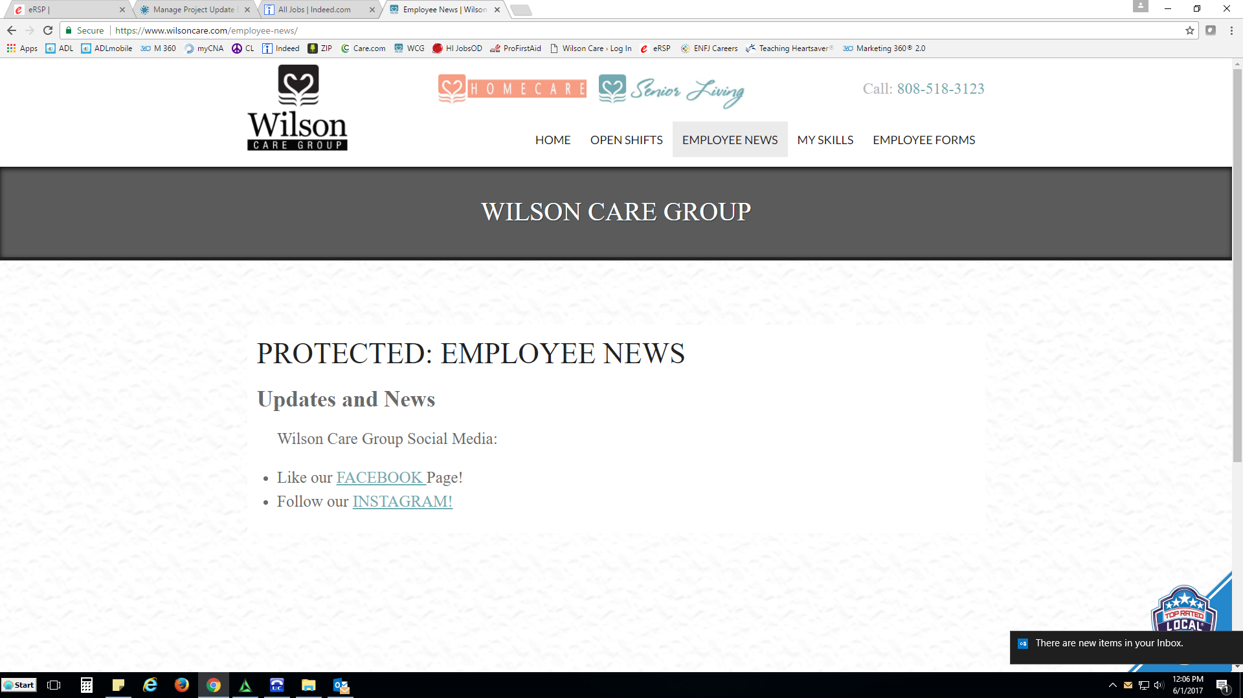

Current Page: We want to make this a fun place for car

