FRONT:

Inspired by patients.
Empowered by knowledge.
Impacting melanoma.

[image to come]
MELANOMA NURSING INITIATIVE LOGO
www.MelanomaNurse.org

BACK

You wear many hats and take care of patients with many different tumor types. Check out MelanomaNurse.org for free access to:
[designer—Please find some way to tie in the list with the labels on the website in an attractive and intuitive manner!]
- Hot off the press! Articles from the Clinical Journal of Oncology Nursing outlining practical strategies to manage side-effects and promote adherence to melanoma therapies
- Visual and text-based therapeutic side effect management tools
- A Nurse’s Toolkit with extensive melanoma nursing care resources
- Printable patient resources to provide patients, organized by therapy
- An oncology nurse community forum to share successes, challenges, insights, and solutions
- Online educational modules, newsfeeds, and other material to keep you up to date
- And much more!

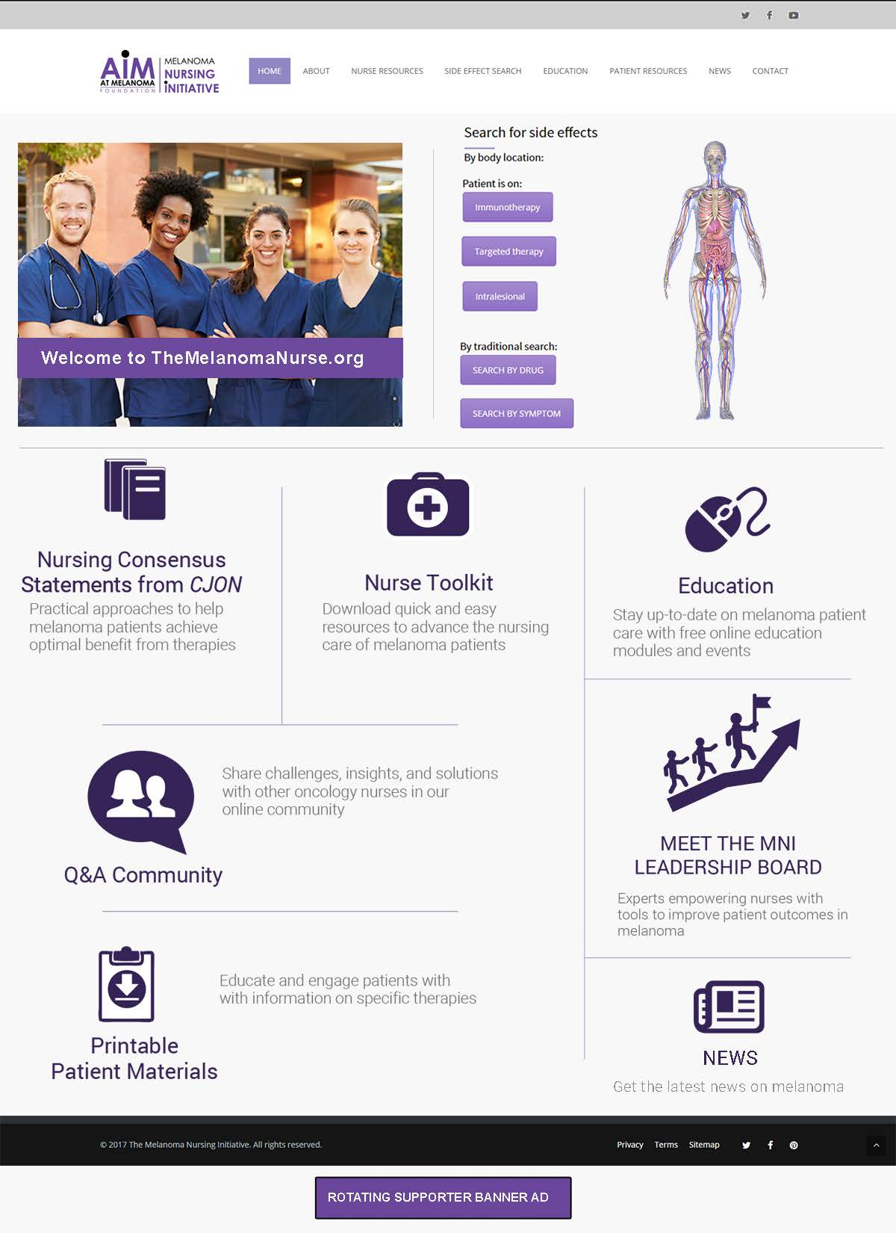
F.
F.
E.
CX.
DX.
B.
A.

