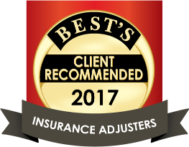

They may seem small, but the ripple effect of doing the basic things right is extraordinary.
At Summit Claim Services, we Focus on the Fundamentals
- Immediate contact with the policyholder
- Prompt scoping of the loss
- Expedient submission of an accurate estimate to the carrier
- Responsive communication
- Thorough file documentation

The challenge today: meet the consumers’ ever-changing expectations and demands driven by advances in technology.
But is new technology the answer? Is claim estimating a self-service insurance item?
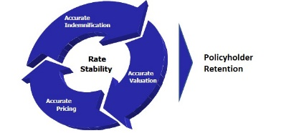
While technology may produce some cost savings and improve the estimating process, the fundamental process of an adjuster meeting with the policyholder and doing a physical inspection is still the most reliable method for preparing an accurate estimate. And, accurate indemnification supports policyholder retention through rate stability… which is also a consumer concern.
Besides, a smile, a handshake and doing business face to face will deliver a positive experience during a troubled time.
Small things done in a great way!
We may not be the only IA firm you use, we just want to be the best one you use.

