My name is Ever Eden and I am an author. I require a site that can provide information about myself and my books and other works. I would like it to have a Home, blog function, about the books/series section, resources page, a Store, social media links and ability to load/embed videos from youtube and other.
I write mild scifi/thriller/conspiracy/secret government type novels. At the moment. The theme would be professional yet show this element.
My budget includes all pages I will need on the site-- but I think the other pages would be similar to the main page so I would please like to see an example of the front page in your submission first. I would also like to see portfolios of your other work too where possible.
I would like to base my branding across social media etc on the site colours and style
I would like a colour scheme which incorporates dark grey, off-white and purple and electric purples for highlights
I am also open to colour ideas you may have too but I like purple, lots of light/grey dark grey/black.
I have attached some colour schemes I have been playing with
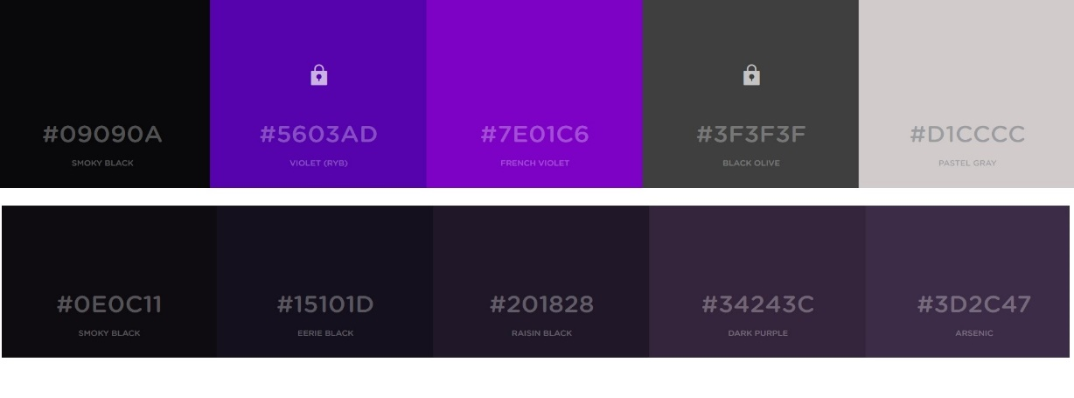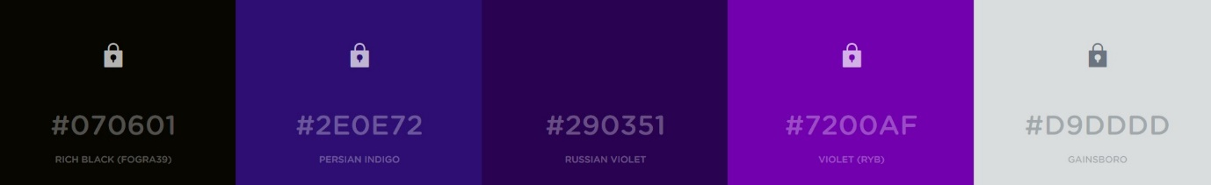
(if the colours don’t appear here, I have uploaded them too.)

I have layouts/other author sites I like
http://alicehoffman.com/
http://www.laurellkhamilton.com/
http://www.eljamesauthor.com/
http://mandywallace.com/
https://cdn.colorlib.com/wp/wp-content/uploads/sites/2/morningtime-minimal-wordpress-blog-theme.jpg
https://cdn.colorlib.com/wp/wp-content/uploads/sites/2/christina-light-wordpress-blog-template.jpg

Home
Header on top right to possible include social media links or cart in the right hand section
(I also like social media bar at the bottom too)

Possible slider with latest news/latest blog post/image or trailer link
Sections/Headings with a faded hover (I am open to other ideas)
Newsletter sign up
Sections at the top to include: Home, Books, Blog, resources, other works, store

Store section;
---grid view with prices under or beside each image as well as quantity option.
---I would like the option for customers to pay via paypal when they checkout
Books:
--I would like the ability to have an image of the cover of the individual books that is able to be clicked to reveal a blurb on the back or
--Ability to put an image of a cover beside some text about the book and have Left alignment, then Right, then Left and so on down the page as the books are in a series and there are a few.
Resources and Extras:
--This is where I would like to have a press kit, images for press kits etc
-- This is where I would have possibly a bio document
Other works:
This is where I would like to put pictures of art or other writing
Links to: Twitter, Facebook, Pinterest, Instagram and Youtube.

