wip.me – Work in Progress Consulting

wip.me – Work in Progress Consulting

wip.me – Work in Progress Consulting

wip.me – Work in Progress Consulting

wip.me – Work in Progress Consulting

wip.me – Work in Progress Consulting

wip.me – Work in Progress Consulting

wip.me – Work in Progress Consulting

wip.me – Work in Progress Consulting

wip.me – Work in Progress Consulting

wip.me – Work in Progress Consulting

wip.me – Work in Progress Consulting

wip.me – Work in Progress Consulting

wip.me – Work in Progress Consulting

wip.me – Work in Progress Consulting

wip.me – Work in Progress Consulting

wip.me – Work in Progress Consulting

wip.me – Work in Progress Consulting

wip.me – Work in Progress Consulting

wip.me – Work in Progress Consulting

wip.me – Work in Progress Consulting

wip.me – Work in Progress Consulting

wip.me – Work in Progress Consulting

wip.me – Work in Progress Consulting

wip.me – Work in Progress Consulting

wip.me – Work in Progress Consulting

ProximaNova-Regular

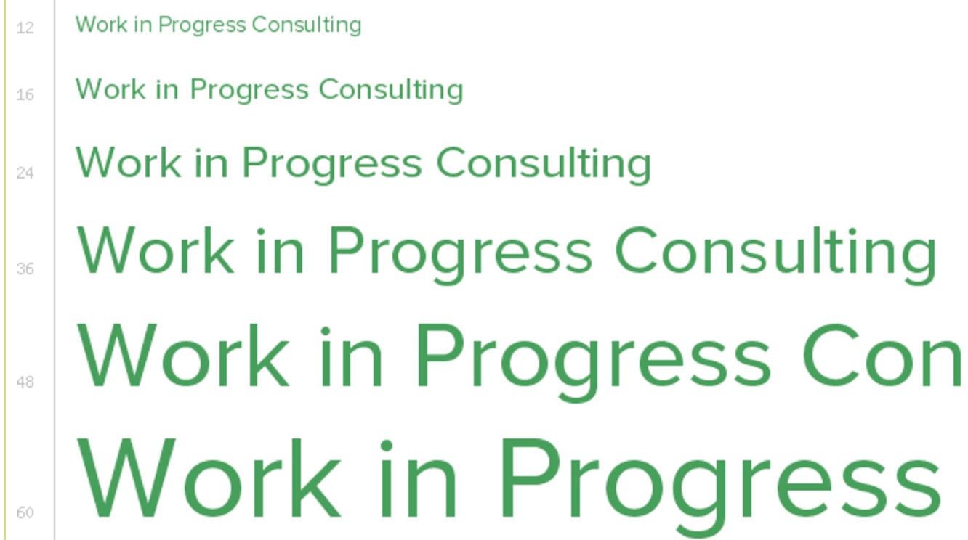

http://www.marksimonson.com/fonts/view/proxima-nova

Museo Sans 300
