Problem Statement:
Increasingly complex markets, low commodity prices and more variable and unpredictable weather are contributing to crop loses and degraded environmental conditions, including harmful algal blooms, that have combined to create problems and elevate risks for Ohio agriculture. At the same time, household food insecurity in Ohio, a state that should be a land of plenty, ranks well above the national average (16.1% of the population of Ohio including one in four children suffer from food insecurity). Clearly the commodities we are so good at producing, are not relieving that insecurity, nor are they keeping all farms and farmers on the land.
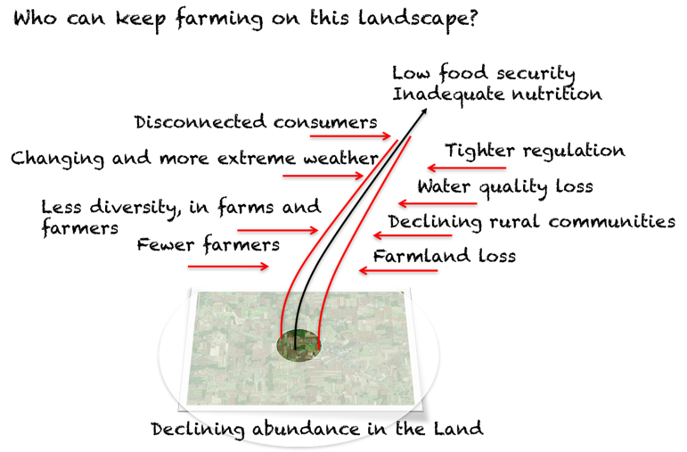
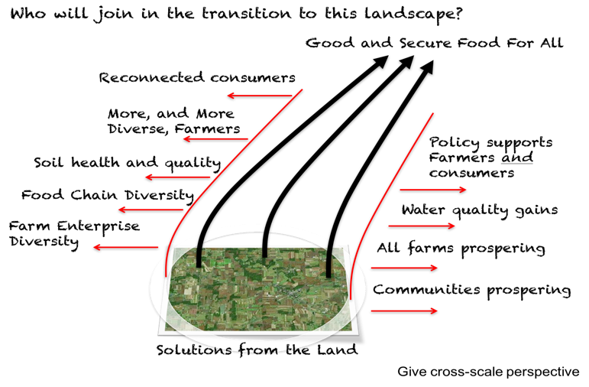
Solutions from the Land
¹ Source: 2015 ERS report, Household Food Security in the United States in 2015.

