

Company Overview
The Newton Institute, based in southwestern Pennsylvania, is one of three Newton family companies, including Aspirant (formerly Newton Consulting), a global management consulting firm, and Newton Talent, a professional recruiting firm. Co-founded by best-selling author and thought leader, John Stahl-Wert, and serial entrepreneur and Serving Leader practitioner, Rick Newton, the Newton Institute provides practical, hands-on leadership development services to business, education, government, and nonprofit organizations worldwide.

Central to the organization's Serving Leader Model℠ is a tool called the Serving Leader Compass℠. This compass answers four fundamental questions all leaders and organizations must ask:
- Who am I?
- How will I operate?
- What am I going to do?
- Why am I doing it?

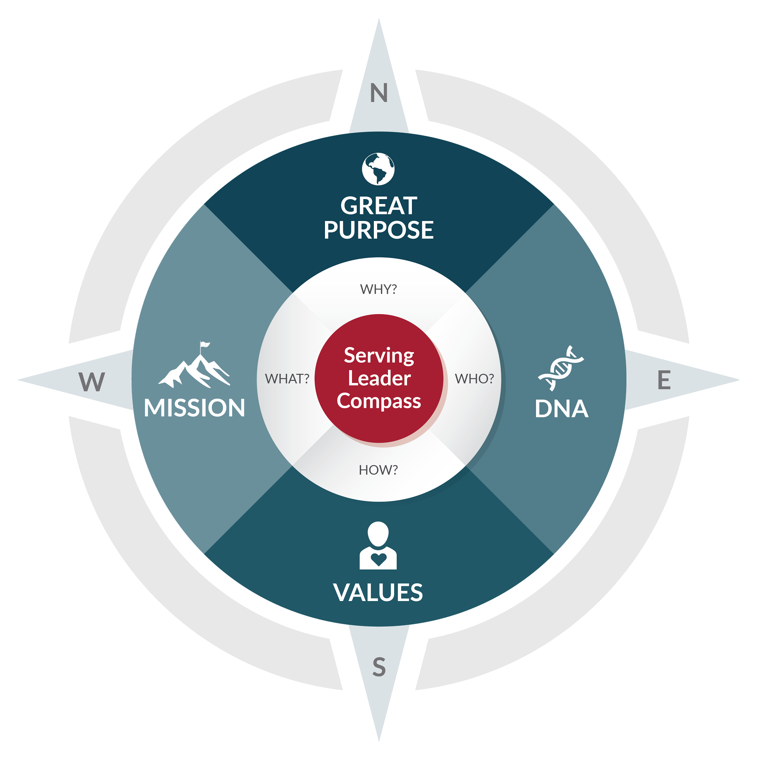

Newton Institute recently launched their online training school to allow more learners to access their leadership courses from anywhere, on any device, and on a self-paced learning timeline.

Course Example
Their flagship course, “The Serving Leader Model℠,” introduces learners to The 5 Actions℠ of the Serving Leader Model. The Serving Leader Model is based on the concepts in the best-selling book The Serving Leader: 5 Powerful Action to Transform You, Your Team, and Your Community by John Stahl-Wert and Ken Jennings. The course has 10 sections, starting with a short orientation and an introduction to The 5 Actions. Learners then progress through course sections exploring their personal leadership journey and learning how to apply each of The 5 Actions in their daily work. The course concludes with a personal breakthrough exercise, and then a commencement.

In spring/summer 2017, Newton Institute will add more courses to their online learning lineup:
- “The Serving Leader Model for Facilitators”
- “Discover Your Design, Unlock Your Potential”
- “The Serving Leader Model for Education”
- Additional specialized facilitators and student guides

The Problem
Before launching their online program, Newton Institute offered their learning in-person only to high-level management. The course ran for 6 months and learners met one time per month in a certain geographical location. “What we found was that there was a lot of barriers of entry for this kind of learning programs,” said Josh Newton, Senior Training Consultant & Technical Marketing Manager at Newton Institute. “Most notably, these kinds of learning programs were very expensive and time-consuming.”

In order to attend an in-person learning session, learners needed to give up at least one work day per month for six months -- more if they were traveling to the geographical location from far away. “Time is the most valuable thing for these upper management professionals,” Newton explained. “Being away from the company was the most significant investment they were making.”

Hosting the in-person training in a specific geographical location also provides some issues for Newton Institute on the supply end of things as well. All in all, taking the course online made it more scalable while also removing the time and finance barriers.

The Decision
When it came to selecting an online learning platform, there were three deciding factors that motivated Newton Institute to choose Thought Industries’ Learning Business Platform™. According to Jim Meyers, Chief Operating Officer at Newton Institute, it came down to:
- Robustness of the platform: The platform had course authoring tools, in=platform reporting, and eCommerce functionality.
- Thought Industries just “got it”: Meyers explained that Thought Industries really understood what their organization was attempting to create in terms of “training as a business.” The platform gave them the ability -- and flexibility -- to do the training they wanted.
- Thought Industries is a part of the team: “When going through the assessment process, we created a very positive relationships with the people we were working with at Thought Industries, explained Meyers. He adds, “Everyone wanted to support us -- they wanted us to succeed. That was the decision factor.”

On the technical delivery side of things, Josh Newton never got the feeling that his organization was “hooked and can’t go anywhere else.” He also suggested that the decision to go with Thought Industries was highly motivated by the fact that the platform was emerging in the eLearning marketplace as a strong offering. “We wanted to be with someone on that leading edge.”

Results and Future Plans
Since launch, a handful of learners have gone through Newton Institute’s flagship online course, “The Serving Leader Model.” Learners shared positive feedback about the learning platform and it’s ease of use, but what they miss is the ability to interact with the instructor live. To alleviate this pain point, Newton Institute plans to make live video conferencing a part of the course using Skype or Zoom.

