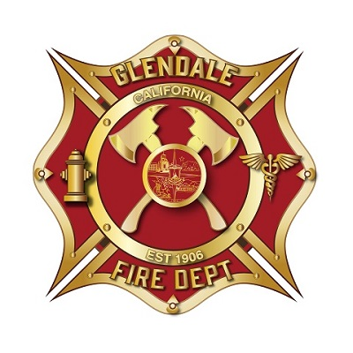
Make the red and gold closer in color and style to the Lafayette Logo that is attached
Make all 4 of these a little bigger to fit the “Glendale”, “Fire Dept” , hydrant and star of life better
Remove and replace with EMS Start of Life as included in the files. Color and tone to match logo.
Make the City Logo larger. Cover the axes as necessary.

