PARRAMATTA EELS  SALARY CAP SCANDAL | - 2015-2016  - •  - john borland
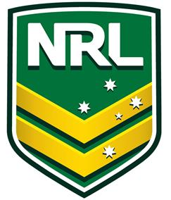  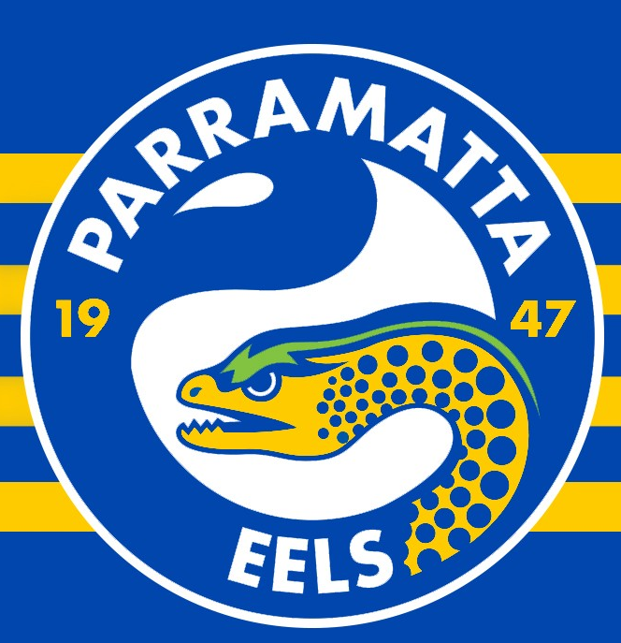  Background:  In 2015/2016 I was contracted by the National Rugby League (NRL) Integrity Unit to assist with investigations relating to the Parramatta Eels committing large scale fraud/breaches to the NRL salary cap policy. Primarily the task assigned was to develop and implement an investigative strategy with the view of obtaining verbal admissions by investigative interviews and locating withheld evidence from persons of interest to allow the NRL integrity unit to prefer sanctions, fines and charges.  Investigation Summary:  - Develop strategies and investigation plan  - Develop and implement investigative interviewing template to other investigators.  - Interview and interrogate relevant subjects in relation to fraudulent activity.  - Extract telecommunications material and conduct forensic analysis.  - Liaise with subjects legal representatives to ensure compliance.  - Complete evidence package and provide to client. | TESTIMONIAL  Head of NRL Integrity Unit – Karen MURPHY  “John, your specialist and unique investigative skills were a key component in the successful closure of the Parramatta Eels salary cap scandal. Your ability to develop strategies, interrogate subjects and locate withheld evidence was fundamental to the prosecution of multiple executives from the Parramatta Eels Board, Thank-you”.  Outcome:  - 5 x Board members including CEO stood down.  - Parramatta Eels fined over $1 million and 12 competition points for 2016 season.  - Identified club was $500,000 over the salary cap due to hidden/illegal payments.  - Parramatta Eels football manager criminally charged as a result of investigations.

