Web content:

Overall layout and content needs to be very similar to brissi.com, sofa.com and arloandjacob.com

Needs the following:
Wood finishes http://www.covercraftupholstery.com/index.php/our-collection/wood-finishes/wood-finishes.html

1 HOMEPAGE

2 SOFAS:
http://www.arloandjacob.com/sofas/?merchname=espot_hp1_sofa
https://www.sofa.com/shop/sofas
Here we need to see all of the sofas shown in the same way as on Brissi.com. Once you click on a sofa you see all the related pictures of that sofa along with 3 options 1. Size 2. Fabric 3. Finishes
We will need to have tabs for the customer to see available:
- fabric swatches
- wood finishes
- various sizes of each sofas

I have spent a lot of time on all relevant competitor websites and feel that Brissi is the one we want to replicate here:
http://www.brissi.com/builder#/style/6748/size/16/fabric/
ie. Buttonback House Sofas – Click on a sofa - Tailor this sofa –

STEP 1
http://www.brissi.com/builder#/style/8677

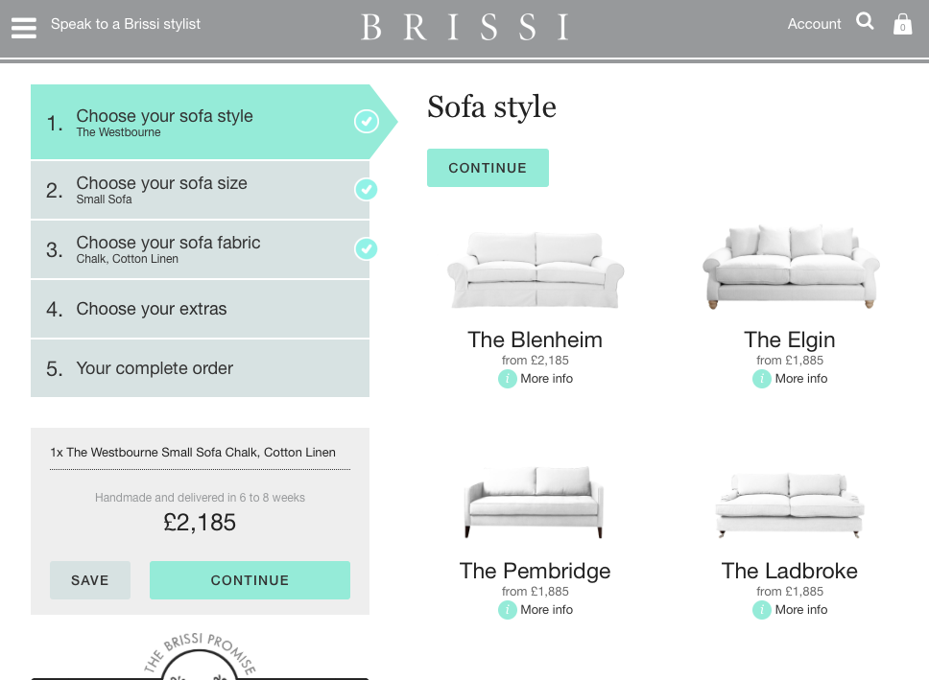

STEP 2:
http://www.brissi.com/builder#/style/8677/size/50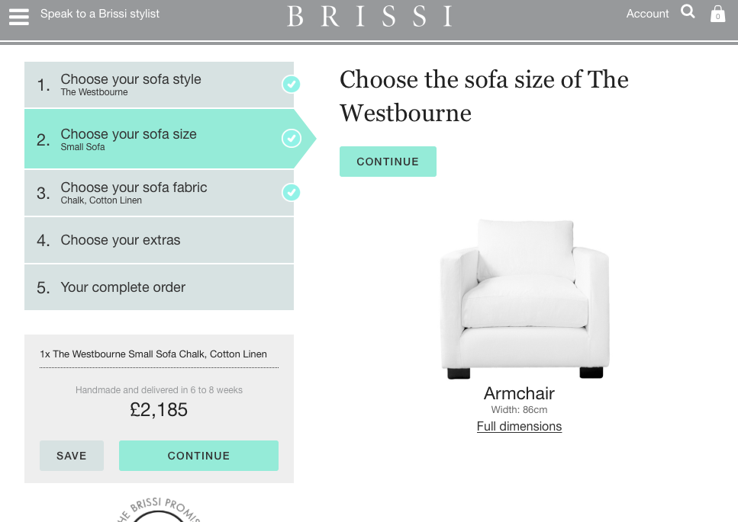

STEP 3:
http://www.brissi.com/builder#/style/8677/size/50/fabric/158
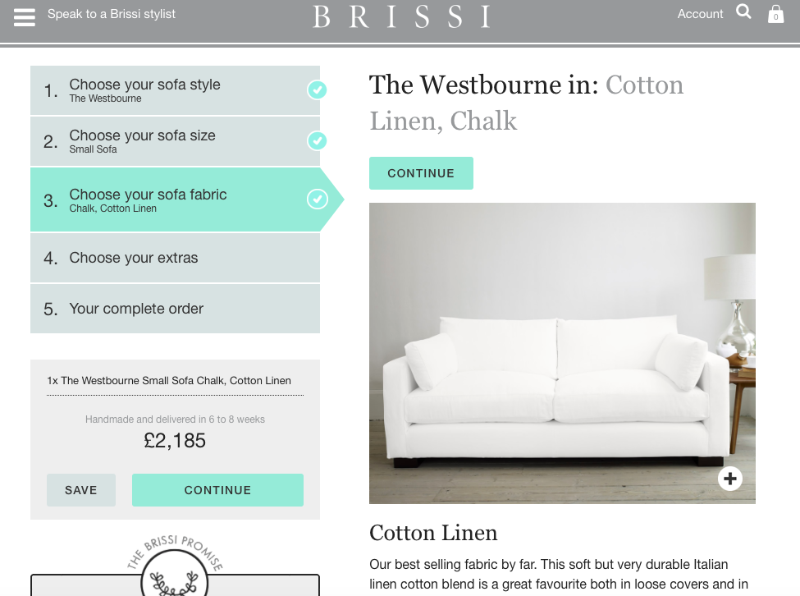

here we will need to show all fabric options in small swatches – again please copy the format of what brissi show here… we will have the same options as them – Cotton Linen, Herringbone, Italian Woven, Pure Linen, Velvet

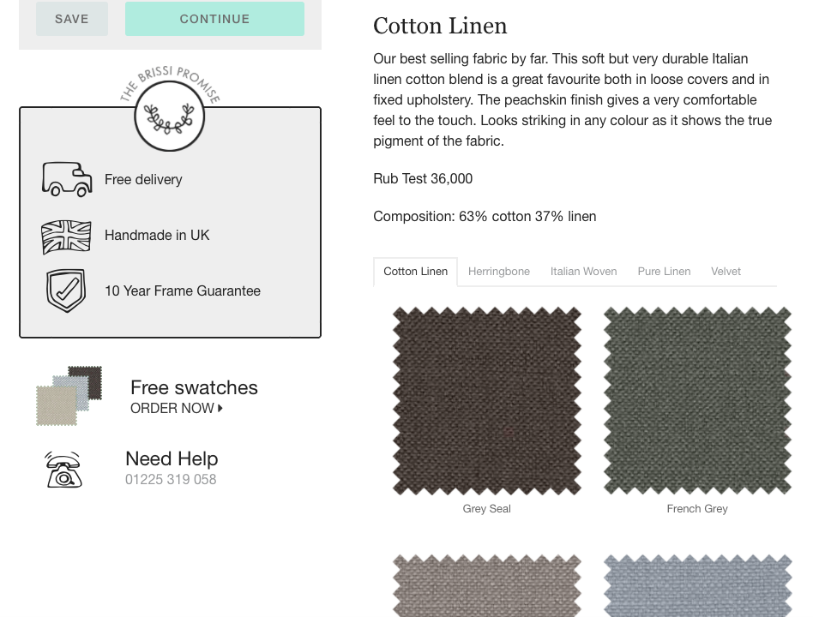

STEP 4:
http://www.brissi.com/builder#/style/8677/size/50/fabric/158/summary

