Brief to design, develop, launch and maintain ButtonBack.com to the UK & Irish market place

ButtonBack aim:
To create and launch a UK & Ireland home furniture business, aimed at the discerning mid-market consumer. Button Back aims to compete with the new breed of furniture e-tailers, as well as more established retail brands.
Our launch strategy has to capture the hearts, minds and wallets of the target audience, placing us firmly into the market place.

Competitors:
The market for upholstered furniture online is already well catered for. We are looking for a slice of this market, not to reinvent the wheel. Loaf.com, sofa.com, arloandjacob.com, sweetpeaandwillow.com are the companies I have concentrated research on to date. They have all developed into very successful businesses and have expanded and grown along the way.

Brand: look and feel:
The sofas will be comfortable, not ultra modern, for every day use (similar to those seen on the websites of competitors listed above).
I like the lifestyle feel of Arlo and Jacob’s website but feel it is all a bit too cosy, I would prefer something a bit more sophisticated and interesting. https://www.roche-bobois.com - I have attached some of their images that I like. For photography I like the idea of a simple but beautiful piece of furniture on its own (or with little else) in a beautiful room (i.e. high ceilings, ornate room) to showcase the piece in a beautiful but simple setting. Roche Bobois is a higher price point but their website is worth looking at.
Colours – think Provence, Mallorca, Cotswolds, beach (see mood images below)
Other websites I like - https://www.sohohouse.com, http://www.studioilse.com , http://www.laminervetta.com , http://www.therugcompany.com

Mood images:

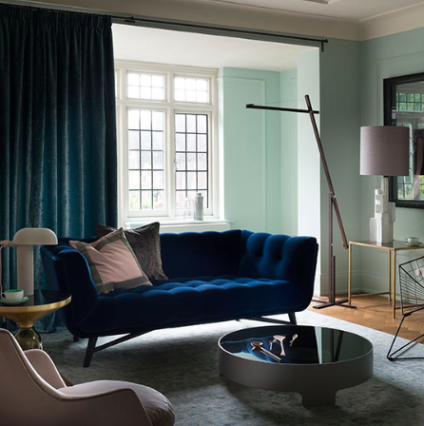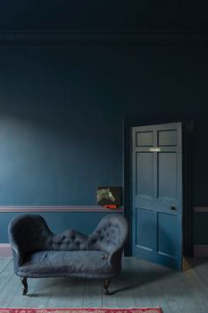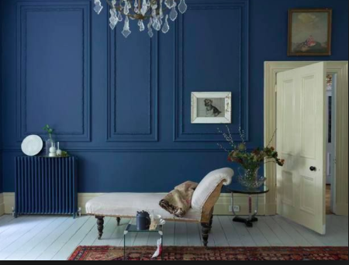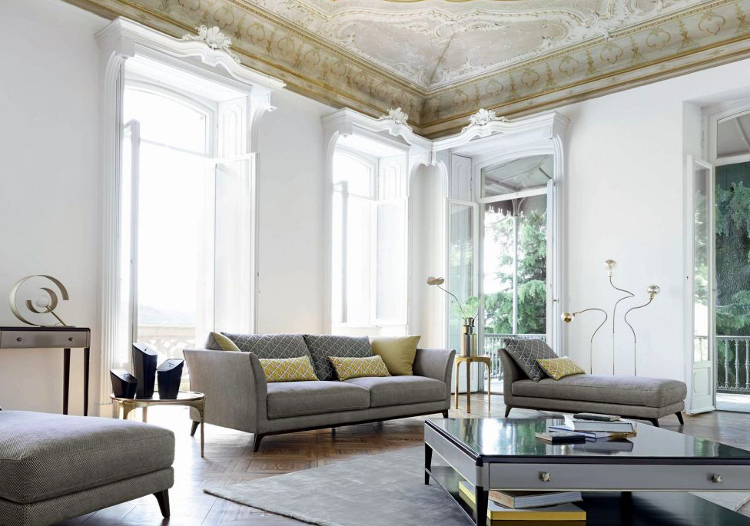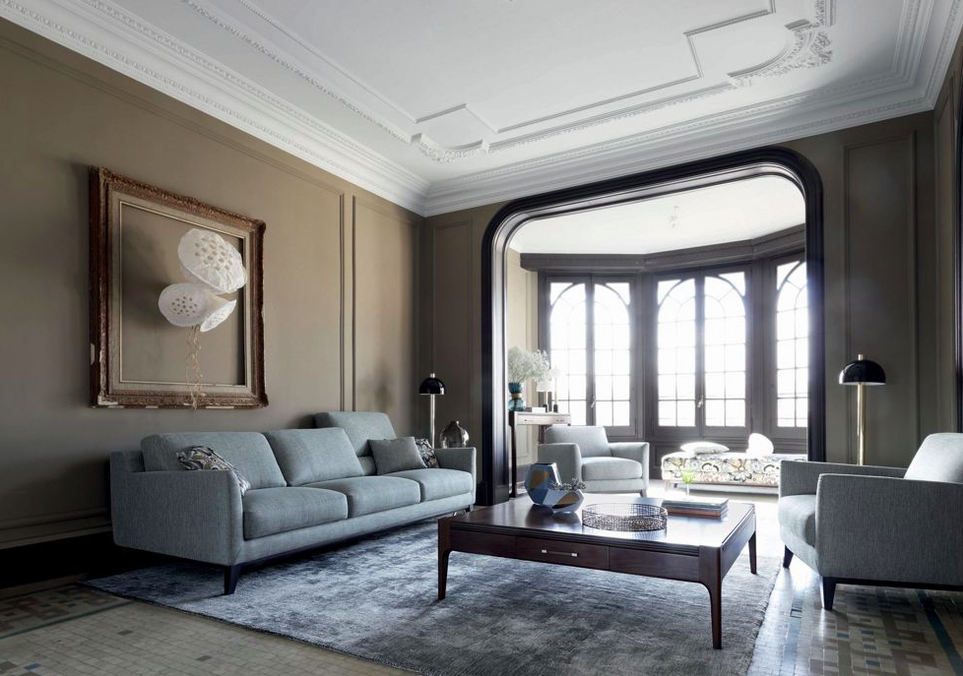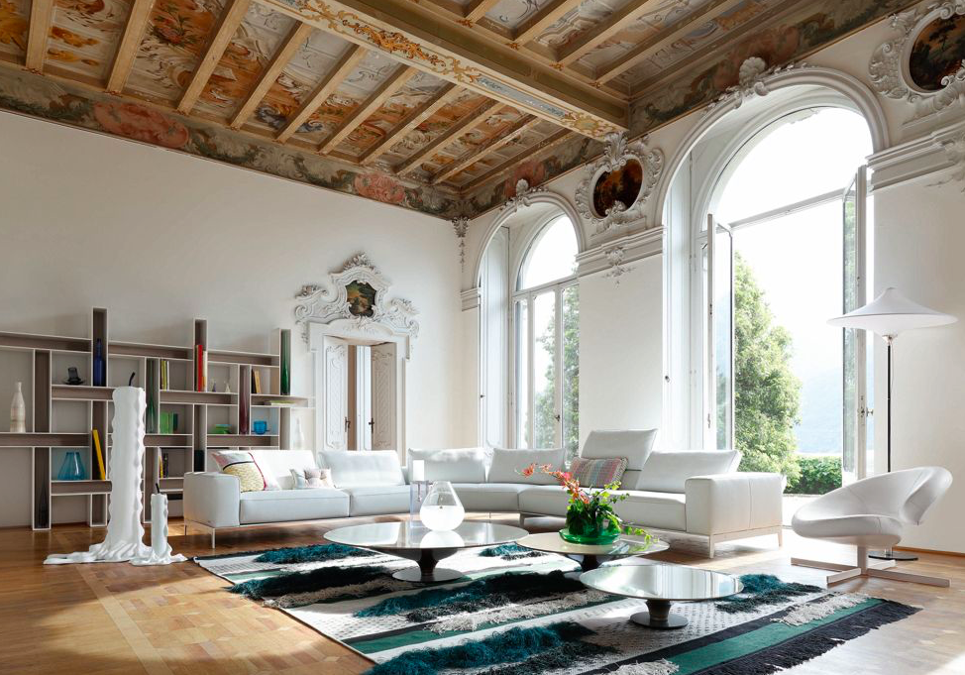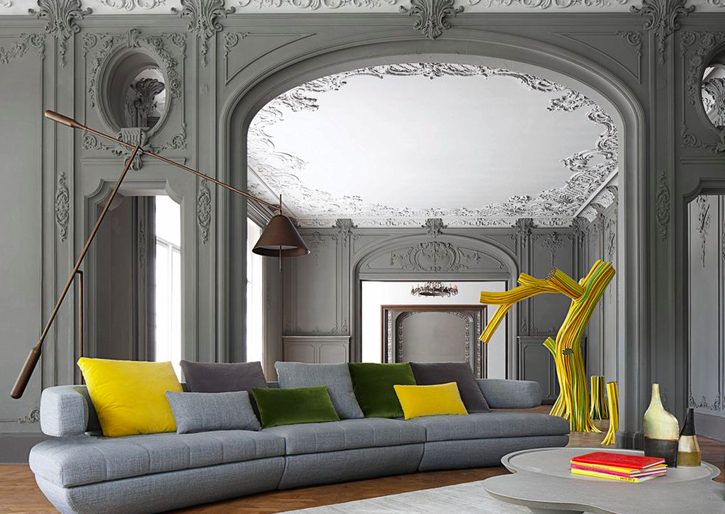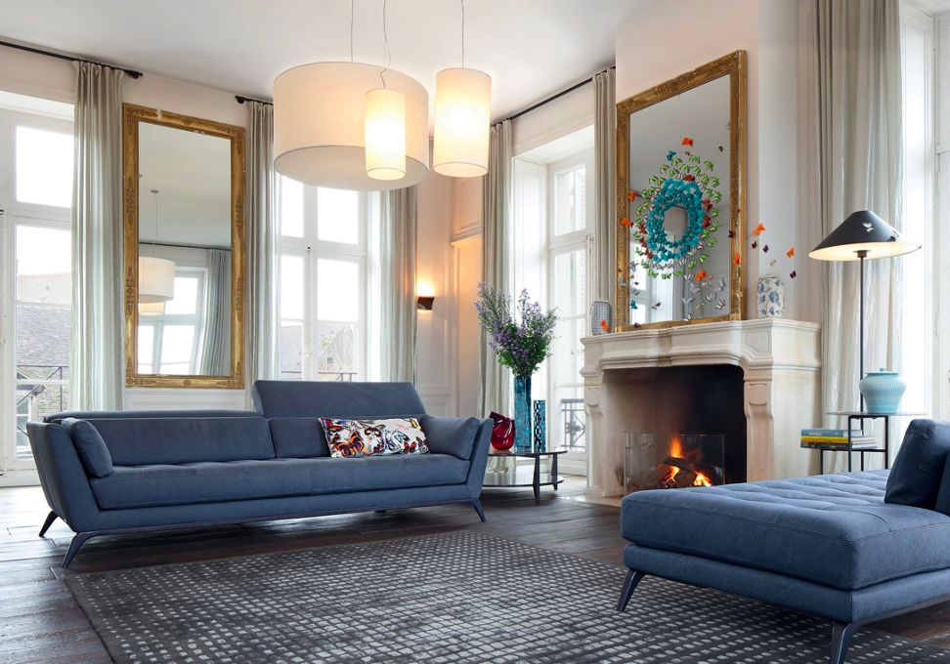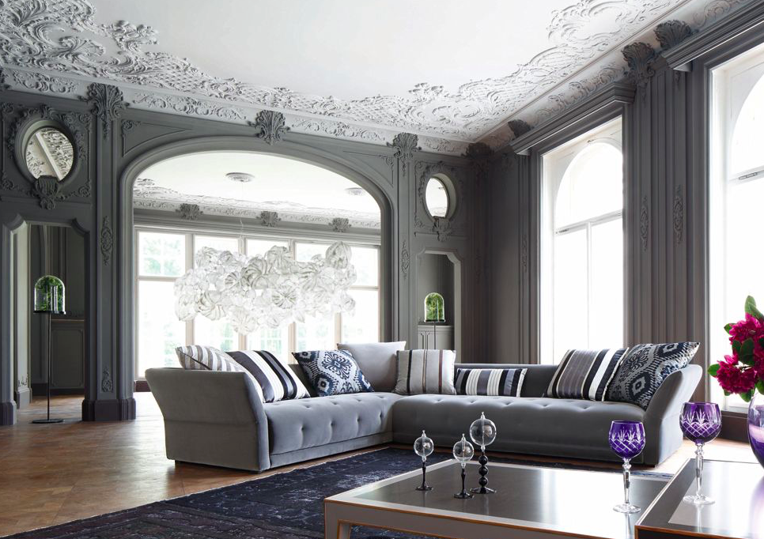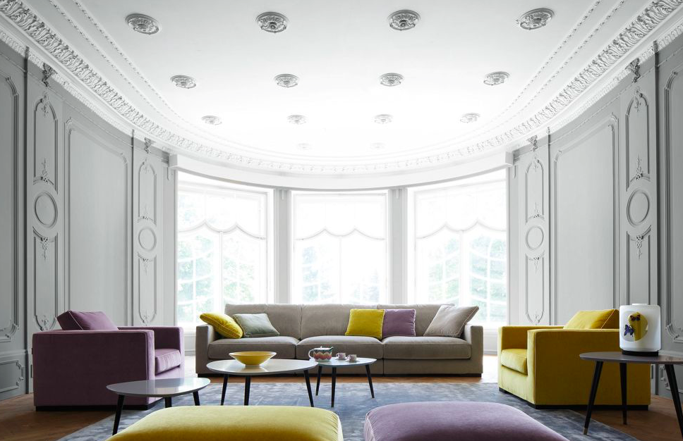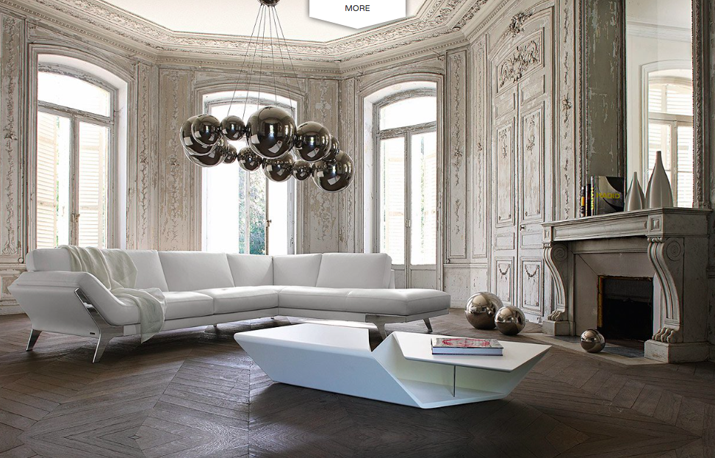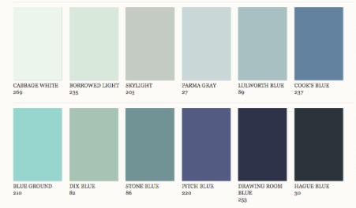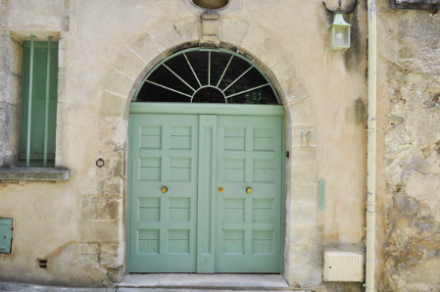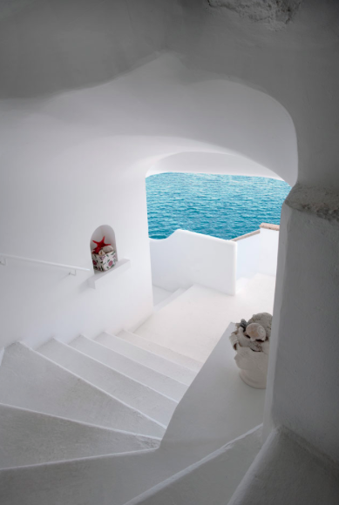

Desired outcome:
(Ultimate aim is to build a fast-growing, profitable business)
To create a brand proposition and identity that is both compelling and differentiating, in a market where everyone is saying the same thing.
We need to develop brand identity and guidelines, including logo, typography, tone of voice and photography style for a slick, user friendly ecommerce website with a clear plan for social media, SEO and ongoing maintenance.

Extra Notes:
As few clicks as possible to get to the end goal.
A phased approach to releasing features – will allow costing for work easier and will allow time to build up?
First need a holding page and logo etc
Create minimum viable version first, get feedback and then commit to whole project
7 second rule – within 7 secs on website user should know – who you are, what you do, and where to go next
KISS principle for web design = Keep is Simple
Need help with setting up on eBay, etsy too
Needs to look great and work well on all mobile devices
Payment system online
Make a list of your key competitors and a list of key words you want to be associated with (for Google search purposes)
Don’t try to be too creative, follow what successful competitors websites look and feel
Consistent theme and message throughout website

Aim for a 3 stage approach:
First: holding page
Second: Brochure style website
Third: ecommerce plus bells and whistles

Extra notes:
Like the way loaf and sofa.com show all sofas in white/ neutral and when you scan over you see in a more lifestyle shot…

Studiosmall - http://depurydepury.com/information/ like the look of the font and the business cards/ stationary

