We are a small, family business and we want to create a brand image of high quality and friendly, personal customer service. Ideally we would like the logos to be professional looking but also fun and original. Here are some examples of logos that we like to give you an idea:
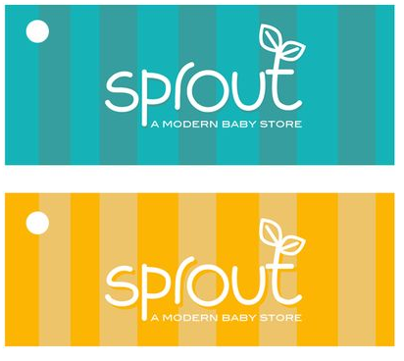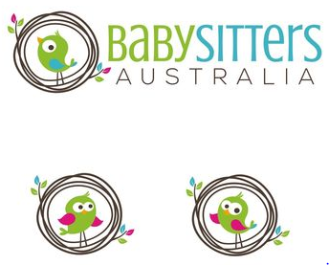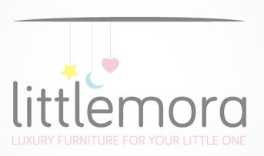
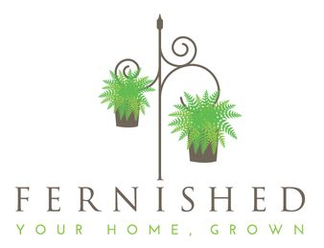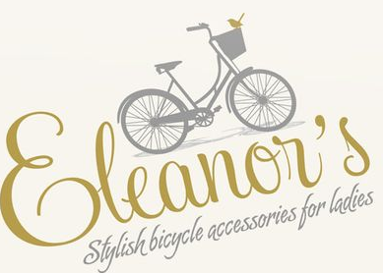

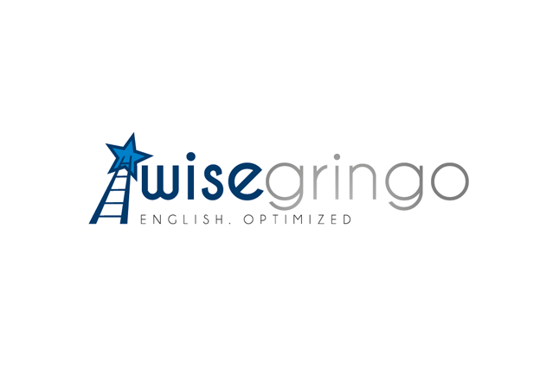
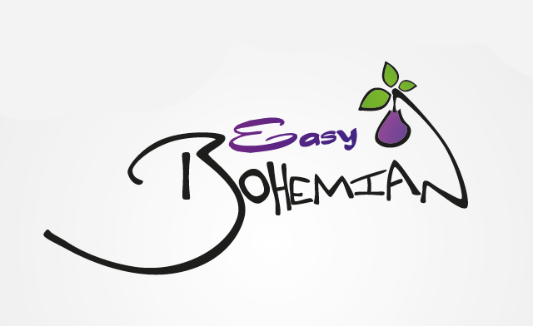

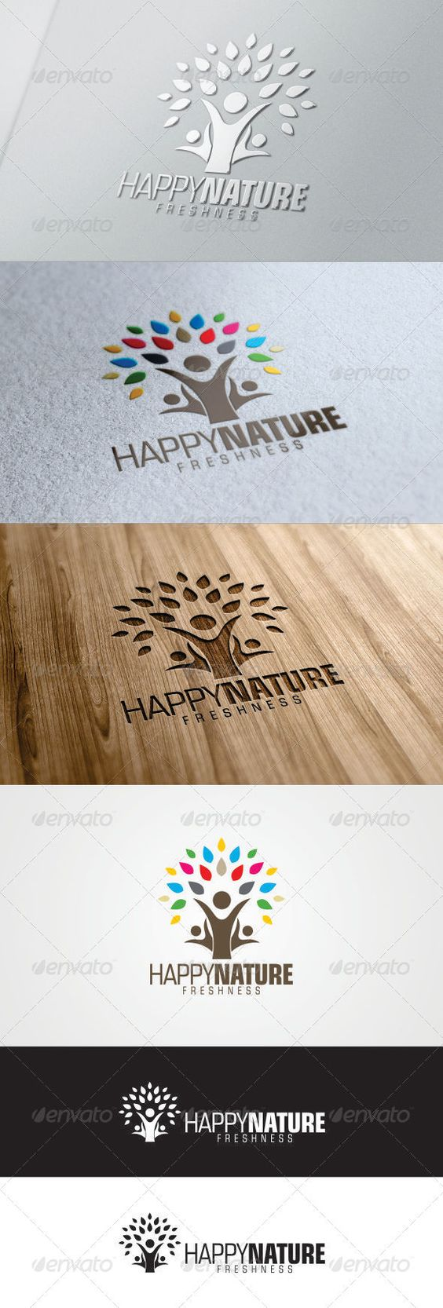
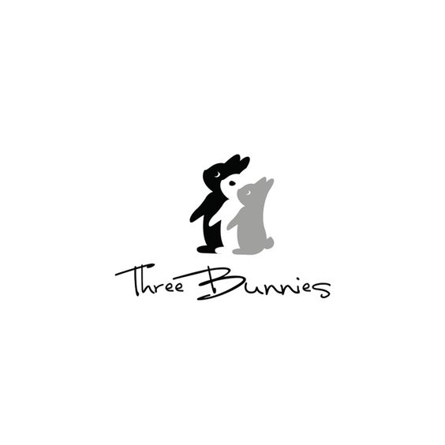
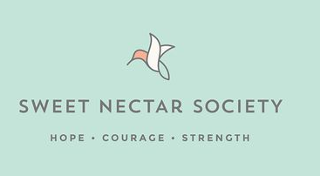

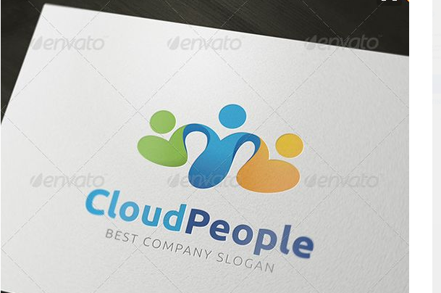

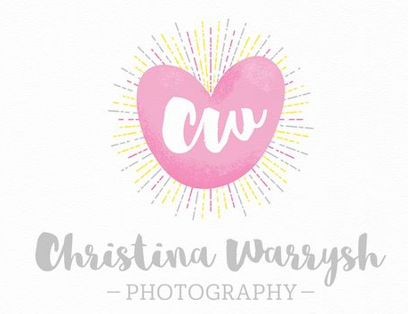

We’ve no set ideas on whether we go for a text-based logo, an illustrative symbol or an abstract symbol. Although we picture a symbol of some sort (as it will be more flexible to apply across The Great Stuff Company, Stuff4Homes and Stuff4Tots) we’re open to suggestions.
We do have a company slogan “A Family Business”. We don’t necessarily have to use this in the logo

