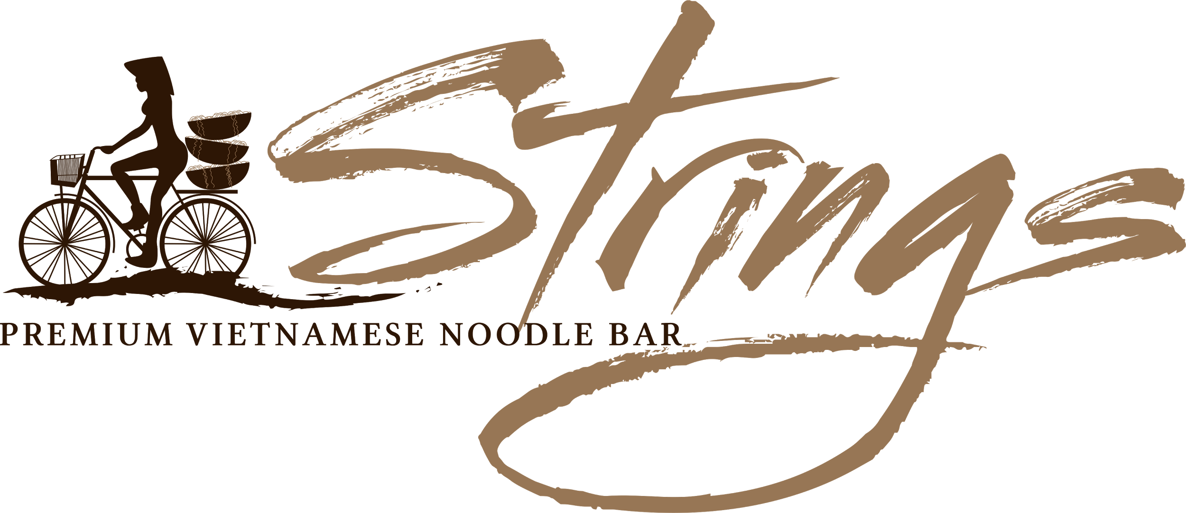
Melody ^{of Entrees}
/ˈmɛlədi/ a sequence of single notes that is musically satisfying in preparing your palate for an amazing epicurious experience
[all entrees are gluten free]

Seafood Spring Rolls Shrimp, Crab, Taro, Mushroom, Water Chestnut (5pcs) 7.80
Vegetarian Spring Rolls Tofu, Taro, Mushroom, Onion (5pcs) 7.80
Vietnamese Grilled Chicken Cabbage Salad Cabbage, Carrots, Vietnamese Mint (Goi bap cai) 8.80
Vietnamese Tofu Mushroom Cabbage Salad 8.80
Vietnamese Street Food Skewers mixed plate (Marinated Pork skewer + Nem Nuong skewer + Sugar Cane Prawn) 8.80

Symphony ^{of Mains}
/ˈsɪmf(ə)ni/ an elaborate musical composition designed to fine-tune even the toughest of tastebuds

[all mains are gluten free]

12 hour Vietnamese Beef Noodle Soup Phở Bò
Star Anise fruit, Clove buds, Fennel Seeds, Cardamom pods, Cinnamon quills simmered in a 12 hour beef bone marrow and oxtail broth
medium 13.80 large 15.80
Choice of:
Plain and Simple: Rare Beef Tái
Adventurous: Rare Beef + Beef Flank Tái Nạm
Safari: Rare Beef + Nam + Bo Vien Beef Balls + Tripe + Tendon (extra $1.50) Đặc biệt

Extra Beef Balls 4 pcs 2.00

6 hour Vegan Vietnamese Noodle Soup Phở Chay
Star Anise fruit, Clove buds, Fennel Seeds, Cardamom pods, Cinnamon quills simmered in a 6 hour Onion, Pear, Carrot, Apple, Radish and Ginger broth
medium 13.80 large 15.80

8 hour Vietnamese Chicken Noodle Soup Phở Gà
Star Anise fruit, Clove buds, Fennel Seeds, Cardamom pods, Cinnamon quills simmered in a 8 hour chicken bone broth
medium 13.80 large 15.80

10 hour Central Vietnam Spicy Lemongrass Beef Noodle Bún Bò Huế
Lemongrass, Paprika, Cayenne pepper, Garlic simmered in a 10 hour pork and beef marrow broth drizzled with annatto seed oil
medium 13.80 large 15.80
10 hour Vietnamese Crab Noodle Soup Bún Riêu
Garlic,Tamarind, Tomato, Onion infused in 10 hour pork marrow,chicken, prawn, and crab broth
Served with melt-in-your-mouth crab and prawn meat balls
medium 14.80 large 16.80

Vietnamese Vermicelli soup-less wonders
Bún Nem Nướng/ Thit Nuong
medium 13.80 large 15.80
Choice of:
Vietnamese Chargrilled Garlic and Roasted Rice Sausage + Seafood Spring Rolls
Vietnamese Chargrilled Garlic and Roasted Rice Sausage + Marinated Pork Belly
Marinated Pork Belly + Seafood Spring Roll
Seafood Spring Rolls + Sugar Cane Prawn
Vegan Tofu + Mushroom
Extra Seafood Spring Rolls / Vegan Spring Rolls 2pcs 2.50

DIY Vietnamese Mixed Meat Vermicelli Rolls with Strings Signature fish sauce 17.50
Gỏi Cuốn
Mix plate of: Vietnamese Chargrilled Sesame and Garlic Pork Sausage, Spring rolls (served with fresh herbs and lettuce, finely woven vermicelli sheets, scallion and pickled carrots)
DIY Vietnamese Vegan Salad Vermicelli Rolls with Strings Signature soya sauce 15.80
Gỏi Cuốn Chay
Mix plate of Tofu and mushroom (served with fresh herbs and lettuce, finely woven vermicelli sheets, scallion and pickled carrots)
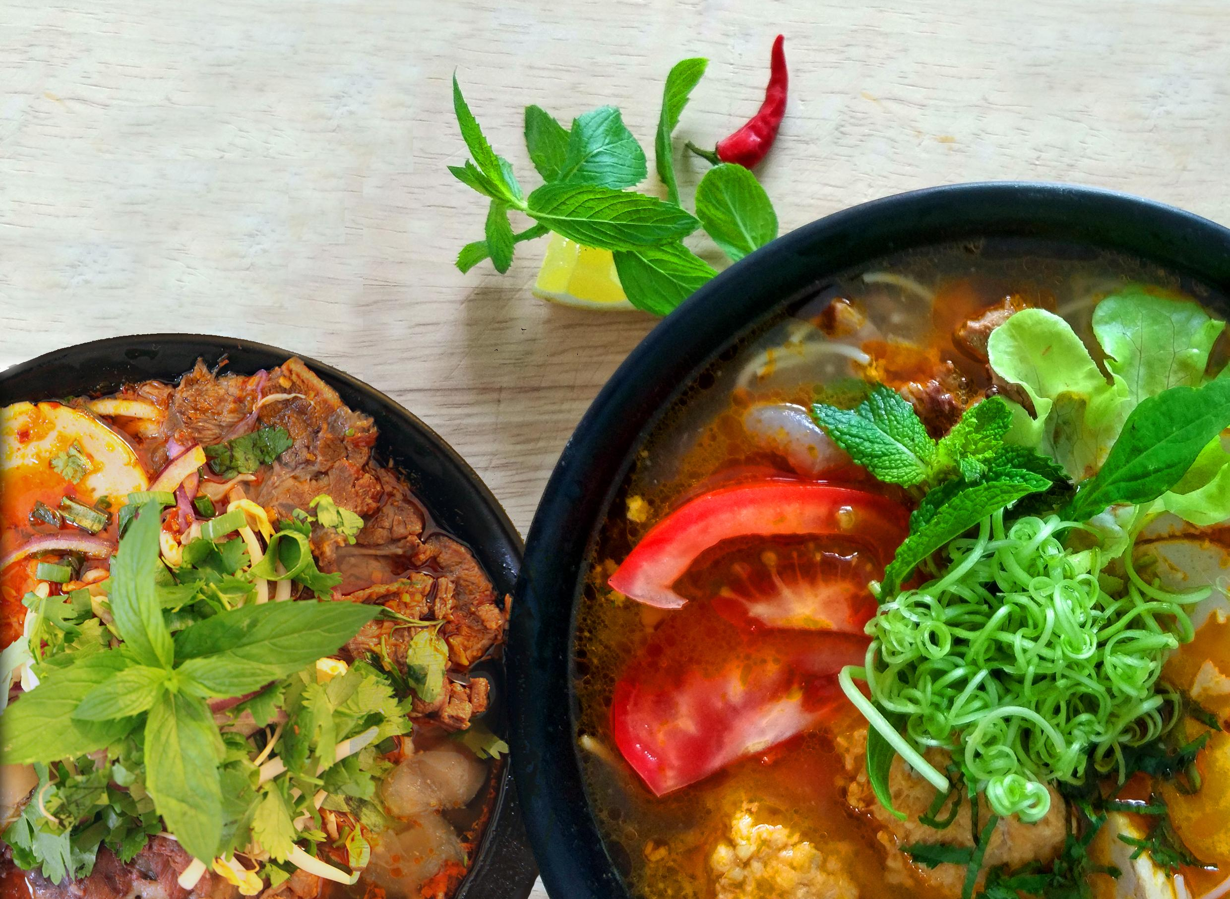
Featured: Bun Bo Hue, Bun Rieu
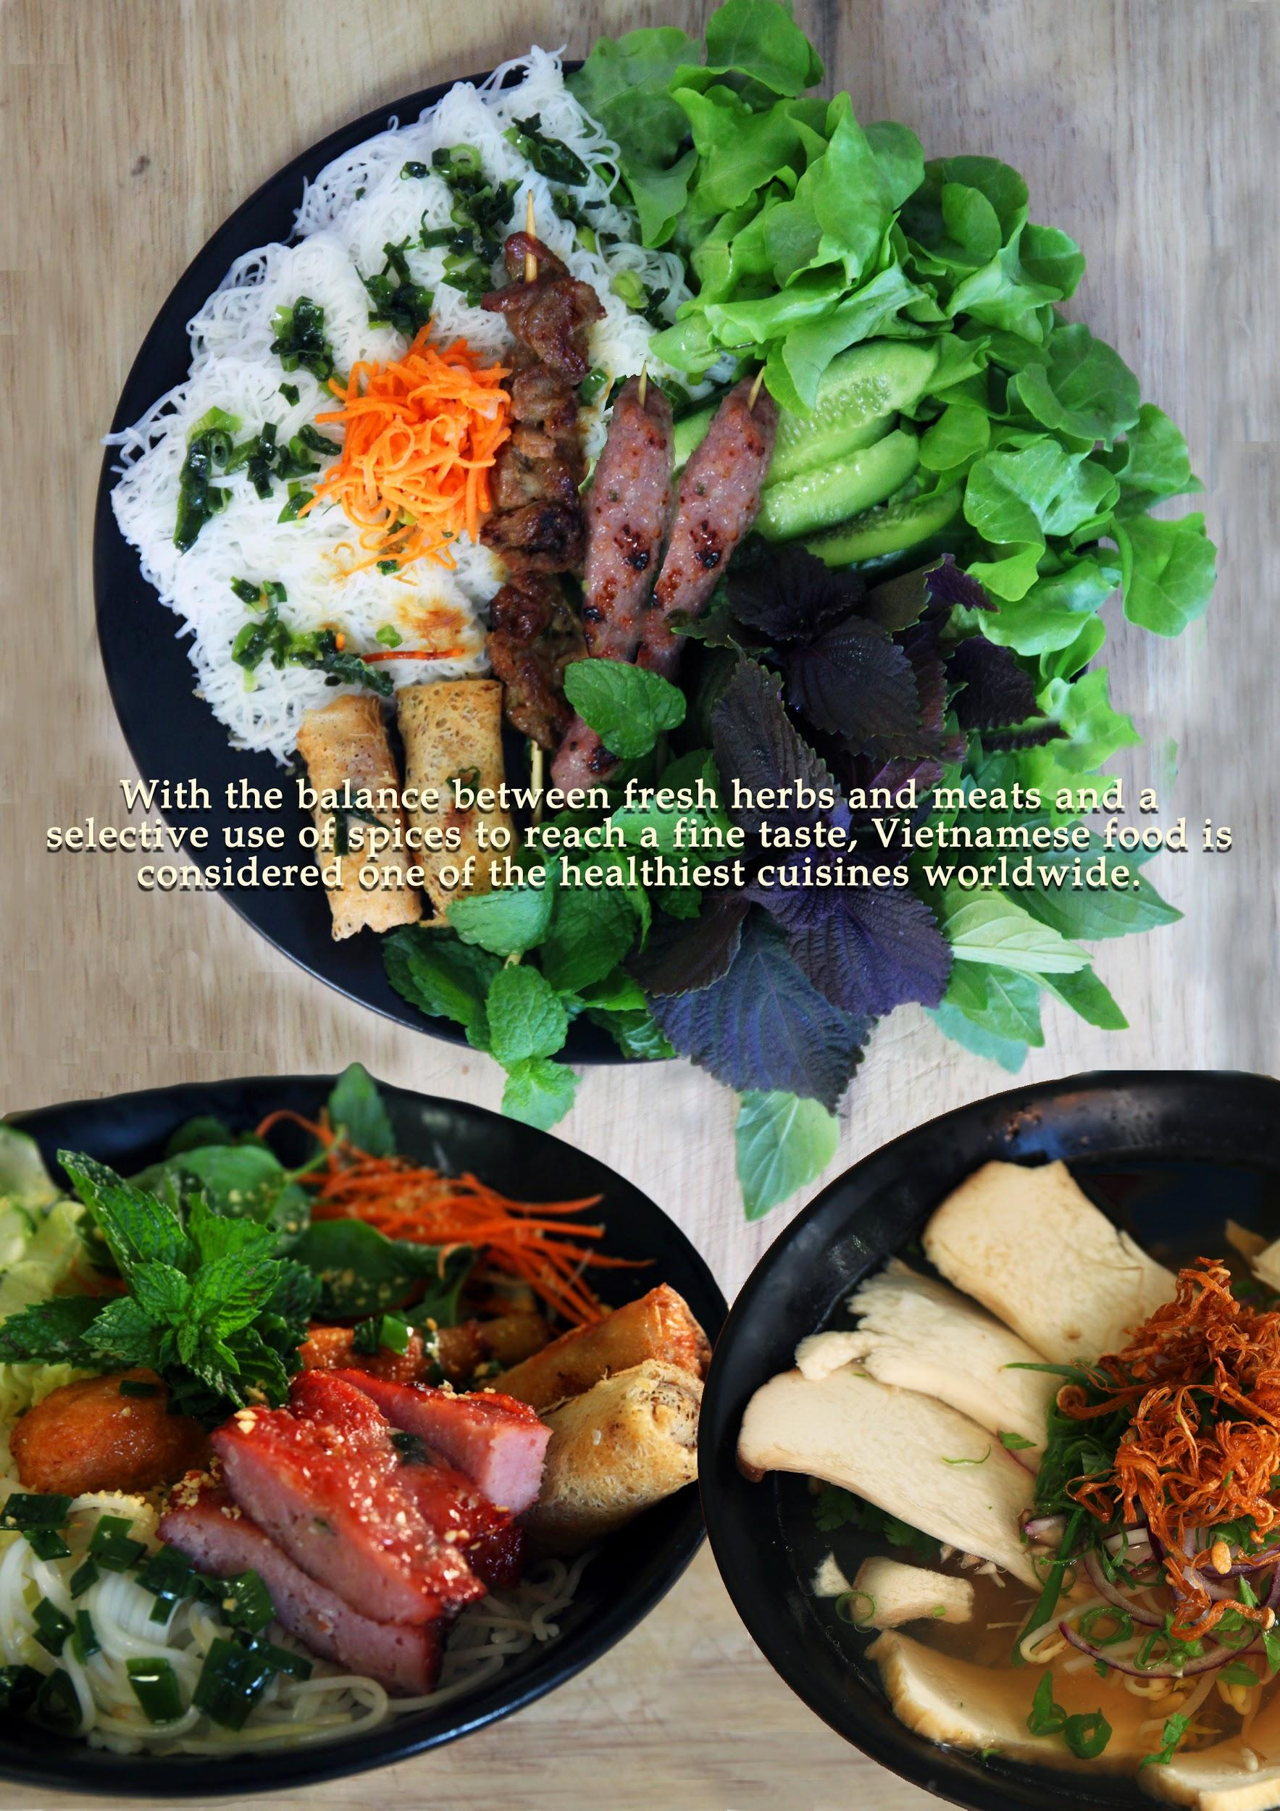
Featured: DIY Goi Cuon, Bun Thit Nuong, Vegan Pho
Counter Melody ^{Desserts}
/ˈkaʊntəˌmɛlədi/ a subordinate melody accompanying a principal one that celebrates the journey one has surpassed
Banana Black Bean Sticky Rice and Vanilla Ice Cream 8.80
Vietnamese tri-coloured dessert Chè ba màu 5.80
Orange Mango Sorbet in half an Orange (sm) 4.80
Lemon Sorbet in half a Lemon (med) 6.80
Coconut Sorbet in half a Coconut (lrg) 8.80
Pineapple Sorbet in half a Pineapple (lrg) 8.80

Drinks
Avocado Shake 5.80
Lychee Shake 5.80
Jackfruit Shake 5.80
Mango Shake 5.80
Watermelon Shake 5.80
Vietnamese Ice Coffee cà phê sữa đá 4.50
Coconut Juice 4.50
Soft Drink - Coke, Coke Zero, Lift, Fanta, Passiona, Creaming Soda 3.80
Apple Juice, Orange Juice 3.80
Mineral Water 2.80
Specialised Tea - Green Tea Jasmine, Green Tea, Oolong Tea, Pandan Tea, Lotus Tea 3.50

STRINGS PREMIUM VIETNAMESE NOODLE BAR
Strings Premium Vietnamese Noodle Bar is a modern restaurant concept focused on authentic Vietnamese foods that are served in deep and flavourful broths. Created by a Sydney-based pharmacist, Jenny, Strings Premium Vietnamese Noodle Bar takes your tastebuds on a journey to Vietnam and back. Jenny's food is an experience that your tastebuds would not want to miss.
While working in community pharmacy Jenny would daydream about her culinary creations for hours on end. Always on her mind were her favourite Vietnamese noodle dishes originally served in nutritious, deep-flavoured, herb infused broths. She then combined her scientific prowess with her fine tuned tastebuds and experimented day and night for months on end. The results were flavourful recipes that embraced the efforts of and honoured the Vietnamese ancestors that have created such wonderful dishes.
To fulfil her dreams she would love to share her culinary delights with everyone in Australia and beyond. Most importantly, starting with YOU!

