PezCá
V Vegetarian
GF Gluten Free

🌶 Mild Spicy

At our seafood restaurant we will serve you an eclectic mix of Phu Quoc flavours all visible in the menu with gorgeous pictures and Fusion dishes highlighted as healthy specials.

Instead of the traditional menu starter/main/dessert you will see our menu setup in a more family style friendly way as people like to eat in Phu Quoc.

From our menu you will be able to choose from our wok, grill, raw, smoke, steam, fried and be able to combine these dishes into a big family style platter.

MAIA’S HEALTHY CHOICES
Goi Ca Trich  Phu Quoc Herring with Salad, Herbs and Rice Paper  As a single dish or sharing | 100  GF | 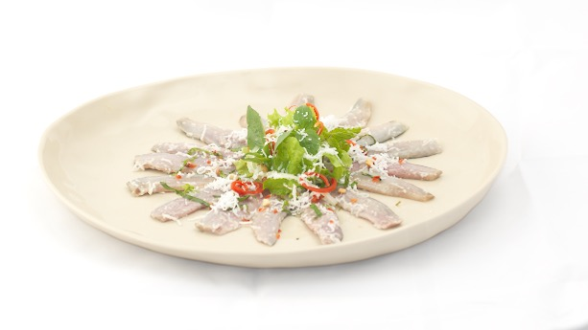
A delicious mix of our fresh spring rolls  Fish cake, shrimps, roasted duck, Phu Quoc crab | 100  GF | 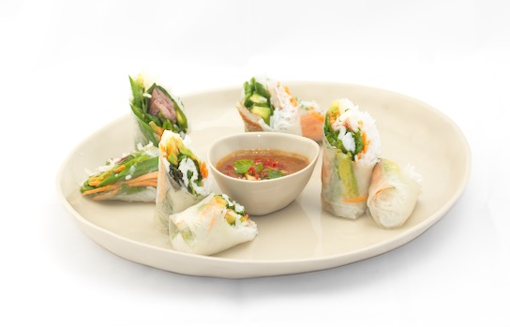
Vietnamese Oysters  ½ dozen, served on ice with Phu Quoc black pepper and lime | 100  GF | 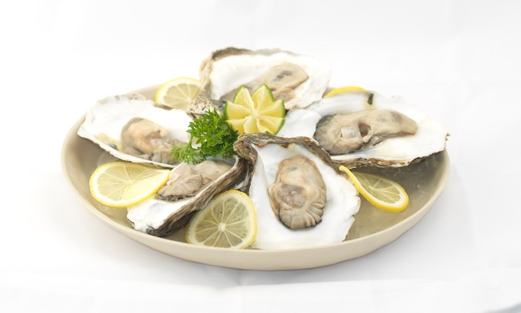
Ceviche swimming in avocado  Raw marinated fish, lime juice, red union, red chili, cilantro, avocado crème | 100  GF | 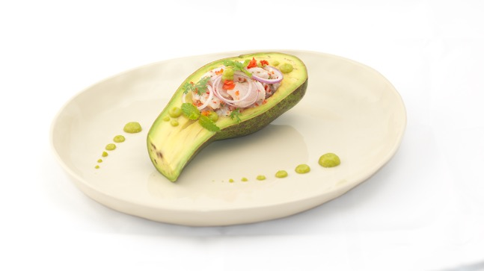
Poached red snapper  Spinach bulgur mixed with sous-vide prawn tartar, saffron foam | 100  GF | 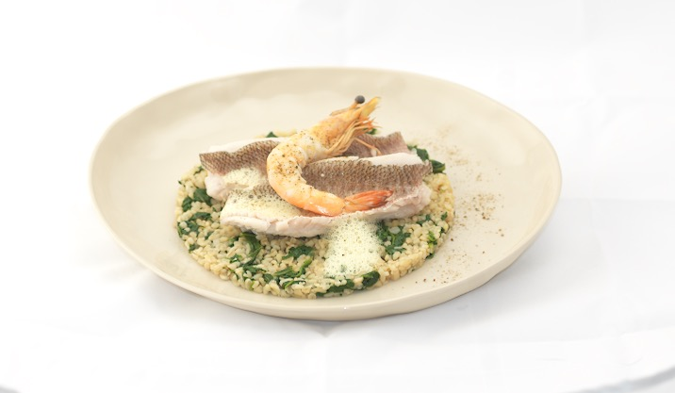
SELECTION OF OUR HOUSE BREAD
Sardine butter, olive/shrimp tapenade, Vietnamese pate | 100 | No Image
PHU QUOC FISH MARKET, SEE OUR SPECIAL DAILY FRESH MENU BOARDS
Local fish,  squid,  prawns,  clams,  shells,  snails,  lobster,  crab  day fresh catch | 100  GF
MAIA’s Phu Quoc Seafood Sharing Plate  Crab, lobster, oysters, clams, snails, local fish sashimi, tataki, prawns, homemade Belgium mayonnaise | 100  GF | 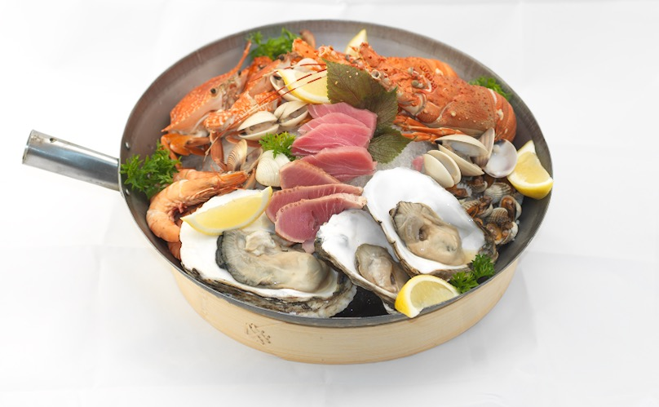
CHEFS SPECIALTY, HOUSE SMOKED PHU QUOC FISH
Eel | 100  GF | 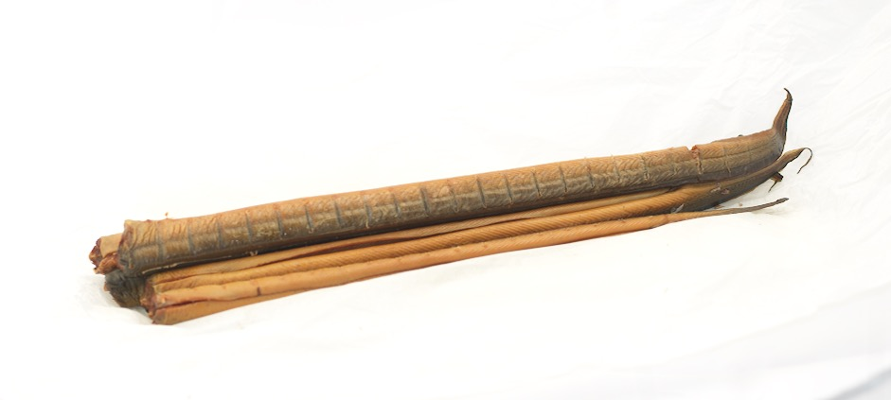
Barracuda | 100  GF | 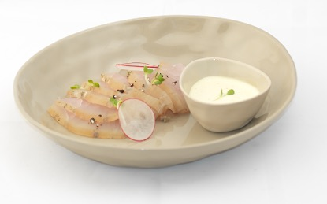
Mackerel | 100  GF | 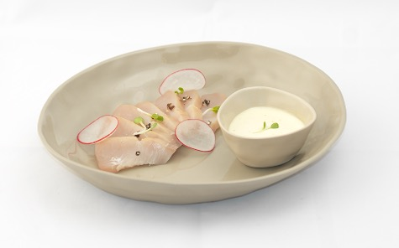
SOUP
MAIA’s Phu Quoc Catch  Local fish soup with shrimps, clams, star anise, eggplant crostini, rouille, grated cheese | 100 | 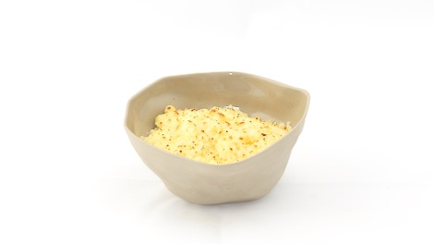
Phu Quoc tram mushroom  Stock with noodles and spring union | 100  GF  V | 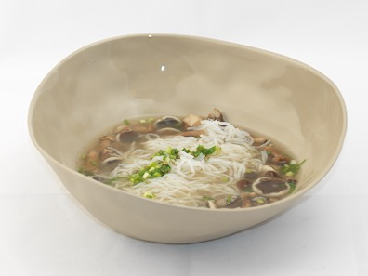
Healthy Dalat tomato  Tomato soup with Vietnamese basil paste, egg sushi | 100  GF  V | 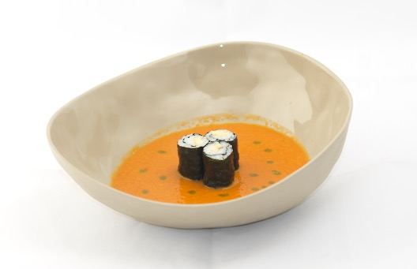
STARTER
Grilled octopus skewers  Jacket potato, Phu Quoc black pepper vinaigrette | 100 | 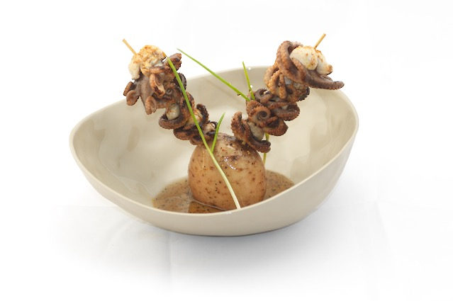
Roasted and caramelized prawns  Roasted corn crème, eggplant & capsicum paste, Phu Quoc fish sauce & honey dressing | 100 | 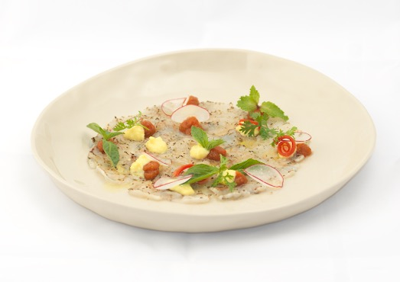
Chef’s charcuter’sea  Smoked local tuna, marinated red snapper, tartar of white mackerel, blue crab cocktail, white cocktail sauce, mango chutney | 100 | 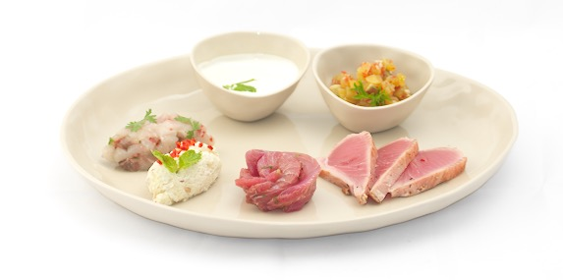
Phu Quoc Crab Meat  Pomelo, sweet potato, avocado crème, crab cracker, crispy kefir lime leave | 100 | 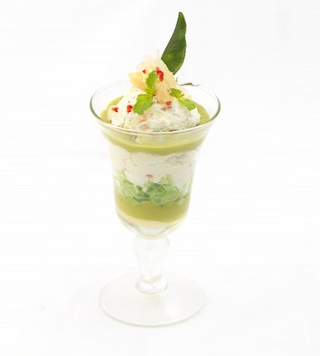
Chef’s Favourite Oysters  Tasting 3 different servings of oyster  Passion fruit, Cucumber, Coffee  With crispy lotus and salad, chips of purple yam | 100  GF | 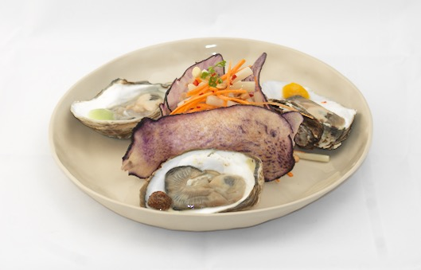
MAIN
Grilled Rose Tuna  Grilled, scallop, beetroot, grapefruit, cress | 100  GF | 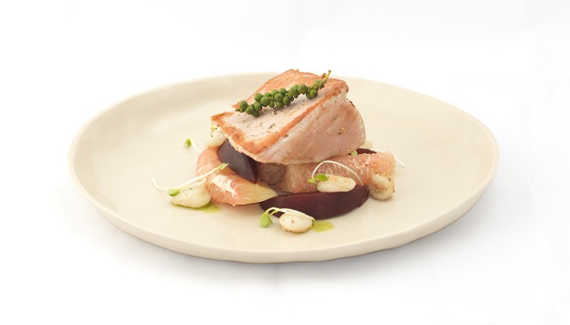
Poached Squid Bathing in a Coconut  Warm served poached Squid salad, lime, chilly, red union, Vietnamese basil, mint, iceberg salad | 100  GF | 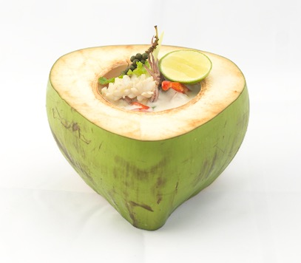
Steamed Sea bass  with lemon grass, chilly and lime | 100 | 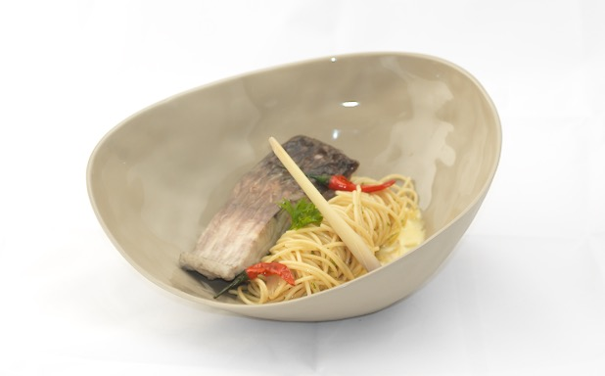
Grilled Prawns  with fresh coconut Risoni risotto, cilantro | 100 | 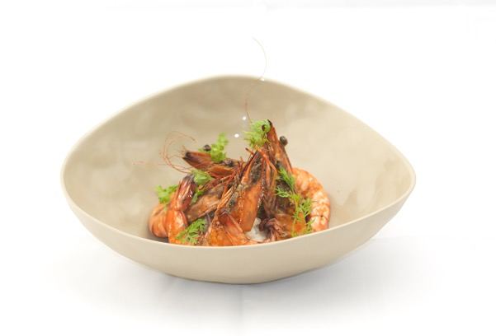
Chef’s Signature Oysters  French savory crepes, crispy oysters, spinach, traditional beurre blanc sauce | 100 | 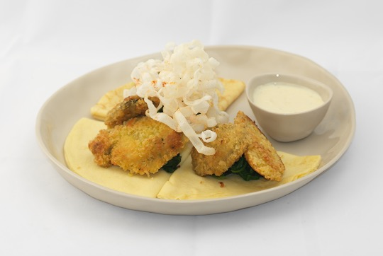
MAIA’s rock lobster  Sweet apple, sour yoghurt, bitter melon, salted lemon, mint | 100  GF | 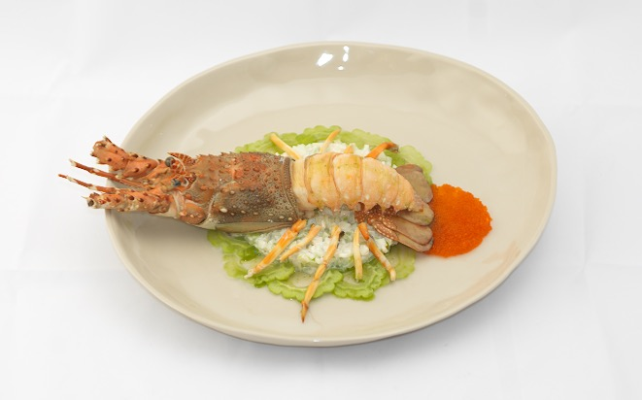
VEGETARIAN
Banh Xeo  Vietnamese pancake with tofu, mushroom, bean sprouts, lattice, fresh herbs, beans, rice paper | 100  GF  V | 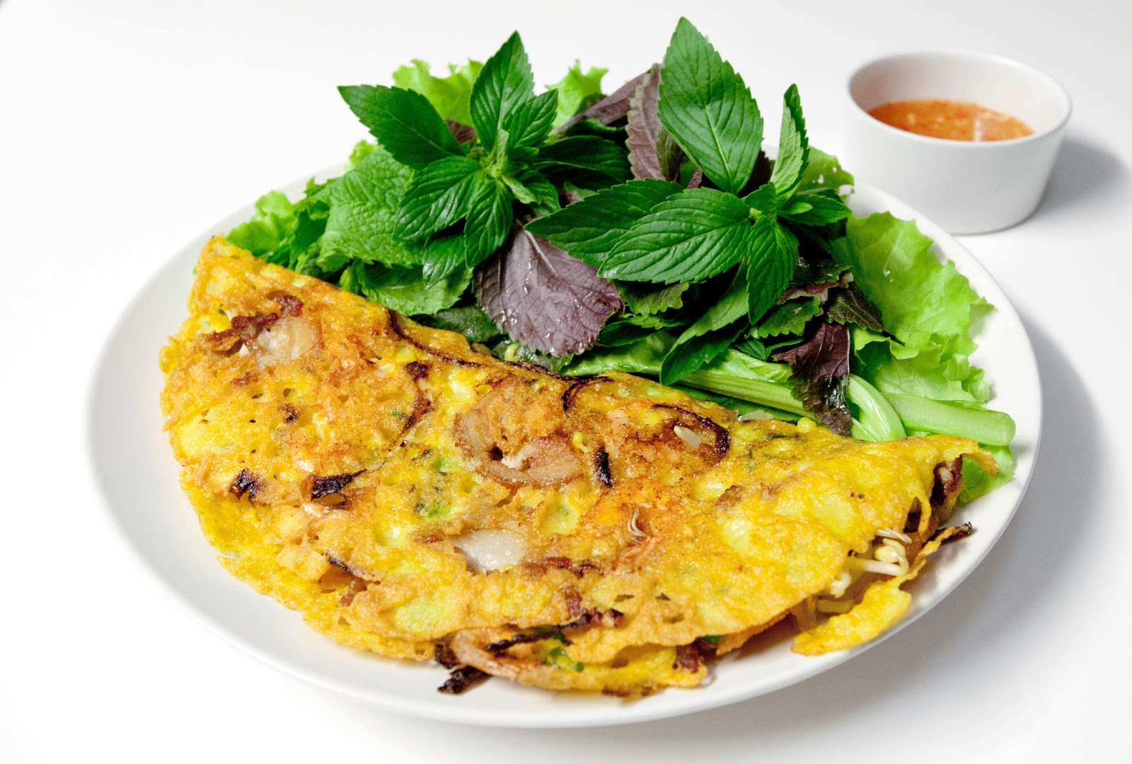
MAIA’S Vegetable Lasagne  Grilled zucchini and eggplant lasagne, roasted tomato sorbet(ice-cream) scalloped mash potato with cheese and Phu Quoc pepper | 100  V | 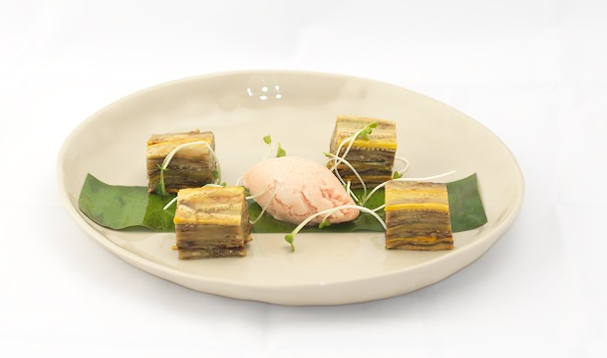
Risotto ai funghi  Italian risotto with local tram mushroom, finished with parmesan cheese | 100  GF  V | 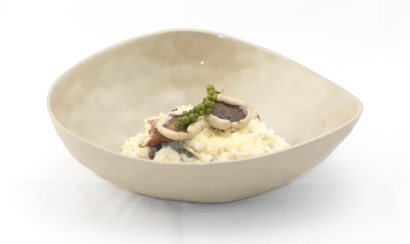
Green Garden Salad  Fresh crispy salad with green mango and green papaya, and peanuts. | 100  V | 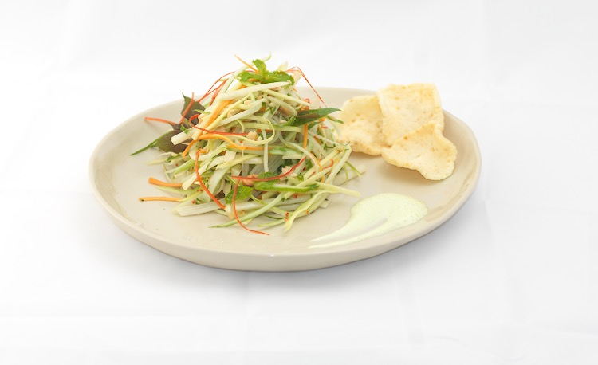
Savour cheese and green pepper crispy “bitterballs”  Mustard sauce and roasted baby tomato | 100  V | 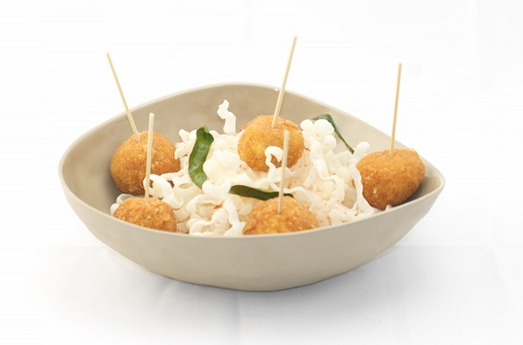
THE SPIRIT OF VIETNAM
Local fish market  See our special daily fresh menu boards | 100  GF | No image
Mackerel & Prawn  Grilled with PQ red pepper oil | 100  GF | 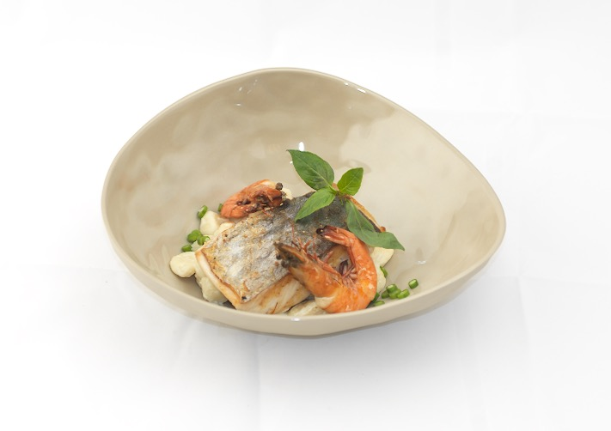
Hotpot  Seafood, stock, vegetables, rice noodles, tofu, fish balls, enoki mushrooms, spinach, | 100  GF | 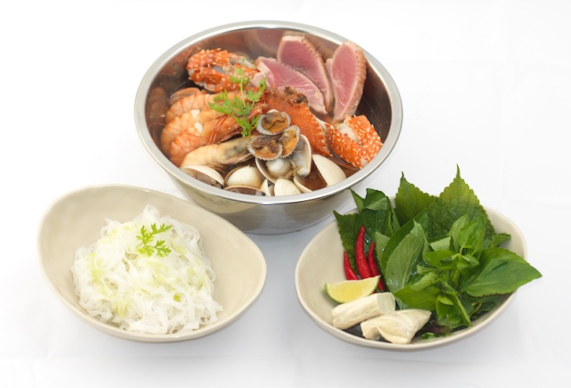
Phu Quoc crab  Stir-fried with egg, green pepper corn | 100 | 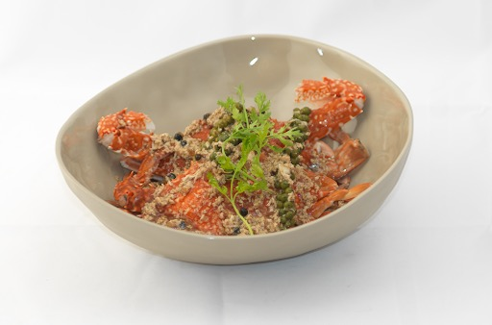
Seafood Banh Xeo  Vietnamese pancake, seafood, beansprouts, lettuce, rice paper | 100  GF | 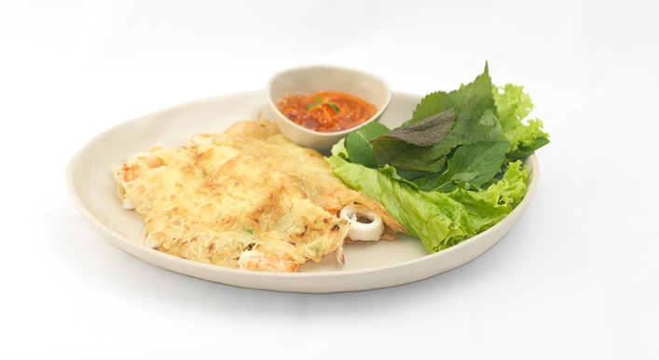
NICE TO MEAT
Steak tartar  Minced beef, egg yolk crème, capper, pickles, shallot, mustard, PQ white pepper | 100  GF | 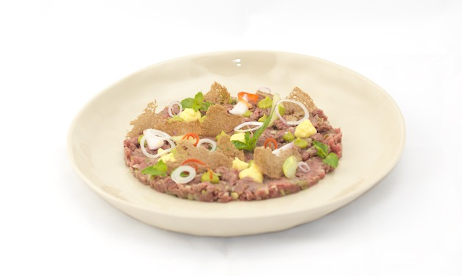
Charcuterie  Parma ham, sausage, chorizo, pate, salami, home smoked tenderloin, union compote, pickles, sweet-sour union | 100 | 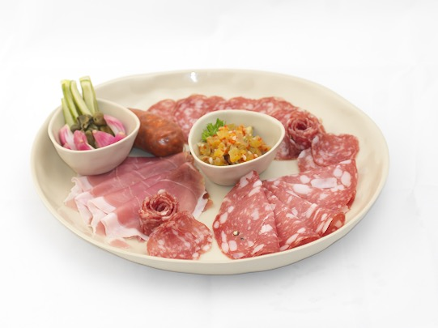
Skirt steak  Grilled, rosemary potato’s, red wine shallot butter | 100  GF | 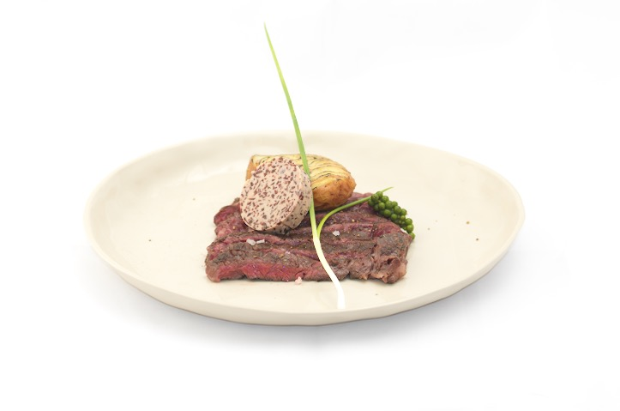
Veal fillet-tenderloin  Marinated with PQ black pepper and mustard, roasted on the planca, pumpkin and green beans, PQ black pepper/mustard sauce | 100  GF | 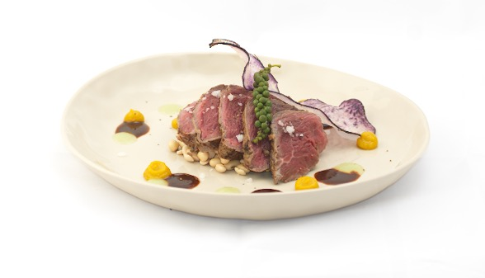
SIDE
Phu Quoc’s Famous Tram Mushroom  Sautéed | 100  GF  V | 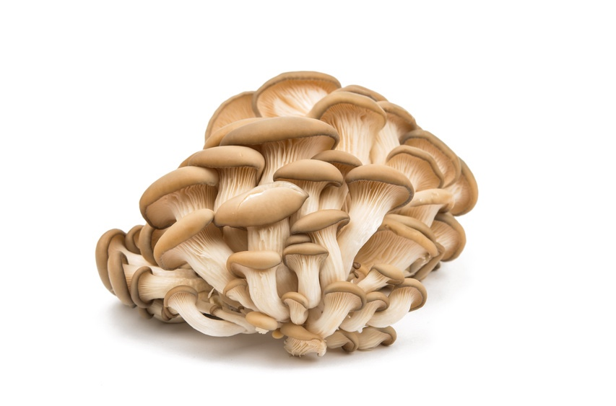
Morning glory  Stir fried with garlic | 100  GF  V | 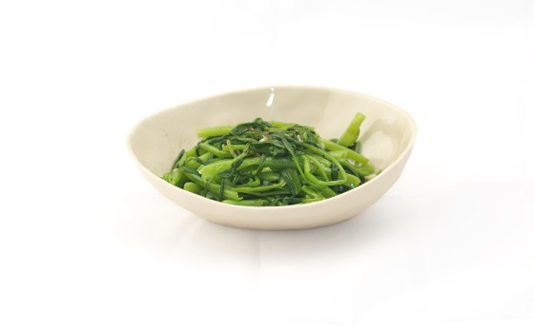
Thien ly Flowers  Sautéed | 100  GF  V | 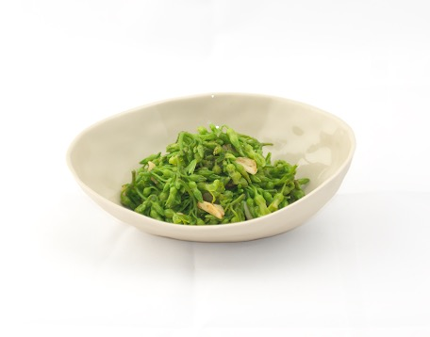
BBQ Eggplant | 100  GF  V | 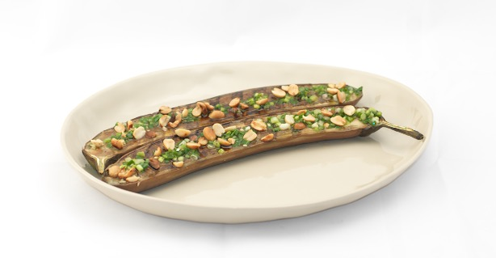
Mixed veggie’s  Stir-fried with garlic, chilli and oyster sauce | 100  GF  V | 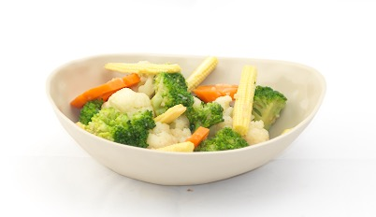
Mix Salad  Fresh basil dressing | 100  GF  V | 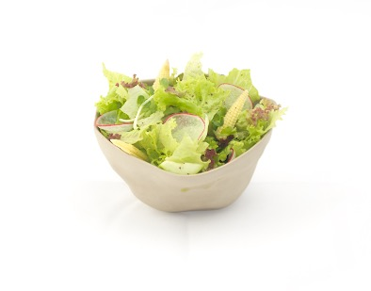
French Fries  House Mayonnaise | 100  V | 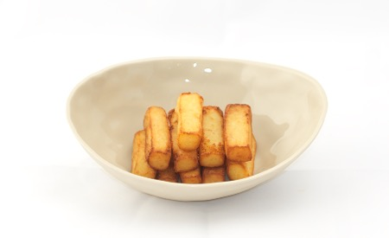
Steamed Jasmin rice | 100  V | 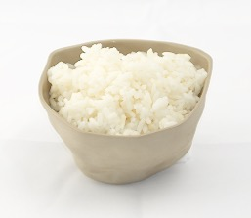
DESSERT
Sorbet  Fresh fruit, simfruit syrup and sorbet ice-cream | 100  GF | 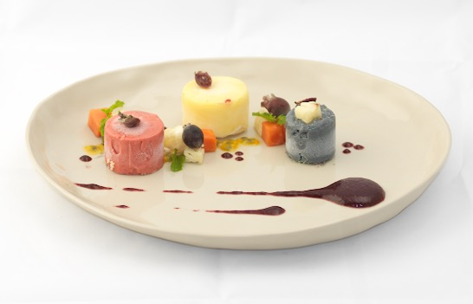
MAIA”S Surprise Crème Brule  Lemongrass | 100 | 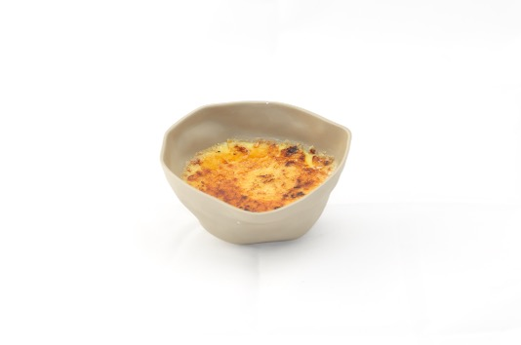
Vietnamese chocolate cake  Coconut ice-cream | 100 | 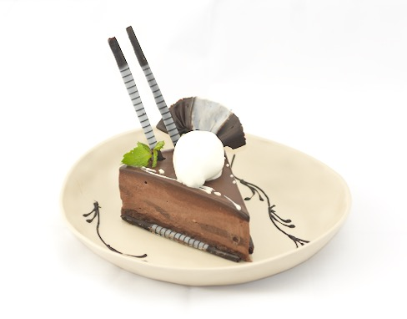
Banh da lon  ASIAN GLUTENFREE LAYER CAKE  Sim fruit sorbet | 100  GF | 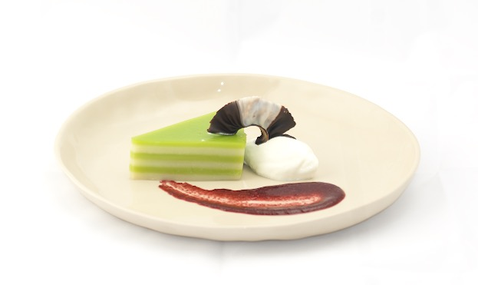
Chè Vải Hạt Sen  Lotus Seed Sweet Soup with Lychee | 100  GF | 