Digital Nomad

Brief

Background- we are a boutique property consultancy company moving to brand new offices in September. We will be offering a co-working space in our office space for approximately 22 business people.

We have decided upon the name Digital Nomad as it represents exactly what we believe the modern business person needs. It is for those people or small businesses who are either start- ups, not ready to sign their own commercial lease yet, or those who would like a structured office environment with access to all amenities and the ability to network as appropriate.

Key words – digital, cloud based, work remotely from anywhere (nomadic) wireless, modern, connected, global, boutique, intimate, professional, urban, dynamic, sleek, agile, now, co-working.

Colours – we are thinking of green being the branding colour, as orange is our consultancy brand colour, although we are potentially open to suggestions.

Logo/branding – we want something that is complimentary to who and what we are, but with its own distinct identity. This business may potentially be expanded into other boutique spaces where it is not a factory but a place for those who know who they are, what they are doing, and want the right fit in terms of professionalism and image as well as premium connectivity.

Requirements

- Logo - including colours (pantone), font (name) sizes (font);
- Branding ideas for lettering and graphics
- Keep in mind that these details will be included on our website, branding including signage, letterheads etc.

Reference:
- www.wilsonhurst.co.nz
- Image of exterior view
- Key words
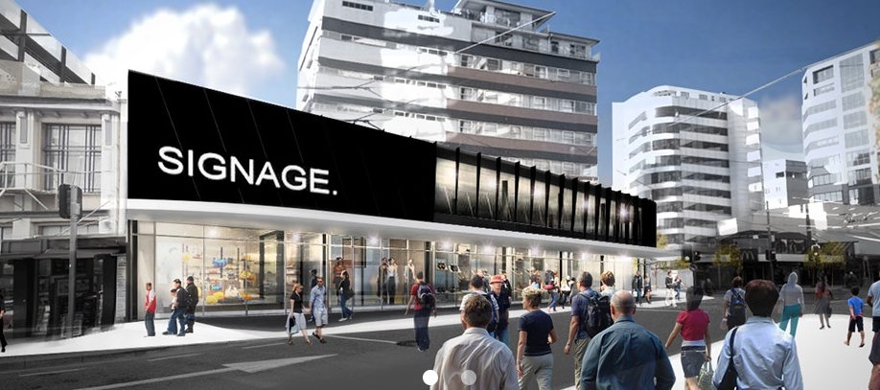

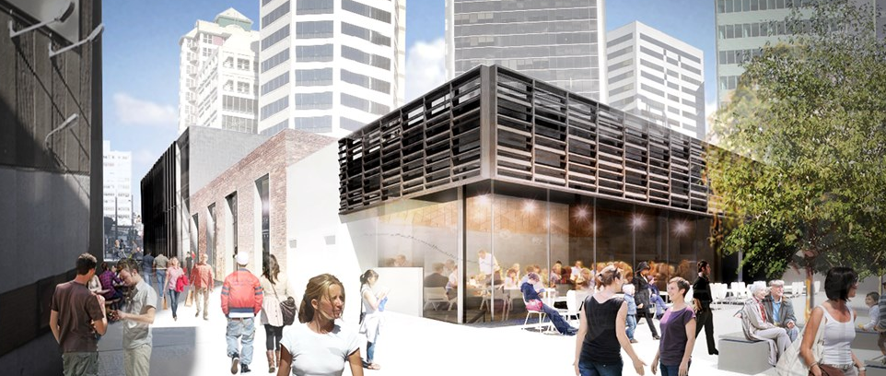
.

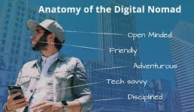
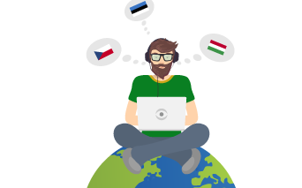

One Idea: some very amateur copy and pastes onto two main ideas –
- Camel with a desk on him/her and possibly some one sitting on the camel at the desk
- Using the film Matrix binary going from the top to bottom either on the camel or the camel is silhouetted say white against the binary (and it is green as per preferred colour choice)
