Goals for logo (incl. tag line: math made simple)

Clean-not busy or complicated
Easy to read
Not too juvenile (mostly for middle/high schoolers and their parents)
Easy to remember
Convey hope to frustrated students and parents (via imagery or small symbol?)
Tagline:
Math Made Simple

Since Simplify it tutoring is not a well- known brand (yet), it is vital that our purpose is clearly represented on our logo.

Like These:

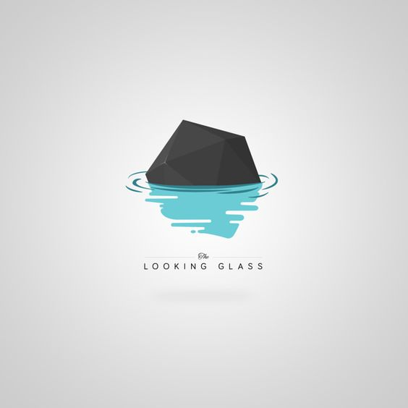
Like the simplicity and imagery


I know from a glance what they do, not too serious but not juvenile, implies graduation

Like the 3 word tagline that all start with same letter, separated by periods.


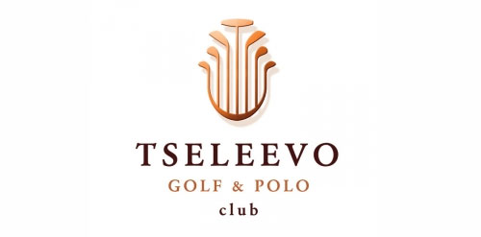
Clean lines, like the symbolic graphic


Like the tag line and imagery
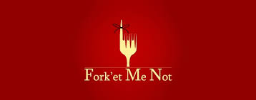
Like the play on words

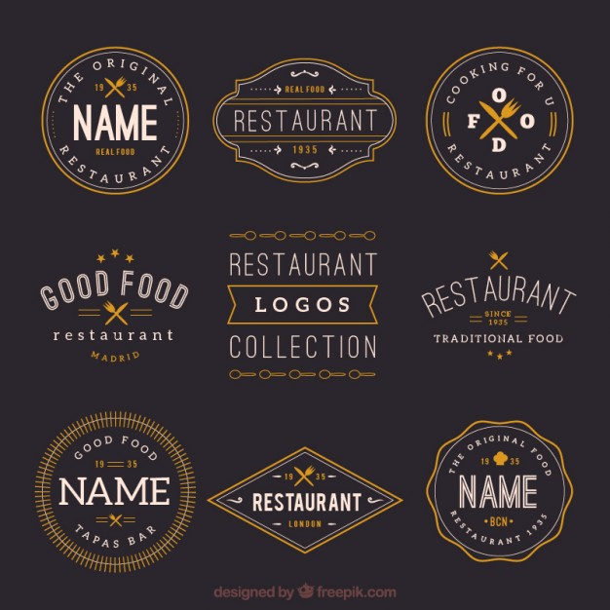
Like this style, whatever it is called
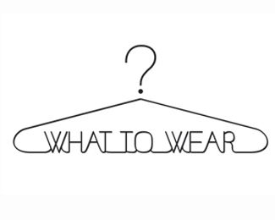
I like the clean look here and how they incorporated the question mark into the hanger.


Like the visual of a peacock meshed with beads. I can tell what this company does. The word “beads” not capitalized works for them and their business, but because we work in education, it is important that we use perfect spelling, punctuation and grammar for our logo and marketing materials.

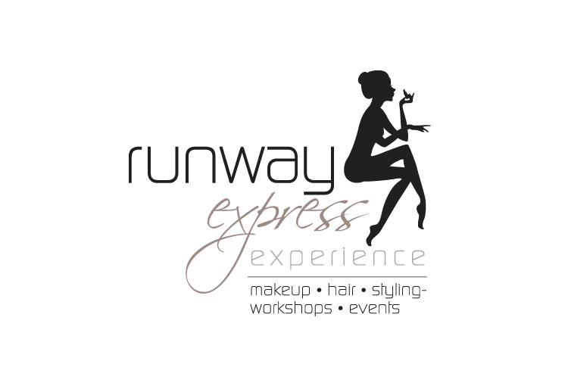
This logo uses various fonts in a tasteful way and fully explains what they do

Don’t like these logos because they are complicated and hard to read:


busy, are they a pizza place?

hard to read font

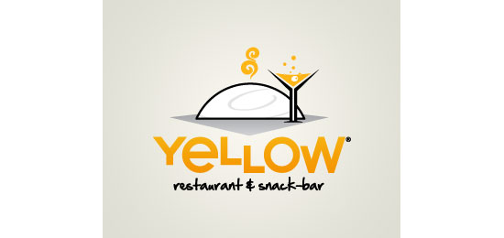small font hard to read, still don’t know what yellow food is, image doesn’t help clarify

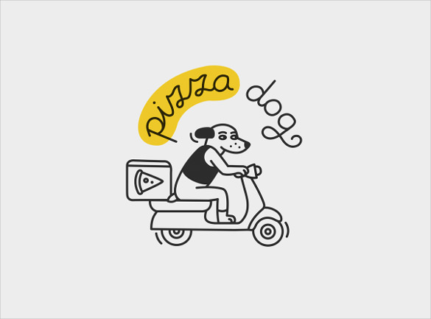love the image, pizza hard to read
do you really want to go to “misfit” fitness?

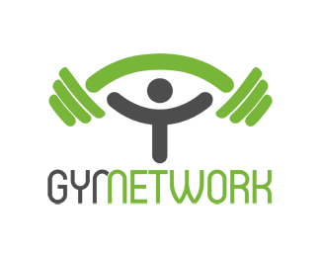takes too much time to try to read and figure out

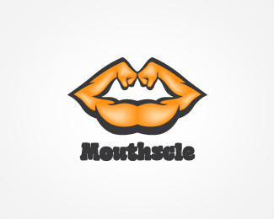Huh? Definitely on the no list. Cannot pronounce nor do I know what they are going for here. Mine needs to be clear and easily understood.

Small font nearly impossible to read. Visual is just…weird. Name hard to pronounce. Accomplishes nothing (for me).


Again, hard to read, what does it mean? What are they selling?

Thanks for reading and looking at our list of likes and don’t like(s)! Our logo is very important to us so please ask questions if further clarification is needed.

