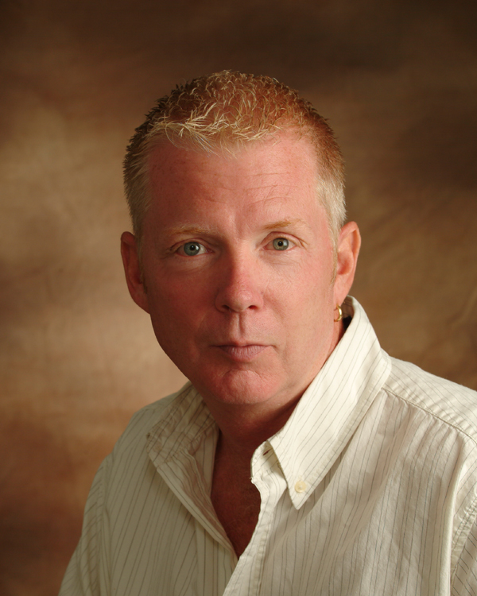

Since 1983, I have been buying and selling real estate, specializing in income producing multi-family properties as well as single family rehab/flip type properties.
I became a Realtor in 2007, where I have been able to use my experiences in real estate investing to help contractors as well as first time home buyers to realize their home ownership and investment goals.
Keeping in line with “helping others”, I feel it a moral obligation to help those less fortunate among us; to “give back” as the saying goes. I work with and support the following organizations:
Connecticut Association of Residential Care Homes (CARCH) - I am the Treasurer of this organization which provides 1,600 beds, in one hundred homes across the State of Connecticut providing housing to mentally and physically disabled people of our communities.
Los Medicos Voladores – I serve as a board member and the trip coordinator for the International Chapter that organizes medical and dental relief missions in Guatemala.
Compassion Flights Foundation – I am the President and pilot for this not-for-profit organization which provides free transportation of animals from shelters facing euthanasia to rescues and adoption centers, where they will find new homes.

