OpenClub Design Brief

OpenClub is a club management system, aimed at simplifying the online process of running any member base online.

Required: We are wanting a website redesign, using static HTML pages. This redesign will involve design of five (5) pages, which will be:

HOME PAGE: Homepage redesign to incorporate:
- Login/signup section for OpenClub platform
- Header with sections
- OpenClub slogan (Bringing your club to the social web)

Below is a screenshot of our current homepage, which we want changed ASAP. Design inspiration should be taken from Stripe: https://stripe.com/au

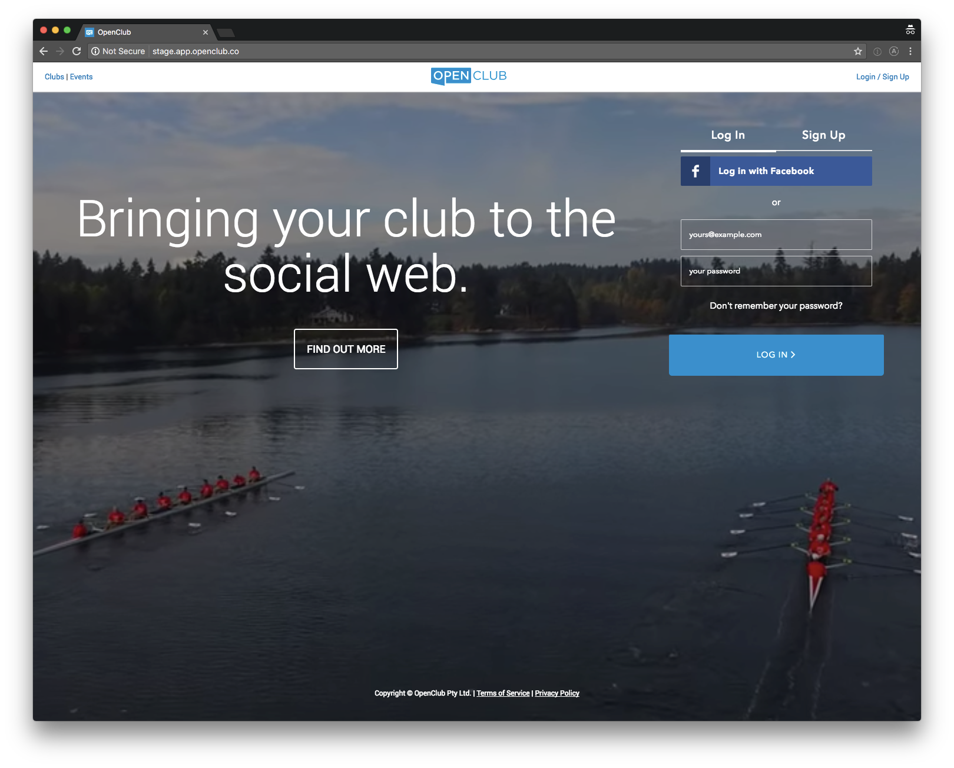

FEATURES: There will be a features page, showcasing an array of features of OpenClub. These will be short snippets of text, with an associated icon. See Stripe for design inspiration: https://stripe.com/au/payments. Use the following placeholder text, and allow for six (6) of these snippets:

PLACEHOLDER TEXT

Here are some words. Here are some more words, but better. Here are some words. Here are some more words, but better. Here are some words. Here are some more words, but better. Here are some words. Here are some more words, but better. Here are some words. Here are some more words, but better. Here are some words. Here are some more words, but better. Here are some words. Here are some more words, but better. Here are some words. Here are some more words, but better.

PRICING: Generic pricing page which we can customise for our seven (7) regions. Pricing page to be similar to Stripe: https://stripe.com/au/pricing

CONTACT: Contact page will contain a form linked to our HubSpot CRM tool for capturing leads. Stripe Contact form – only needs to be a simple page. Sections required:
- Name (Required)
- Phone (Required)
- Email (Required)
- Type of club
- Message

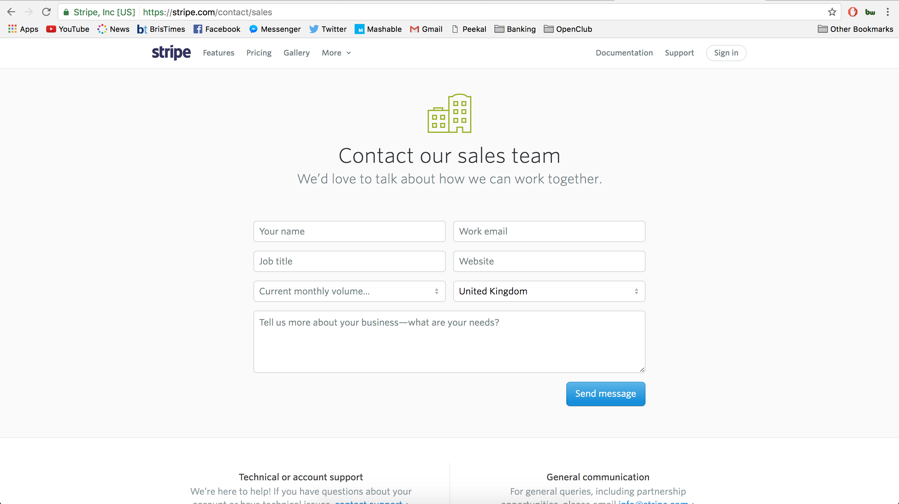

GENERIC BLANK CONTENT PAGE: This page will be a blank page which will allow us to change the content at will. Will likely be used as the page to host blog content.

