B01-2 Massage Chair

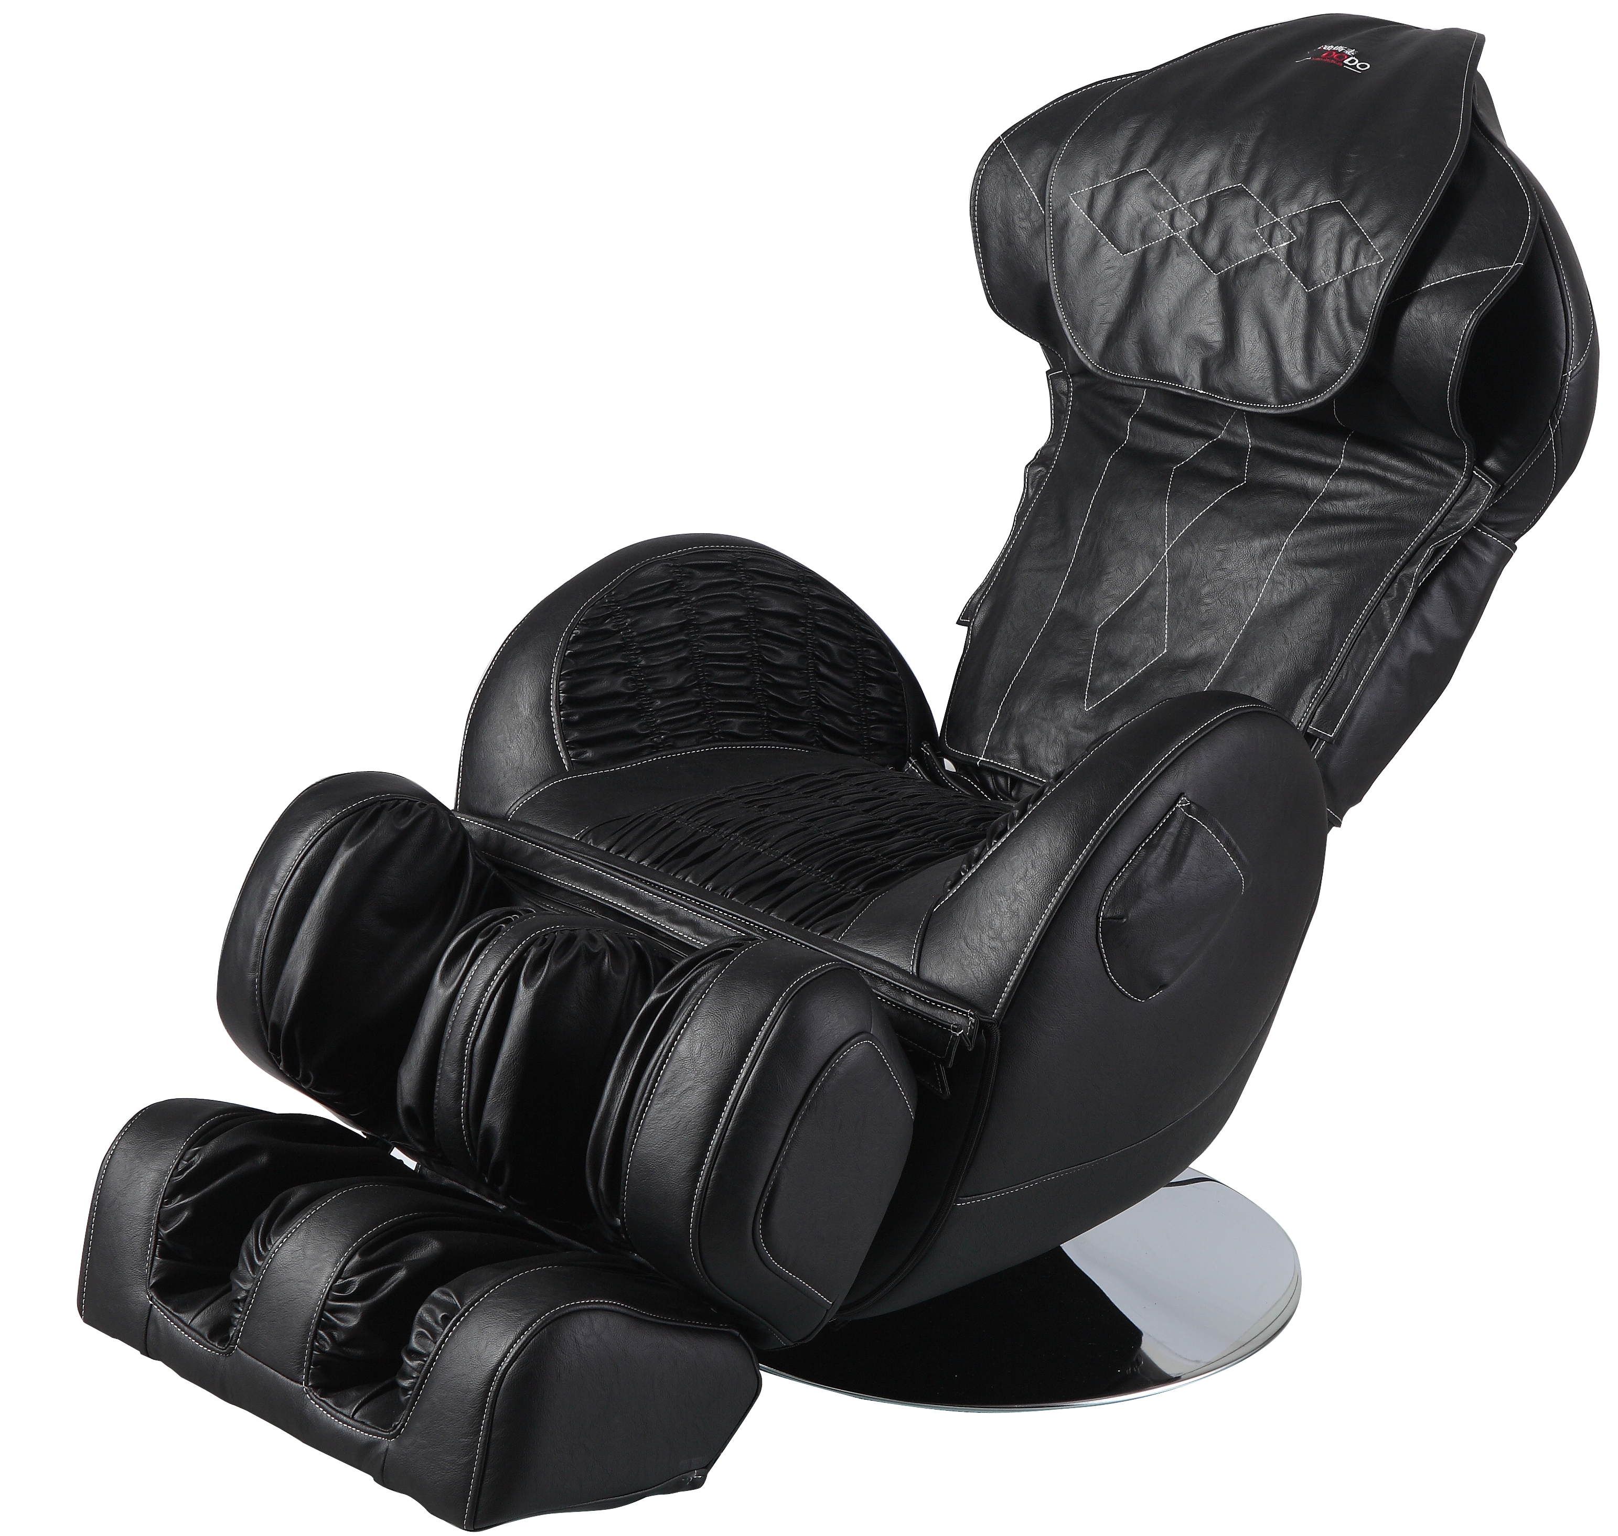

Neck and shoulder kneading to relieve stress and fatigue
- The hip and seat air bag system massages the user’s buttocks, while the calf air bag system works together with the heating pad to provide relief to the legs.
- The leg and hip heating infrared heating system works to ease cold hands and feet, injury, muscle soreness and numbness
- Provides relief to tired feet, including the soles
- The back of the chair can be extended backwards, into a lying position. This position is the best for releasing pressure, and combating tired mucles. The airbags on the pillow, back and armrest work in tandem to massage the body thoroughly.
- The neck height is adjustable
- The roller speed is adjustable

