A10 Massage Chair

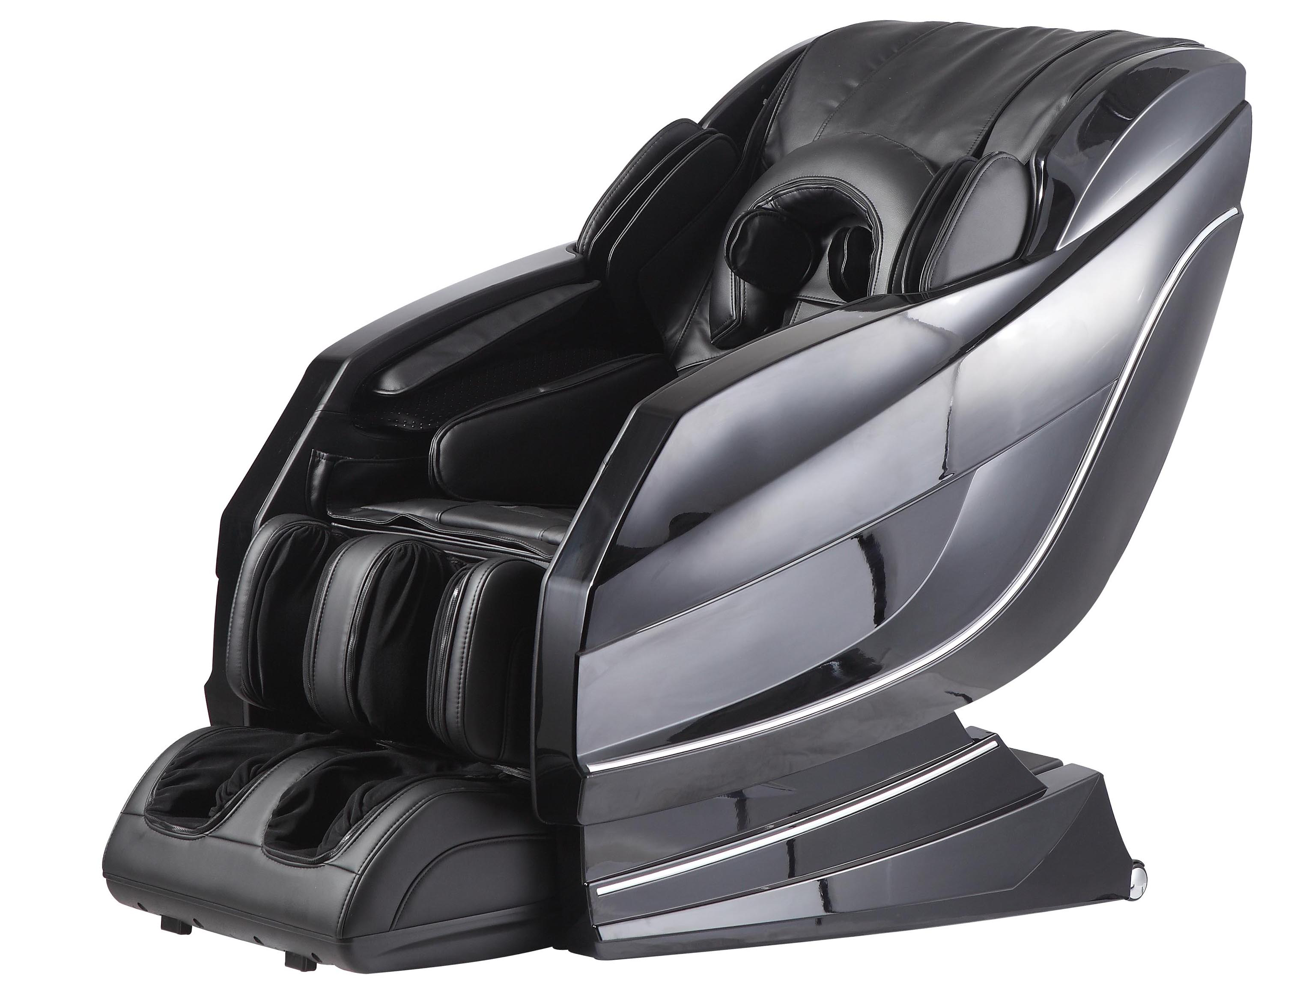

S-L back track fits the human shape perfectly
- The U-shaped pillow massages the temples to relieve fatigue
- Assumes the zero gravity position that astronauts take during lift off, allowing for a deeper, more intense massage experience; and promoting circulation in the legs, and reduced swelling
- Equipped with body scan sensor that adjusts back roller position, and leg length automatically to match the user
- Equipped with Bluetooth chips, it allows you to display music via any Bluetooth enabled device
- The foot and calf roller system help relieve foot stress and tiredness
- The chair gives a classic “rocking chair” feeling for total relaxation by moving upper part of the chair back and forth
- Equipped with carbon fiber heating pad, which offers heat for the back, buttocks, calves and ankles
- 89 air bags are built into the chair, which inflate and deflate during your massage session.

