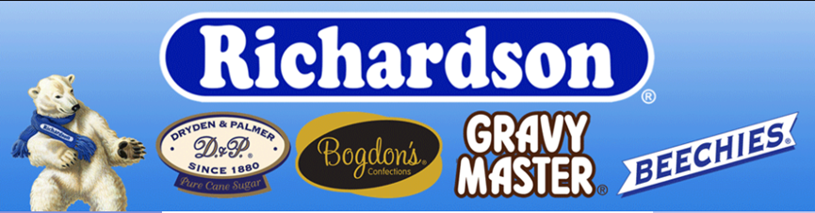
Richardson Brands Company, founded in 1880 in New York, carries a long heritage of award-winning confectionery products, and uncompromised quality. The company has 6 major product lines, that can perfectly meet the needs of different consumer groups.

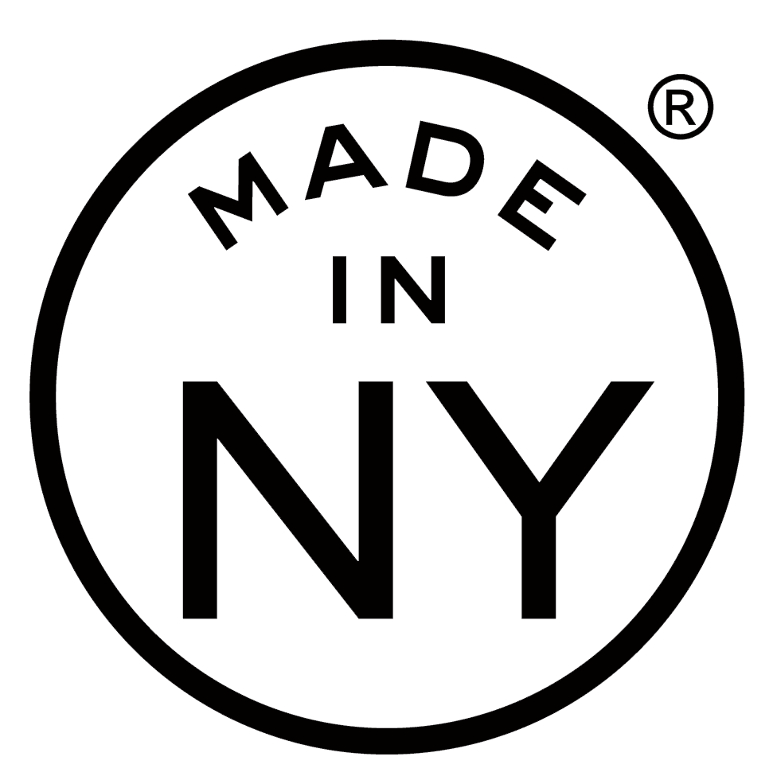
OUR BRANDS
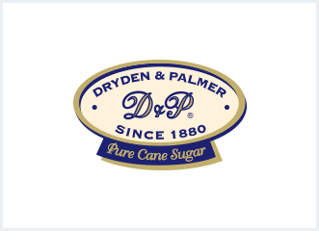

DRYDEN & PALMER Rock Candy (Since 1880)
Dryden & Palmer Rock Candy products can be found in all states across America, as well as in most countries in the world. With an amazing range of popular colors, flavors and sizes. D&P Rock Candy has something for all ages: colorful lollypops, bright crystal sticks for unique party favors and decorations, crystals for baking and cakes decoration, and edible stirrers for many beverages like Coffees, Teas, Scotch, Whiskey and even Champagne.
The product: Rock candy grown Artisan style which is then delightfully flavored and colored. Festive, elegant and decorative! Custom flavors and colors available.
Flavors: Ginger, green tea, maple, black cherry, raspberry, blueberry, bubble gum, cherry, cotton candy, grape, green apple, lime, lemon, strawberry, orange, root beer, watermelon, natural. Sour rock candy is offered in: raspberry, cherry, apple, lemon and watermelon.
Sizes: 7, 10, 13, 14, 17, 22 and 55 gram sticks.
Attributes: Rock candy contains no allergens, is fat free, gluten free, vegan, kosher OU, does not contain GE (Genetically Engineered), PHO’s (Partially Hydrogenated Oils), HFCS (High-Fructose Corn Syrup) or allergens. Custom flavors/colors available.

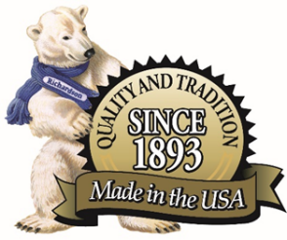

RICHARDSON Mints (since 1893)
Richardson is one of the first candy manufacturers in the US, specializing in pastel mints, butter mints and assorted chocolate products.
The product: Richardson is synonymous with mint! Our famous Jelly mints have returned better than ever! They have a hint of mint and have a jelly middle flavored in delicious fruit flavors. Gourmet mints have a creamy mint center coated in real chocolate with a bright and festive candy shell. Butter mints have a creamy minty and buttery taste and texture while pastel soft sugar mints have a refreshing mint flavor.
- Jelly Mints:
- Gourmet Mints:
- Butter Mints:
- Pastel Soft Sugar Mints
Flavors: Mint, Green tea, strawberry/berries, lemon, apple, peach, orange, watermelon, ginger, and other great flavors.
Sizes: 4.5 oz, 5.5 oz, 12 oz, 44 oz tub, 4 lb and 25-pound/30-pound bulk available.
Attributes: Jelly mints are naturally flavored, vegan, kosher OU, fat free and contain no PHO’s (Partially Hydrogenated Oils), or HFCS (High-Fructose Corn Syrup). Butter mints are gluten free, fat free, kosher OUD, contain no GE (Genetically Engineered) and are naturally flavored. Pastel soft sugar mints are kosher OU, contain no GE (Genetically Engineered), naturally flavored, fat free and are gluten free.
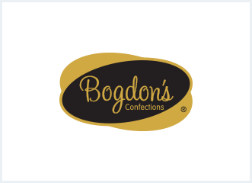

BOGDON'S (since 1945)
In 1945 the Bogdon Reception Stick was born - a delicious, thin, crunchy, chocolate-covered treat. Great for dessert, baking or just a snack and tasty with coffee or tea. Flavors include mint, lemon, orange and cinnamon, as well as Mint Double Dips.
The product: Crispy candy sticks paired with a deliciously rich chocolatey coating. Custom flavors and colors available.
Flavors: Peppermint, chocolate, green tea, ginger, French vanilla, strawberry, orange, cherry, cinnamon, blueberry, cotton candy, sugar cookie, lemon, lime, pumpkin spice, candy corn, and wedding cake.
Sizes: 2.6 oz, 6.5 oz, 7 oz, 7.5 oz, 7.75 oz, 8 oz, 8.5 oz, 12 oz, 36 or 48 count or bulk.
Attributes: Bogdon sticks are gluten free, kosher OUD, contain no PHO’s (Partially Hydrogenated Oils) or HFCS (High-Fructose Corn Syrup) and can be naturally flavored and/or colored.

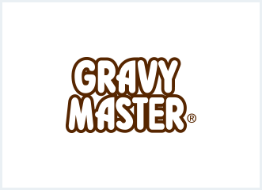

GRAVYMASTER - the choice of top chefs in the United States
GravyMaster™ is the popular American browning and seasoning sauce typically used to add flavor and color to marinades, barbecue, roast duck and meat dishes and Stir Fry. From top chefs in commercial kitchens to the master chef at home, GravyMaster™ is the quick and tasty flavor enhancer that adds color, and richness to delicious meals.

The product: Savory seasoning blend is not just for gravy! Gravy master brings the elusive Unami flavor to proteins, vegetables, sauces and stews. Gravy master adds depth of flavor to any savory dish.
Sizes: 2 oz, 5 oz, quart and gallon.
Attributes: Made with apple cider vinegar. Gravy master is vegan, kosher, contains no PHO’s (Partially Hydrogenated Oils) or HFCS (High-Fructose Corn Syrup), is low calorie.

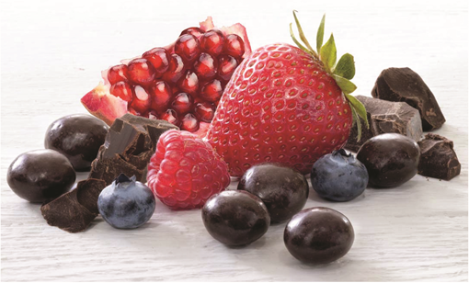

6. Fruit Snacks
There is nothing like the taste of NY! Try our Signature Collection of dark chocolate covered berries.
The product: Various natural fruits and berries covered in rich dark chocolate.
Flavors: Blueberry, strawberry, raspberry, blackberry
Attributes: Made with real fruits

For further information, please contact:
Company URL: http: Richardsonbrands.com
Company Address: 101 Erie Blvd Canajoharie New York 13317
Phone: (518) 673-3553

