RESTYLING BURGUM NOVUM LABEL
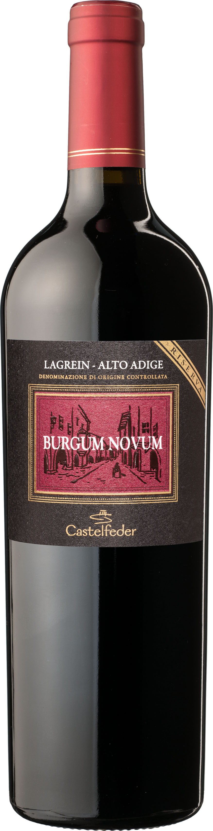
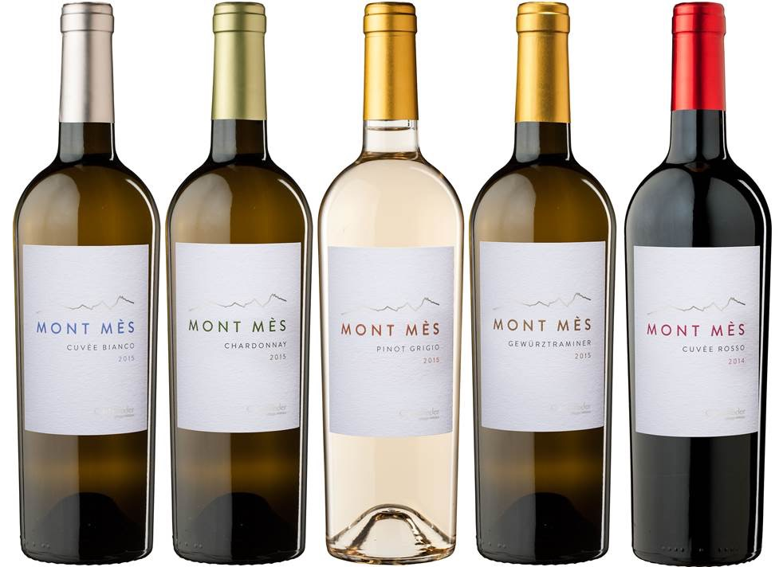
BY CASTELFEDER WINERY
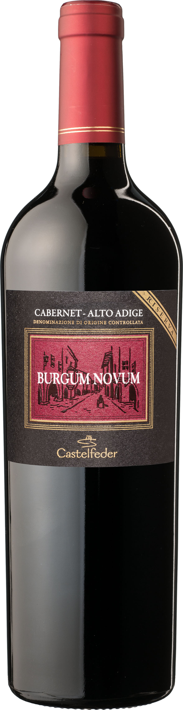
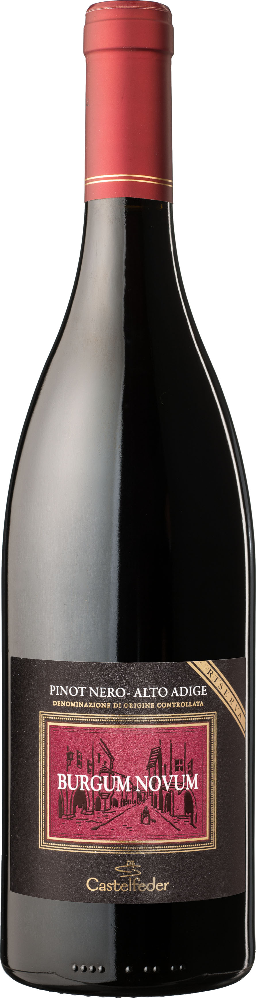
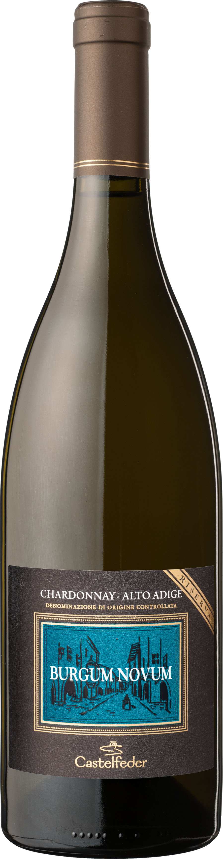
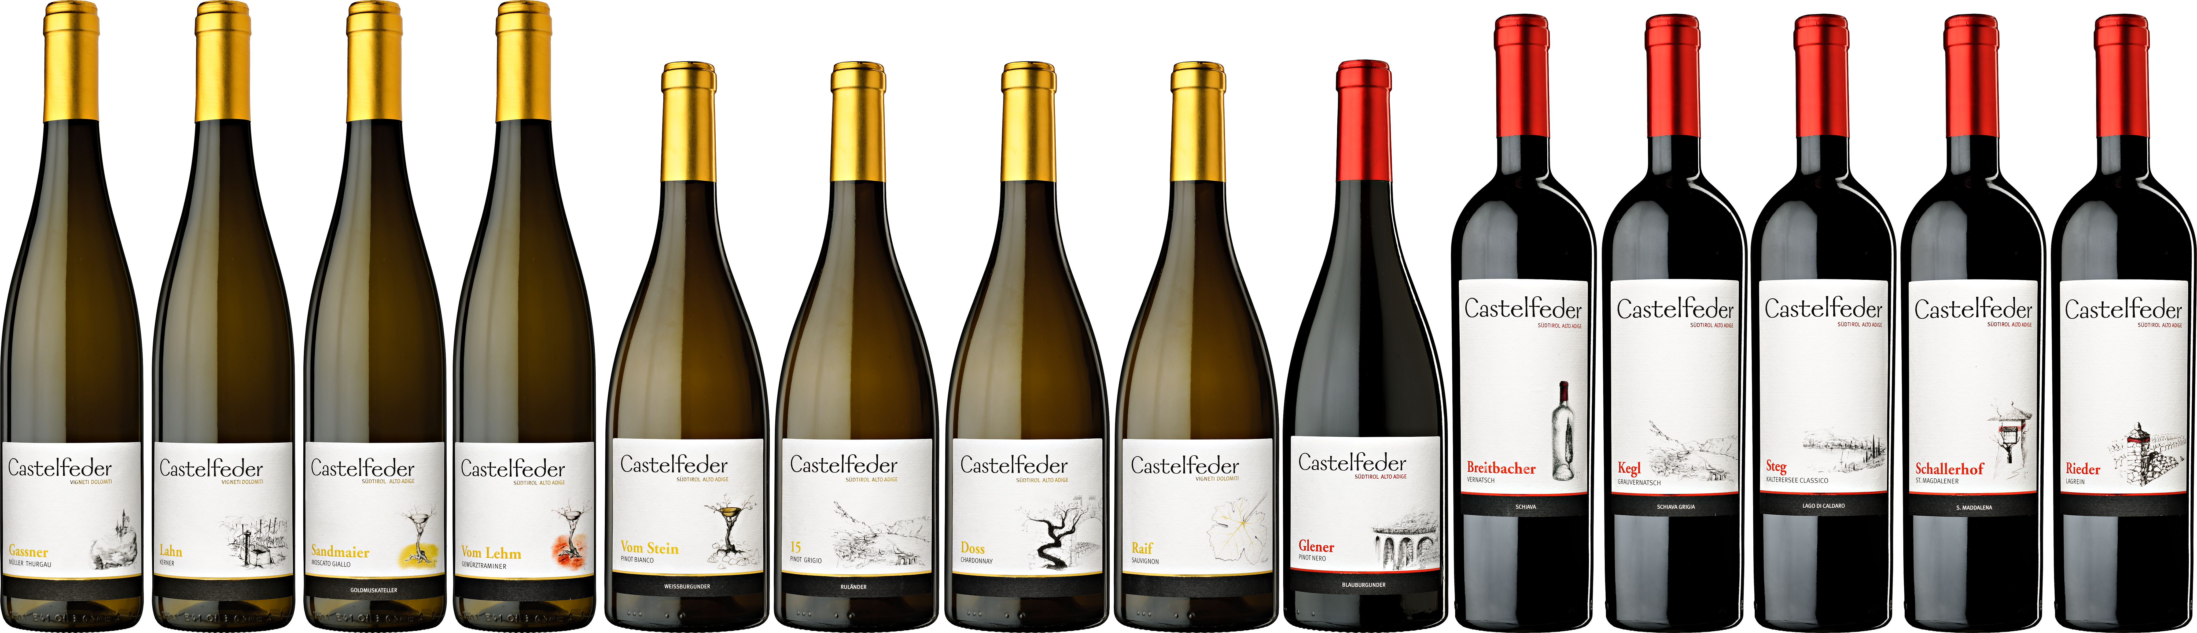

General Information:
- Castelfeder winery is a traditional 4th generation family owned winery in Alto Adige, Italy’s most northern region.
- We produce typical white and red wines in our region and these wines are divided in 3 line-ups:

Mont Mes (entry level) modern, fresh fruity wine style
Castelfeder - Selections (single vineyard selections) complex, medium-high end wines
Castelfeder - Riserva Burgum Novum (high end) traditional, oak aged wine

In the past years we have done a restyling for the first two line up-s and would now like to freshen up our Burgum Novum line up (to the right and connect it with the selection label.

Infos about Burgum Novum:

- Name: latin name of the town were the winery was founded (see picture attached)
- Arches of this old historic town have been on the labels until now, not necessarily required but could be used.

- Wines:
2 whites Chardonnay, Sauvignon
3 reds Pinot Nero, Lagrein, Cabernet

- Bottle: 2 different bottles (Burgundy bottle for Chardonnay/Sauv./Pinot Nero and Bordeaux bottles for Cabernet and Lagrein) see pictures
- Colors: free
- Format: free
- see attached the two prior labels of this brand

Requirements:

- Classic/traditional design prefered
- Design should reflect the high quality of the wines and the tradtion of the winery
- Variety needs to be clearly recognizable and on the front label
- Brand name Burgum Novum on the front label
- Winery name Castelfeder (see logo attached) on front label

legal requirements
Sùdtirol - Alto Adige Doc Riserva indicated on front label
Castelfeder Azienda Vinicola (logo) needs to be a group of words (see other labels)

Budget 500 €

