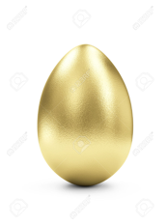Golden Egg
Branding Boutique
From scratch to market in six months

